## Award Winning Canberra Roofing Company Redefines Small Business Success, Expands Horizons Across Australia

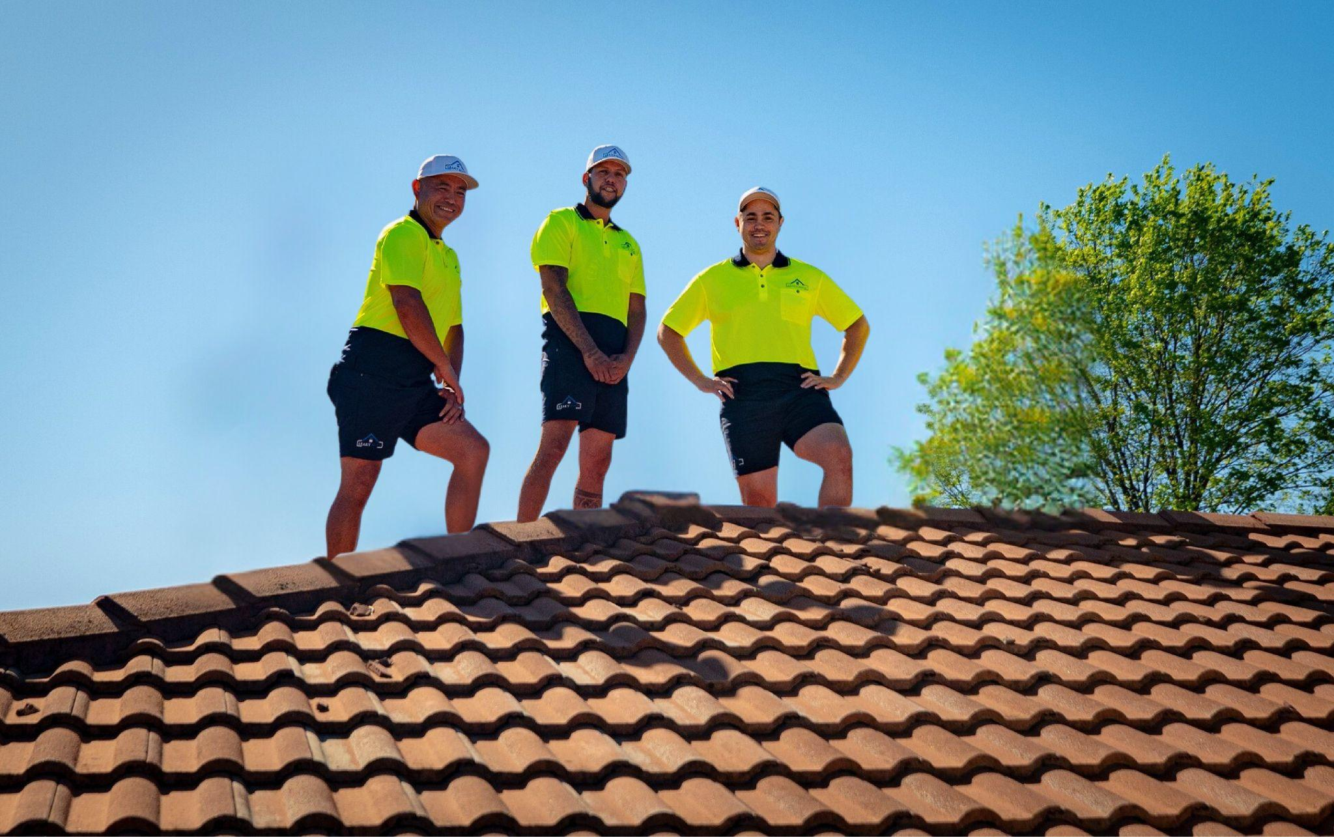

**Canberra, ACT**: In an era when large corporations dominate the construction and trade sectors, one Canberra-based company is rewriting the narrative for independent businesses. Leaky Roof, a family-founded roofing company, is setting new benchmarks for innovation, sustainability, and community impact. With a proven track record of success in its home market, Leaky Roof is now turning its gaze towards national expansion, offering a compelling blueprint for how small businesses can achieve big things while staying true to their roots.

From its inception, Leaky Roof has stood out for its superior craftsmanship and its steadfast commitment to the community it serves. What began as a small operation addressing Canberra's frequent storms and roof damage has evolved into a powerhouse of innovation and customer-centric solutions. As the company expands to Sydney, Melbourne, and other major Australian markets, it demonstrates that independent businesses can thrive by embracing values-driven growth.

"We've always believed that being a small business doesn't limit your potential; it enhances your ability to innovate and connect," says Justin Vetsavong, CEO of Leaky Roof. "Our goal is to prove that independent companies can not only compete with larger players but lead the way in setting new industry standards."

### **A Record Year of Achievements**

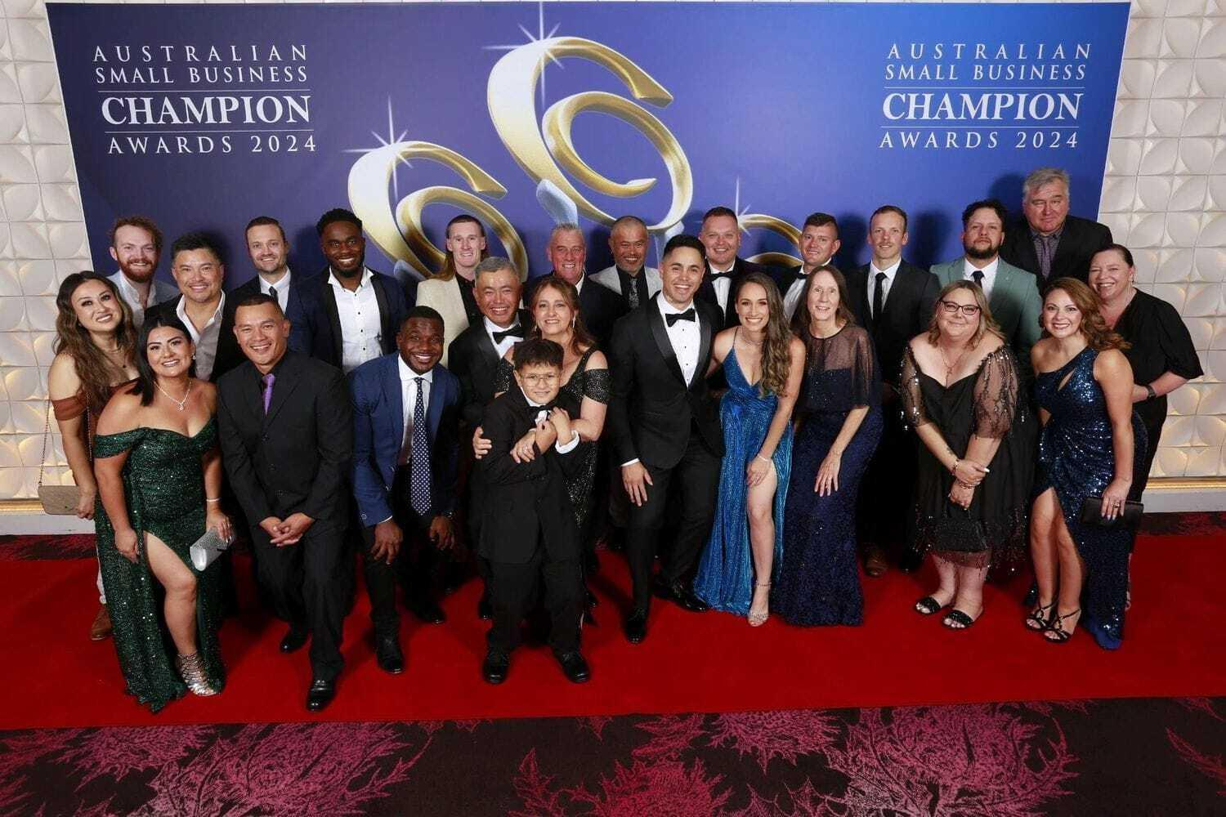

2024 was transformational for Leaky Roof. The company's efforts culminated in its win at the Australian Small Business Champion Awards, recognised for excellence in the roofing category. CEO Justin Vetsavong earned the prestigious Small Business Champion Entrepreneur Award, highlighting his visionary leadership and dedication to redefining the roofing industry.

Locally, the accolades continued, with Leaky Roof being named **the Best Roofing Company in Canberra** by Riotact and earning the title of **Business of the Year** at the 2023 Local Business Awards. These honours reflect the company's technical expertise and community-first approach, which has resonated deeply with homeowners and businesses alike.

### **Innovation with a Purpose**

Leaky Roof's success is not built on tradition alone; it directly results from forward-thinking innovation. Over the past year, the company introduced advanced drone-powered roof inspections, allowing for greater precision and efficiency in assessing roof conditions. This approach has enhanced service delivery and reduced costs and disruptions for customers.

The upcoming launch of Roof Care Subscription Packages, a first for the Australian market, underscores Leaky Roof's commitment to proactive solutions. These packages provide routine maintenance and inspections, ensuring roofs remain optimal year-round and offering homeowners peace of mind.

Another standout initiative is developing a self-service quoting system, allowing customers to receive instant quotes and book appointments online. By leveraging technology, Leaky Roof makes high-quality roofing services more accessible and convenient.

"Innovation isn't just about technology," notes Vetsavong. "It's about finding new ways to add value, improve customer experiences, and solve problems before they arise. That's what drives us every day."

### **A Focus on Sustainability**

As Leaky Roof expands, it remains deeply committed to environmentally responsible practices. By prioritising sustainable materials and minimising waste, the company is helping to address the growing demand for eco-friendly solutions in home improvement. This approach has strengthened its appeal among environmentally conscious consumers and positioned Leaky Roof as a leader in the movement toward sustainable construction.

"Sustainability isn't optional—it's essential," says Vetsavong. "We're not just building roofs; we're building a future where businesses and the environment thrive together."

### **Expanding Horizons, Redefining Possibilities**

While firmly rooted in Canberra, Leaky Roof's ambitions extend beyond its local market. The company is actively planning its expansion into key metropolitan areas, including Sydney, Melbourne, and Brisbane. This growth strategy is not merely about scaling operations; it's about exporting a business model that prioritises quality, integrity, and community impact.

Leaky Roof also paves the way for other small businesses by showcasing what is possible through creativity and determination. By challenging the notion that bigger is always better, the company inspires a new generation of entrepreneurs to think differently about growth and success.

### **A Business Built on Values**

At the heart of Leaky Roof's journey is its commitment to values that prioritise relationships over transactions and long-term impact over short-term gain. The company's involvement in local initiatives, such as its $50,000 charity giveaway benefiting Roundabout Canberra and Kids in Care ACT, demonstrates that success can and should be shared with the communities that help build it.

"A business is only as strong as the community it serves," says Vetsavong. "That's why we're committed to giving back, supporting local causes, and ensuring our growth benefits everyone, not just the bottom line."

### **Looking Ahead**

As Leaky Roof continues to innovate and expand, its journey is a testament to what independent businesses can achieve with a clear vision and a commitment to excellence. From Canberra to the rest of Australia, the company sets new standards for quality, sustainability, and customer care—proving that even small businesses can make a significant impact.

For more information or to arrange an interview with Justin Vetsavong, please visit Leaky Roof's [website](https://www.leakyroof.com.au) or e-mail their publicist Nadya Rousseau at nadya@alternewmedia.com.

**About Leaky Roof**

Founded over two decades ago, Leaky Roof is Canberra's trusted roofing provider, known for its innovative solutions, sustainable practices, and community-first approach. With plans to expand across Australia, Leaky Roof is redefining the possibilities for small businesses in the modern economy.