Media Release |  | 24 January 2025
Supporting Local Initiatives: The EMRC Awards Community Grants

Newly appointed EMRC CEO Matthew MacPherson, together with EMRC Chairperson, Cr Filomena Piffaretti, and EMRC Councillors Cr Tallan Ames; Cr Paul Poliwka; and Cr Doug Jeans presented EMRC community grants to eight worthy recipients, on Wednesday 22 January at the Red Hill Waste Management Education Centre. Also in attendance was EMRC Deputy Councillor, Cr Kathyrn Hamilton.

The worthy recipients operate within the EMRC region, in close proximity to either the Hazelmere Resource Recovery Park or the Red Hill Waste Management Facility. A total of $16,844 was awarded across the eight organisations.

The EMRC’s Community Grants Program is designed to support local initiatives that aim to enhance the well-being and development of local communities. The initiative demonstrates the EMRC’s commitment to community while the grants help foster a collaborative approach to addressing local needs.

The grant recipients included:

- Trillion Trees for their Community Compost project. Trillion Trees Australia is a not-for-profit organisation operating across WA. At Trillion Trees, they are not just planting trees; they aim to grow communities, restore landscapes, and educate generations.
- Susannah Brook Catchment Group for their Native Fauna Conservation and Community Education project. The goal of Susannah Brook Catchment Group (SBCG) is to link fragmented patches of bushland creating wildlife corridors, improving surrounding remnant vegetation, controlling weeds, planting native species, and providing habitat for endangered and threatened species.
- Gidgegannup Men’s Shed for their Custom Signage project. The aim of Gidgegannup Men’s Shed (GMS) is to provide training and opportunities for members to work on projects targeted to reflect their lifestyle, as well as to share time, recreation, and fellowship with other members, with focus on mental health.
- Gidgegannup Basketball Club for their Equipment Upgrade project. The mission of the GBC is to provide children and families the opportunity to engage in basketball, regardless of skill level, in a welcoming and family-friendly environment.
- Self-Made Girls for their Autism Awareness Market project. The SMG Inc mission is to provide the tools, resources, and community support necessary for young girls to bring their entrepreneurial ideas to life.
- Cancer Council for their Life Now Exercise Project. The grant will enable Cancer Council WA to offer its ‘Life Now Exercise’ 12 week course for cancer patients living in Midland and surrounding suburbs.
- Bibbul Ngama Aboriginal Association for their Community Cultural Awareness Project . The purpose of the Bibbul Ngarma Aboriginal Association Incorporated is to promote, preserve and grow Aboriginal culture, heritage, language, and traditions.
- Swan View Cricket Club for their Equipment Upgrade project. The primary purpose of the Swan View Cricket Club is to provide a positive, improvement focused environment with clear cricket pathways for players of all ages while fostering a supportive community and vibrant social atmosphere

We extend our thanks to all applicants for their inspiring proposals and dedication to enhancing their communities.

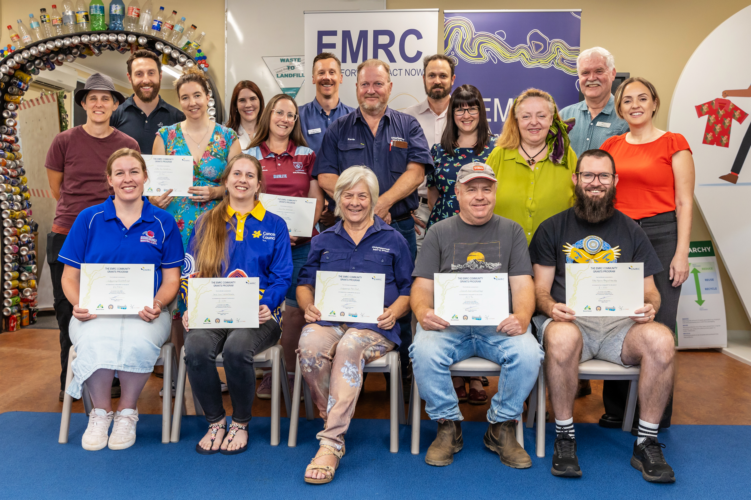
Notes to Editors:

Founded in 1983, the Eastern Metropolitan Regional Council (EMRC) is a forward-thinking regional local government representing the interests of four-member Councils located in Perth's Eastern Region: Town of Bassendean, City of Bayswater, the Shire of Mundaring and City of Swan. The Region covers a third of Perth’s metropolitan area and is home to 338,000 people.

The EMRC provides a broad range of services across the region, including waste management and education, resource recovery, and sustainability initiatives. Working in partnership with its member Councils and other stakeholders, the EMRC delivers local and regional scale projects across each of these areas for the beneﬁt of the region.

For further information please contact: communications@emrc.org.au

