The Resurrection of Rock

Rock Is Not Dead Australia covers all things in Australian Rock. The group is a collaborate of music enthusiasts who have banded together to get the rock n roll scene of Australia back up and running. Their efforts began in the form of a Facebook group (Fans of Hair / Glam / Sleaze Metal Aus), that now encompasses a 50/50 split including Australian Rock Acts. The page now has over 1000 followers. From this page a YouTube channel (Rock Is Not Dead Aus) was created showcasing the plethora of talent across the Australian Rock Scene. Their latest expansion has been their Instagram (Rock Is Not Dead Aus), tailored to promoting Australian Rock acts no matter how big or small.

Having found a following on their social media platforms the group have produced the “Rock Is Not Dead Festival”. This event is planned for February 1st, 2025, at The Koala Tavern, Capalaba. It is a self-funded event consisting of eight Australian Rock bands, each with own unique sound for all the rockers out there. The lineup features, *Avalanche* (the next big thing), *Tailor Made Rejects* (the unapologetic alt. rockers), *Snake Bite Whisky* (the kings of sleaze), *Black Whiskey* (pure Aussie rock), *Stone Rising* (underrated icons), *Whiskey On The Rox* (a crowd-pleasing 80s cover band), *Goatzilla* (legends of the live show), and *Slythr* (the up-and-coming rock prodigies).

The event’s purpose is not for profit but to raise awareness towards the unrecognised talent circulating within the rock scene of Australia. Tickets will be available at $35 per person through Oztix and if successful will go towards funding another event of Aussie Rock.

The announcement date is set as November 1st. Between now and the show our only request is to spread the word to as many rockers as possible. Let’s kick start the resurrection of rock.

Many Thanks,

The Rock Is Not Dead Australia Team.

Contact: Mark Elstone: 0431 619 937 / [mlesltone@outlook.com](mailto:mlesltone@outlook.com)

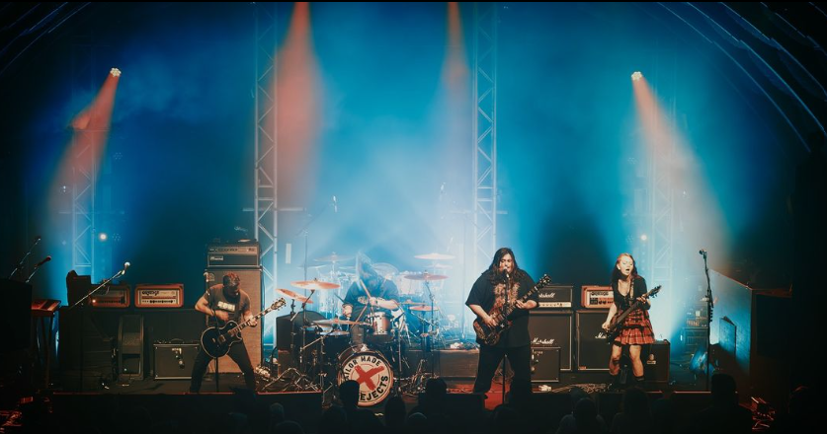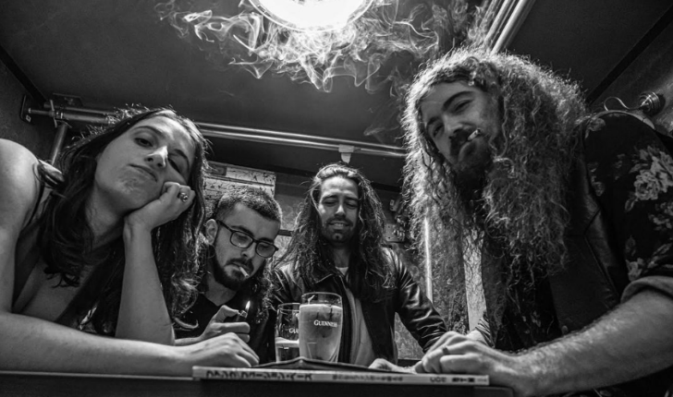

Tailor Made Rejects

Avalanche