**Headline: Cyclone Chaos: Homeowners Left with Massive Repair Bills as Insurers Refuse Payouts Over Roof Neglect**

*Sub: Over $2 billion in damages as people prioritise rooftop restorations after damaging winds*

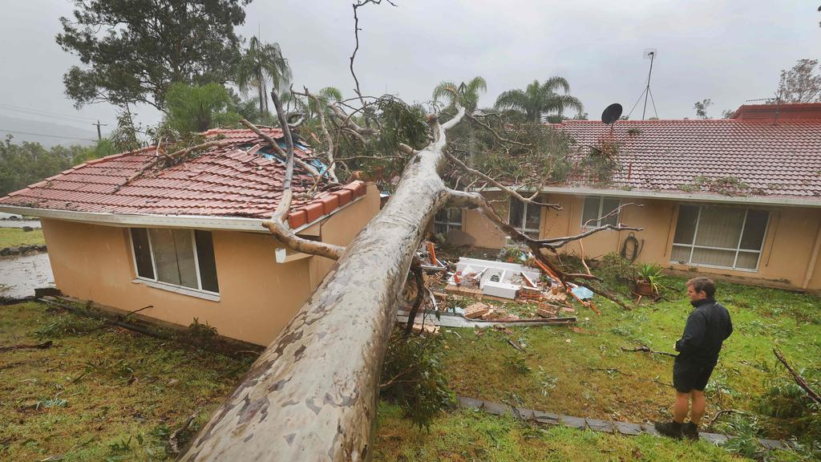

Insurance claims are ringing in the deep parts of Queensland after homes suffer along Cyclone Alfred’s path of destruction. The Federal government is providing little aid to pay victims of Alfred’s devastation equating to $1,000 per adult and $400 per child. Hardship payments are also being handed down equating to $180, a state-disturbed emergency hardship payment. While these limited funds are being divided out to Australians affected by Cyclone Alfred, it barely reached the ceiling of costs associated with the aftermath of the devastating winds that destroyed homes and damaged roofs.

What insurers and the government alike aren’t telling victims is the fine print associated with claiming damages for roofing. Unfortunately, Insurance companies hold an ace up their sleeves they are using against Australia’s cyclone victims, and that ace is—Australians need to show a level of roof maintenance before claiming damages. Insurance companies will not pay out claims without this proof of maintenance. For insurers, the get out of jail free card and the ace in the hole that shouldn’t be played, gets played. All too often.

As David Baird from [Prestige Home Transformations](https://www.prestigehometransformations.com.au/our-services/roofing/) explains, “ Roofs are often neglected but in reality, are one of the most important aspects of your home. If your roof isn't maintained properly and water gets in it can cause all sorts of damage. Adding to that the risk of not being covered by insurance it makes sense to get regular inspections or book a roof restoration which can be quite cheap compared to the alternative and give you peace of mind for at least 10 years”

Even amid water damage, Aussies must show some level of upkeep to make an insurance claim bulletproof, and the kicker? Aussies don’t know this until they make a claim. As insurers are flooded with claims for damaged homes and displaced Australians—Over 41,000 claims have been longed so far without knowledge of the diabolical fine print. David encourages Australians to take a proactive approach when making insurance claims, emphasizing the importance of foresight and preparation to ensure your claims are fully honored.