**FOR IMMEDIATE RELEASE**

**BASQUIAT HEADLINES ABBEYS’ CLASSICS COLLECTION AUCTION**

***Abbeys Auctions will launch its April Classics Collection auction with an extraordinary art feature, headlined by Jean-Michel Basquiat’s “Untitled, 1982”***

This Easter Saturday, Abbeys Auctions is bringing a touch of New York art history to Melbourne with Untitled, 1982 by the legendary Jean-Michel Basquiat—offered as Lot 1 in its April Classics Collection Auction.

As one of the most influential artists of the 20th century, Basquiat’s bold and provocative works continue to command global attention. Despite a post-COVID softening in the art market, his work remains among the most sought-after. This significant piece is set to open what promises to be a show-stopping auction event.

Jakob Smith, Abbeys’ art valuer, commented: “This piece is a powerful example of Basquiat’s signature motifs—grappling with race, inequality, and identity in 1980s New York—topics that still echo in today’s world.”

The auction will also feature works by acclaimed artists including Hugh David Sawrey, Sali Yakubowitsch Herman, John Tyson, Charles (Pro) Hart, George Hyde Pownall, Theodore Penleigh Boyd and Mark Hanham. In addition, the 950+ items include Mid Century furniture, antiques, West German pottery, garagenalia, glassware, silver, model cars, cameras and coins.

The April Classics Collection Auction will be held on Saturday 19 April from 9:30am, with bidding available both online and in-room at Abbeys’ Burwood showroom.

This Easter, Abbeys is inviting art lovers, collectors, decorators, bargain hunters and the curious to enjoy more than just the thrill of the gavel. Guests attending in person will be treated to a full day of viewing, a festive atmosphere, and some special Easter treats. It's the perfect opportunity to spend Easter Saturday immersed in remarkable artworks, enjoy a sense of occasion, and raise your paddle for something truly extraordinary.

Public viewings will be held on Thursday 10 April and Thursday 17 April, with the showroom at 80 - 86 Highbury Road, Burwood, Victoria open to all.

With a Basquiat opening the event, an outstanding lineup of artworks, and a warm in-room welcome, this is set to be one of the most memorable auctions of the year.

**Media Contact:**  
Nicole Minster | Abbeys Auctions | 03 9898 2118 |

[marketing@abbeysauctions.com.au](mailto:marketing@abbeysauctions.com.au) | [www.abbeysauctions.com.au](http://www.abbeysauctions.com.au)

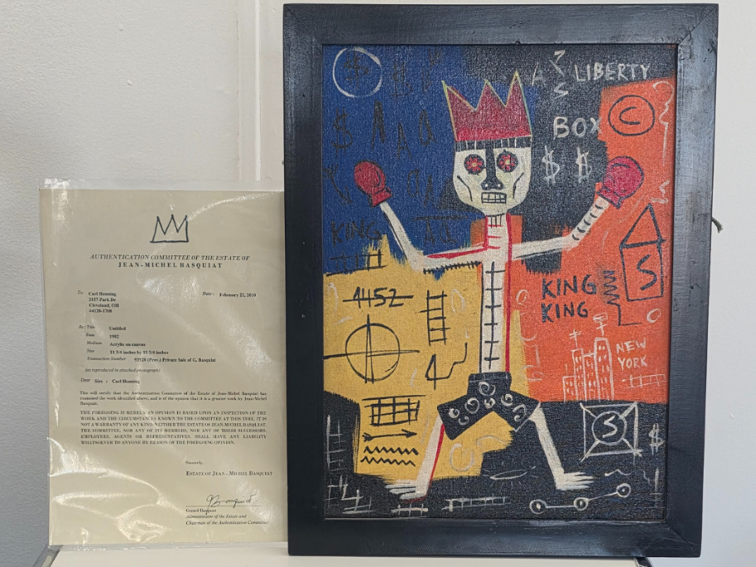

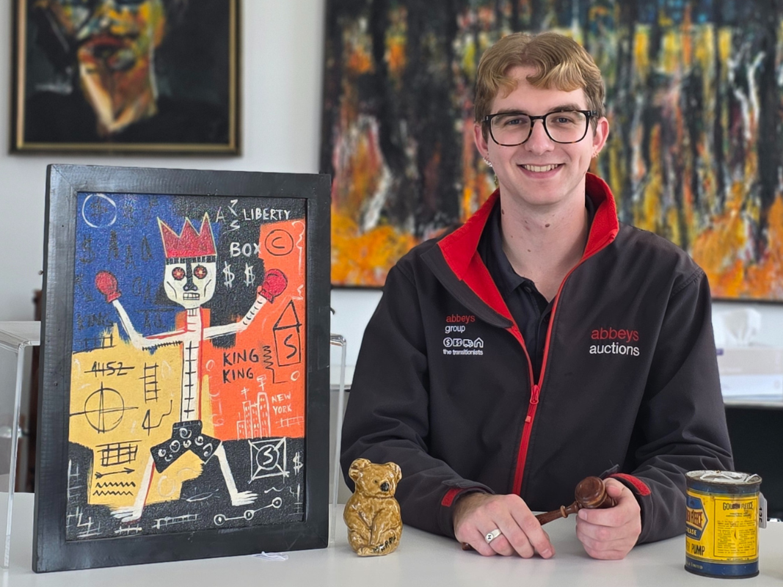

*Valuer Jakob Smith of Abbeys Auctions with Jean-Michel Basquiat’s “Untitled, 1982”*