**FOR IMMEDIATE RELEASE**

**The Musicmen Rally Australia to Support ‘Our Ange’ with New Anthem ‘Ange Ball’ Ahead of Europa Cup Final**

**MELBOURNE, AUSTRALIA — May 19, 2025** – The Musicmen, a beloved group of ex-pat professional soccer players turned entertainers, have released a spirited new anthem, **‘Ange Ball’**, in support of legendary Australian coach **Ange Postecoglou** as his team, Tottenham Hotspur, faces Manchester United in the **Europa Cup Final** on **May 22 at 5AM AEST**.

A heartfelt tribute to Ange and a celebration of Australian soccer pride, *Ange Ball* is a clever reinvention of The Choirboys’ classic hit *Run to Paradise*. Mark Gable ‘The Choirboys’ and writer of the original song was more than happy for The Musicmen to parody this awesome song!

The track led by Steve Cal calls on Aussies everywhere to rally behind Ange and share in a moment of national pride.

YouTube clip below on BROOKSYMUSICMEN <https://youtu.be/dgrnz_raTVw>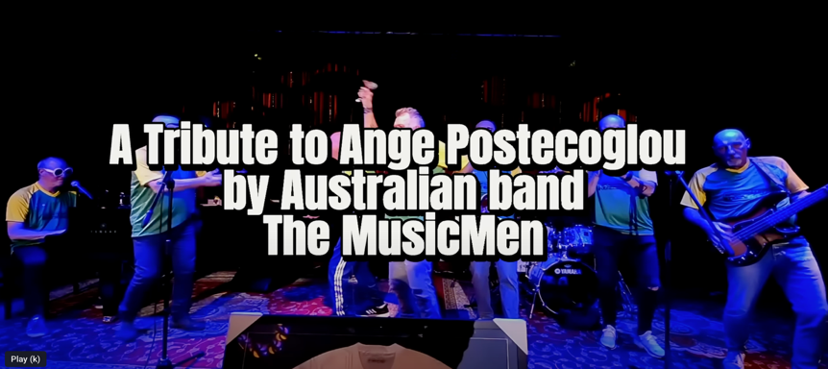

The Musicmen first rose to fame with a memorable appearance on *Red Faces* on *Hey Hey It’s Saturday* and have continued to entertain and inspire for more than four decades. Founding member **David Brooks** shared the group’s passion for the project:

“We all came here leaving our families back in the UK to play soccer. But now, after so many years, we are a family. I’m proud that I’ve kept this group going, proud of the lifelong friendships we’ve made, and proud of the smiles we continue to put on people’s faces. Most of all, we’re proud to call Australia home — and proud of what Ange has done for Australian soccer.”

**‘Ange Ball’ by The Musicmen is available now on Spotify.** Join the chorus and show your support for Ange and Aussie football on the global stage.

on Spotify here <https://open.spotify.com/track/1ISXk0a2Q0dwNhw7mt0GnW?si=e4d0e43e21a2474e>

**MEDIA CONTACT**

📞 **0420 647 989 David Brooks Founder, The Musicmen**📧 davidebrooksfilms@gmail.com