**Caviar, The Kid LAROI, and Confidentiality: The Secrets of George Mirosevich’s Elite Dining Experience**

*NDAS on entry. Wagyu steaks flown in from Japan and private jets as standard. That’s life. 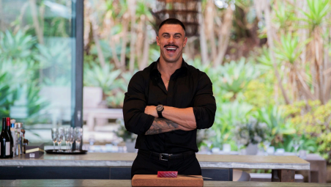*

In a world where access is currency, and discretion is priceless, George Mirosevich is quietly becoming the most sought-after name in private-dining that you’ve never heard—until now. At just 30, George has carved out an elusive, rarefied niche: the personal chef to the 0.01%, where his craft is less about feeding the rich and more about seducing their senses.

George is a modern culinary enigma with chiselled good looks, fast-paced social videos, and a kitchen presence that’s equal parts Gordon Ramsay and GQ cover star. And while most chefs chase Michelin stars, George’s currency is far rarer: trust. The kind of trust that earns you a midnight call from a billionaire’s private assistant, asking if you’re free to jet to Monaco or Malibu—tonight. No cameras, no press releases. Just George, his knives, and the world’s most powerful people, waiting to be impressed.

“I’ve cooked in rooms where NDAs outnumbered the guests,” he laughs over a coffee in Sydney’s Double Bay, one of his few public haunts. “You don’t ask questions. You don’t post. You just serve the best thing they’ve ever tasted… and disappear.”

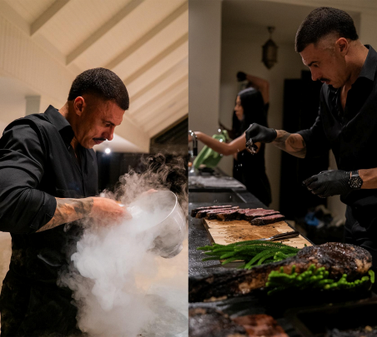

This was the case for George when he found himself having one of those weeks where nights blended into mornings and coffee was no longer scratching the surface. George, halfway down the freeway from Newcastle to Sydney (Australia), received the phone call. “George, the client is flying on a private jet from the US and needs dinner ready in three hours.” Without hesitation.Without a client name. No produce. With a drive that would equal George's sleep total, the James Bond of cooking adventures began. Little did George understand he was about to cook for one of the biggest stars in the world, The Kid LAROI. Like something paranormal, George arrived, cooked and disappeared.

The next morning, after a routine sweat, the phone call arrived again. Only this time, it was lunch at 12 pm and a request to cook for The Kid LAROI for another seven days.

“I’ll always bet on the relationships you don’t see,” George shrugs, barely masking a grin.

That vanishing act is becoming harder to pull off. George is on the cusp of breaking out of culinary anonymity with the upcoming reality series *Billion Dollar Playground*—an unscripted eight-part immersion into Australia’s most elite service industry, funded by Luxico and airing globally across Binge (AU), BBC (UK), Brave (NZ), Corus (CA), and Talpa TV (NL).

Think *Below Deck* meets *Succession*—but instead of superyachts, the playground is Australia’s most palatial private estates. And threading it all together? George. The man they call when the caviar needs to be flown in, the wagyu marbled just right, and the champagne sabred perfectly on the third floor of a $50 million beach house.

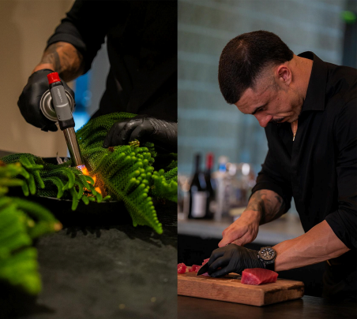

George is slated for 15 guest appearances throughout the series—each an intoxicating peek into his quiet power in these high-net-worth circles. But in true George fashion, the biggest drama of the season doesn’t even make the screen.

“It’s not about being famous,” George says. “It’s about being famous to the right people. The ones who pick up the phone say, ‘Fly to Lake Como. The jet’s waiting.’”

For George Mirosevich, this is just the entrée. The main course is yet to come.

**Billion Dollar Playground premieres Tuesday, 13 May at 10.00am AEST on BINGE, with new episodes dropping weekly.**