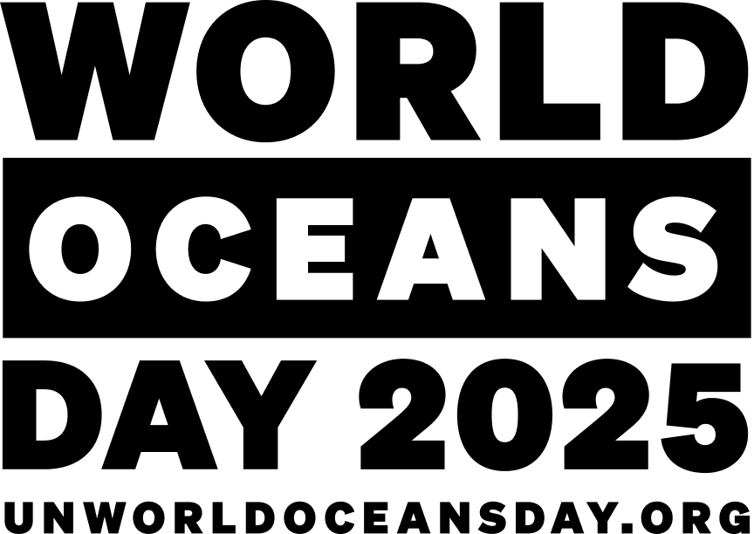

8 June 2025

***World Oceans Day 2025***

**FOR IMMEDIATE RELEASE**

"Wonder: Sustaining what sustains us" is the theme for World Oceans Day 2025.

This year, the day celebrates the wonder that the ocean inspires in us: its beauty, its mystery, and its vital role in our lives and on the planet. This day reminds us of our deep connection with the sea and calls for its protection through decisions guided by curiosity, wisdom, and a commitment to collective well-being.

The ocean is full of amazing sea creatures – from the giant Blue Whale that can grow up to 33 metre long, to the fast Black Marlin which can reach speeds up to 132 km/h, to the smart Octopuses that can solve complicated puzzles. There is so much variety of animals and plants in the ocean. Not only is it home to most of the worlds biodiversity, it also produces at least 50% of the planet’s oxygen and covers over 70% of the planet!

The United Nations states “The purpose of the Day is to inform the public of the impact of human actions on the ocean, develop a worldwide movement of citizens for the ocean, and mobilize and unite the world’s population on a project for the sustainable management of the world's oceans.”

Australia’s Ocean Literacy Portal celebrates the wonder of the ocean and it provides teachers, students, and communities with the tools they need to understand, protect, and advocate for our blue planet.

It is a centralised online platform designed to freely share teacher resources and community knowledge. “It aims to enhance an understanding of the ocean in the community and Australian schools, leading to knowledgeable individuals being able to take action and make informed and responsible decisions regarding the ocean and its resources” said Brett Shorthouse, Director of Oceans IQ.

Denise and Geoff Illing from the Unico Conservation Foundation highlight the power of education in driving conservation action. “What if the key to saving Australia’s oceans wasn’t just scientists or politicians—but students, teachers and entire communities?”

World Oceans Day is celebrated on 8 June each year and is recognised in the United Nations Decade of Ocean Science for Sustainable Development (2021 to 2030). The Australia Ocean Literacy Portal can be found at [oceanliteracy.com.au](https://oceanliteracy.com.au/). It’s education that gets your hands wet!

Oceans IQ, in partnership with Deakin University and the Unico Conservation Foundation, has developed Australia’s Ocean Literacy Portal. The Victorian component of the portal was developed with seed funding from Unico Conservation Foundation and the Victorian Government. The remaining States and Northern Territory will be developed and rolled out during 2025 and 2026.

Media Contacts:

**Claire Perryn – Oceans IQ**

Ocean Literacy Portal Project Manager

P: 0451 121 321

E: [claireperryn1@gmail.com](mailto:claireperryn1@gmail.com)

**Michelle Lauder PSM – Oceans IQ**

Oceans IQ Director

P: 0400 598 024

E: laudernrm@gmail.com