**MEDIA RELEASE**

18 February 2021

**Care Day 21**

**CREATE CALLS FOR Celebration of Kids in Care!**

Taking place on February 19th, 2021, Care Day is the world’s largest celebration of children and young people with care experience overcoming adversity and recognising their rights.

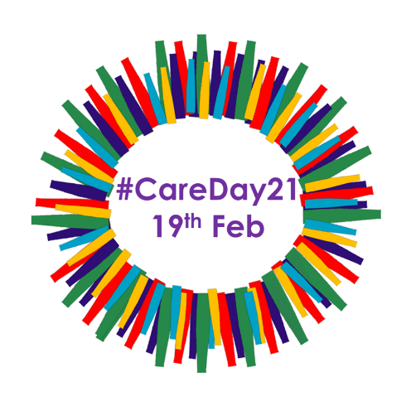Never before has it been more important to shine a light on the achievements of over 2.7 million* children who are currently growing up away from their family. In Australia alone, over 44,9061 children did not sleep in their own home last night and are living in out-of-home care.

Tobias, from Victoria, was raised in care and is now attending university as well as working part-time. When asked about Care Day, he shared that “*it is a massive thing to know we are talking about disadvantaged kids and if we can stop and think about what can we do, as individuals and community, to help them to catch up and keep up with others, that is very positive.”*

Now in its’ sixth year, the Care Day initiative is underpinned by a collective of nine global voice of care organisations from across the world, including [EPIC](https://createfoundation.cmail20.com/t/d-l-mlkbjt-ihdlhddjd-j/) in Ireland, [VOYPIC](https://createfoundation.cmail20.com/t/d-l-mlkbjt-ihdlhddjd-t/) in Northern Ireland, [Who Cares? Scotland](https://createfoundation.cmail20.com/t/d-l-mlkbjt-ihdlhddjd-i/), and [Become](https://createfoundation.cmail20.com/t/d-l-mlkbjt-ihdlhddjd-d/) in the UK, Voices from Care in Wales, Fepa in Spain, Fice in Croatia, Voyce in New Zealand and CREATE in Australia all working together to promote conversations about young people defying the odds and succeeding in their own right.

CREATE Foundation’s Chief Executive, Ms Jacqui Reed, shared that, “*Care Day is an important opportunity as a global community to recognise and be inspired by young people with a care experience as they strive to achieve.”*

*“As an organisation, we are committed to supporting and advocating for the rights of the child and reducing stigma faced by people with a care experience.* *Through community working together at all levels from government to employers, advocacy groups and individuals we can contribute to the reducing stigma and supporting positive change for those with care experience.”*

Read more on stigma in out-of-home care by reading [CREATE's stigma position paper](https://createfoundation.cmail20.com/t/d-l-mlkbjt-ihdlhddjd-h/), or learn about CREATE's awareness campaign to change out-dated stigma experienced by those with a care experience through our [#SnapthatStigma campaign here](https://createfoundation.cmail20.com/t/d-l-mlkbjt-ihdlhddjd-k/)

For more information, please visit the CREATE website at [**www.create.org.au**](http://www.create.org.au)

Read about Care Day at <https://careday.org/>

**For further comment from CREATE’s Chief Executive, Ms Jacqui Reed, and/or a young person with care experience contact Leigh White, CREATE Communications Advisor, via (m) 0431 932 122 or leigh.white@create.org.au**

CREATE Foundation is the national consumer body representing the voices of children and young people with an out-of-home care experience (including kinship care, foster care and residential care). CREATE develops policy and research to report on and advocate for a better care system.

Sources:

* Unicef data states “At least 2.7 million children are living in residential care…” www.data.unicef.org/topic/child-protetion/children-alternative-care/ (website accessed 16/2/21)

1. 44,906 children were in out-of-home care across Australia (AIHW 2020)