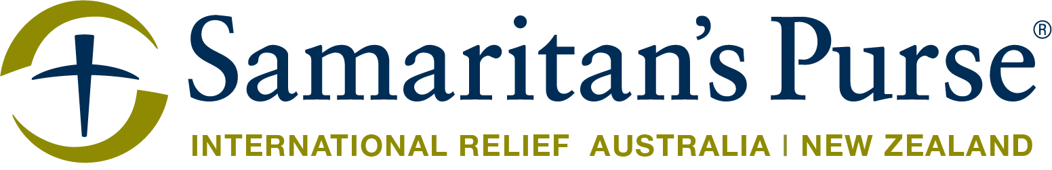

SAMARITAN’S PURSE AIRLIFTS CRITICAL RELIEF SUPPLIES TO HAITI AFTER 7.2 MAGNITUDE EARTHQUAKE; EMERGENCY FIELD HOSPITAL DEPLOYS TO SOUTHERN HAITI

Sydney, NSW, 18 August 2021 — On 14 August, a 7.2 magnitude earthquake struck Haiti. It caused severe damage – destroying homes and trapping people in the rubble. More than 1,000 have died and casualties are feared to rise as search and rescue efforts continue. Samaritan’s Purse immediately began to mobilise disaster response specialists and position relief supplies for deployment.

On Sunday, the Samaritan’s Purse DC-8 cargo plane airlifted 13 disaster response specialists and 31 tons of emergency relief supplies, including shelter material and two community water filtration units to Haiti. Each unit is capable of providing clean water to 3,500 people each day.

Today, at the request of the Haitian government’s Ministry of Health, Samaritan’s Purse deployed an Emergency Field Hospital to southern Haiti. The international Christian relief organisation sent the trauma hospital – complete with a laboratory, pharmacy, and an operating theatre.

Once in operation, the 36-bed field hospital will bring critical relief to orthopaedic and trauma patients. It will also include an emergency room and outpatient services with anaesthesia and oxygen capabilities. An additional 35 medical personnel are arriving in the coming days to staff the hospital.

“This massive earthquake has devastated Haiti – it’s left many families homeless and searching for their loved ones,” said Franklin Graham, president of Samaritan’s Purse. “We are responding to help meet needs in Jesus’ Name. We sent this field hospital today to bring more relief to the suffering Haitian people.”

MEDIA OPPORTUNITIES:
- Interview Daniel Stephens, disaster response manager for Samaritan’s Purse.
- Interview disaster response specialists on the ground in Haiti.
- High-quality photos and broll

MEDIA CONTACT:
Nikita Kumar
Email: nikitak@samaritanspurse.org.au
Mobile: 0434 319 722

Samaritan’s Purse has worked in Haiti for more than a decade – responding to disasters and maintaining a permanent country office based in Port-au-Prince. In 2010, the international Christian relief organisation responded to the 7.0 magnitude earthquake and the subsequent cholera outbreak. In 2016, Samaritan’s Purse responded to Hurricane Matthew and provided life-saving relief supplies in the hardest-hit areas.

Samaritan’s Purse Australia and New Zealand responds to physical and spiritual needs of individuals in crisis situations – especially in locations where few others are working. Led by President and CEO Franklin Graham, Samaritan’s Purse works in more than 100 countries to provide aid to victims of war, disease, disaster, poverty, famine, and persecution. For more information, visit SamaritansPurse.org.au

