MEDIA RELEASE | 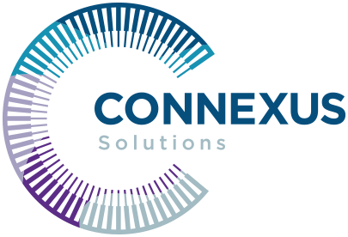

For Immediate Use: 2 September 2021

Mark Stephen appointed Managing Director of Connexus Solutions, a provider of broad licensee services and practice solutions to small-medium AFSLs.

MELBOURNE, AUSTRALIA – 2 September 2021: Connexus Solutions, a leading provider of licensee solutions to boutique AFSL owners that launched in 2020, is pleased to announce the appointment of Mark Stephen as Managing Director effective 1st September 2021.

Bringing together over 30 years of industry experience, Connexus Solutions was developed to provide a broad range of licensee services and practice solutions to small-medium AFSLs. Having worked with many leading Australian advice businesses, they have a deep understanding of the integrated and standalone advice space and the benefits this business model brings to clients.

Fellow Director, Murray Swilks, said, “we are fortunate to have someone of Mark's calibre and experience joining the business. He has been a passionate advocate for supporting boutique financial planning practices and AFSL’s to better their businesses and their leaders, helping them improve their business models while retaining ultimate control of their future state.”

Stephen was most recently CEO of IOOF Group owned, Lonsdale Financial Group, which he led for over 10 years.

Since its launch, Swilks said they had seen impressive growth, with close to 35 self-licensed financial planning groups now committed and members of Connexus Solutions and their Connexus Club. Stephen and Swilks, together in their new business venture have a clear-cut vision: ‘to provide a union of licensee elements to Empower: Lead: Connect.’

Stephen said, “we’re here to help Financial Planning businesses explore their licensing options. Our aim is to assist them in providing better advice and service to clients, to become more profitable, sustainable, and actively exhibit the values and standards set by FASEA, which has become a benchmark for all advice businesses. This often means exploring self-licensing as an option, where we facilitate the transition from AR to AFSL.”

Stephen also commented that “Connexus Solutions differs from other licensee services providers in that we are not corporately owned or driven by platform or product providers. We operate in a purist sense, with a 'by advisers, for advisers' approach.”

Release ends.

Logo
Image | 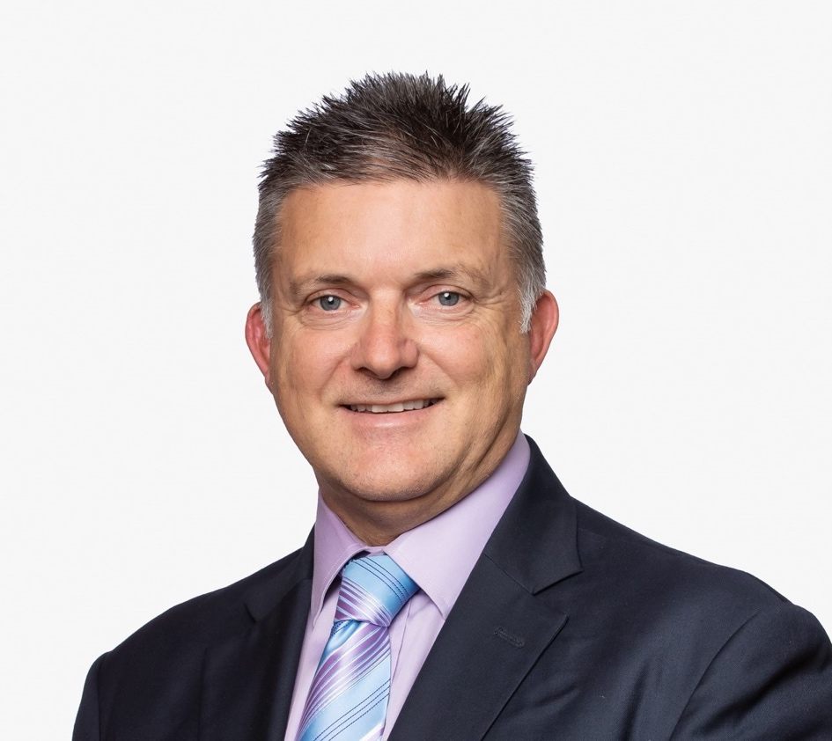
Contact details | Mark Stephen  Managing Director, Connexus Solutions  +61 421 055 159  mstephen@connexusls.com.au  http://connexussolutions.com.au/

