**20/09/2021**

**OZFOODHUNTER**

**07 4072 4022**

[**admin@ozfoodhunter.com.au**](mailto:admin@ozfoodhunter.com.au)

**OzFoodHunter**

Online food Delivery APP in Australia

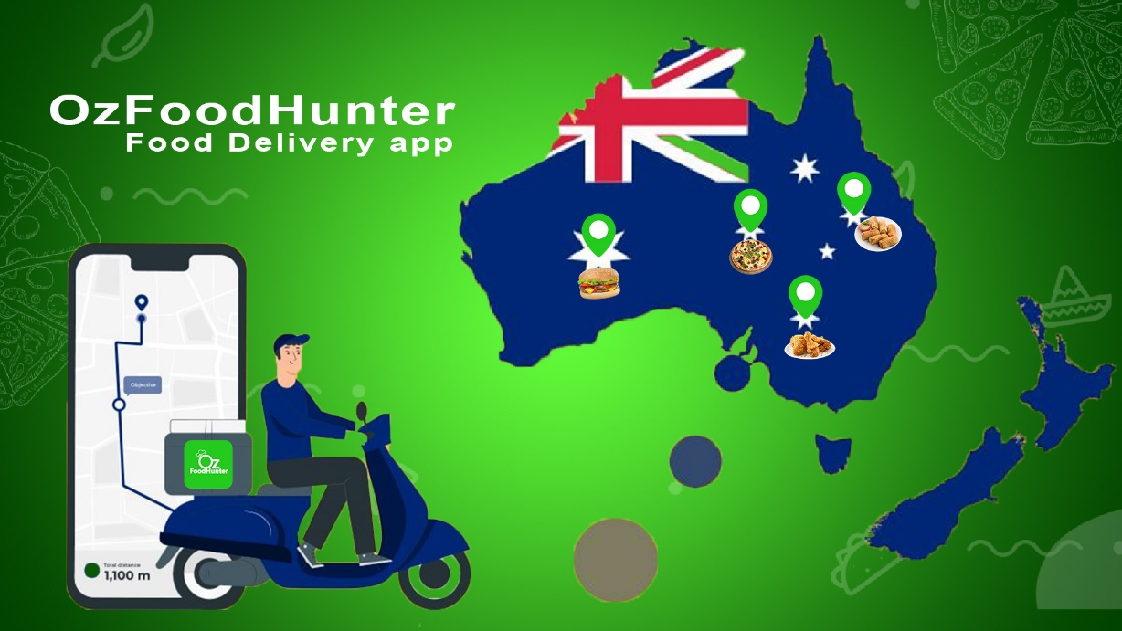

**Brisbane, Queensland Oz Food Hunter Pty Ltd, today announced the new version of mobile app release. This milestone is a major move for Oz Food Hunter on its mission to achieve the main goal of Oz Food Hunter. To learn more** [click](http://www.ozfoodhunter.com.au/) **here**

OzFoodHunter Pty. Ltd. Is an online food ordering App in Australia. E-commerce website launched in Feb 2016. OzFoodHunter headquartered in Brisbane, QLD Australia.

OzFoodHunter offering over 45 cuisines and over 3500+ restaurant partners all over Australia.

**History**

Oz Food Hunter operates in all six states (NSW, QLD, SA, TAS, VIC, and WA), two territories as (the Australian Capital Territory, and the Northern Territory) across Australia. With a successful track of dedication and innovation by the team, OzFoodHunter expanded all over Australia within 2 years. Eventually reaching every corner of Australia with 3500+ restaurants as well as state and localized suburbs. Restaurants offering more than 100+ cuisines through OzFoodHunter website /App (IOS/ANDROID). Now OzFoodhunter operates in all major cities in Australia.

OzFoodHunter was established by a simple Hospitality and accounting background person called Veeravel Kesavan. He decided to start a home-based business to provide a user-friendly website **to Ordering food online Easily**. When he was running a small Restaurant in cairns, found that the online ordering trending up near future. Initially, took around 6 months to overcome the challenges. He sought out to do something better then the website, and then decided to build an APP to serve the food community in Brisbane and to support his fellow restaurant owners.

In 2018, OzFoodhunter decided to provide the free android printer device to all restaurant partners to receive the order without any hassles. That was worked very well and smoothened the order processing method.

In 2019, Gradually increase the market share up to 500,000 users, a decent reach crossed from 100s of orders to the 1000s on daily basis.

In 2020, during the COVID19 Pandemic, OzFoodHunter decided to reduce the commission to the small struggling business and offered a reasonable discount to users to get benefitted.

**NEW MEALS DELIVERY SERVICE FOR SOUTHEAST QUEENSLAND – OZ FOOD HUNTER GOES FULL DELIVERY**

Thursday 15th April is the official launch of the latest online meals delivery service in Brisbane. OzFoodHunter has been around the scene for the past four years providing a meal ordering platform, through the [OFH APP](https://ozfoodhunter.page.link/o7L9), that linked with restaurants that provided their own deliveries.

All of that is about to change with the commencement of a third-party delivery partner – Black & White Cabs – to provide the delivery service for restaurants linked to Oz Food Hunter. Despite what some may say is a crowded marketplace, the Owner of Oz Food Hunter Mr Veeravel Kesavan, believes his timing to enter this market couldn’t have come at a better time. Expectations are that within a few years at least half of all take-away meals will be home delivered and with Covid persisting in Queensland, many more customers will move to have their meals delivered.

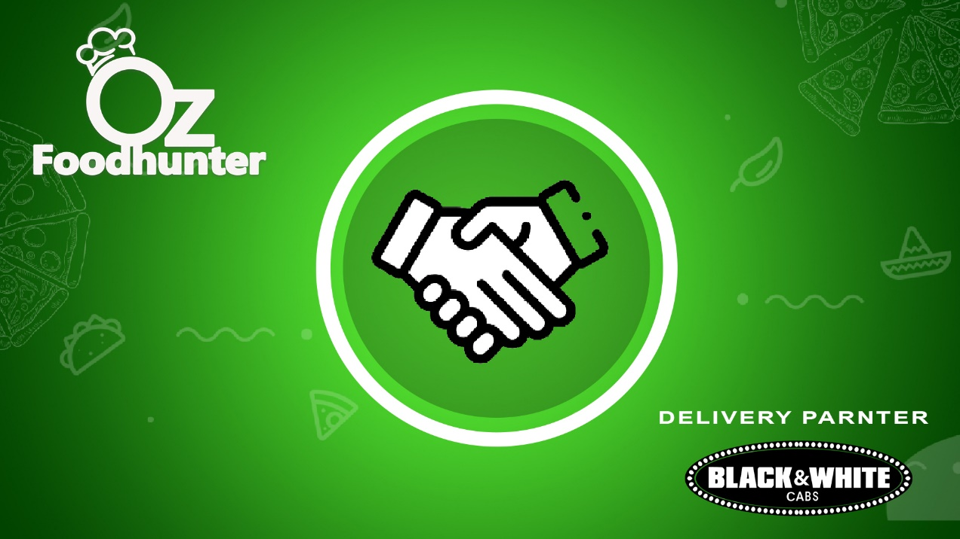

“Reaction from many of Oz Food Hunter aligned restaurants to Black & White Cabs being the delivery partner has been very positive” , Mr Kesavan said. The service will commence in Brisbane, Toowoomba, Gold Coast, Redcliffe and Maryborough from the 15th April.

Oz Food Hunter’s cost model will see restaurants paying less in commission rates set by other third-party delivery partners and also have a better payment rate for the Black & White Cabs drivers. “This will deliver a better result for all parties, the customer, the restaurants and the BWC cab drivers”, Mr Kesavan said.

The Oz Food Hunter delivery program will be officially launched at 4.30pm Thursday 15th April at the Royal on the Park, Alice Street Brisbane.

As a team, the most important of all is that OzFoodHunter never lost our **One and Only goal** which is to serve the community. Whenever the team achieves a goal, we look up for the next impossible task and make it possible. We are still trying to improve the quality of the service and finding new ways to give advantages to our customers and restaurant owners