**20/09/2021**

**OZFOODHUNTER**

**07 4072 4022**

[**admin@ozfoodhunter.com.au**](mailto:admin@ozfoodhunter.com.au)

[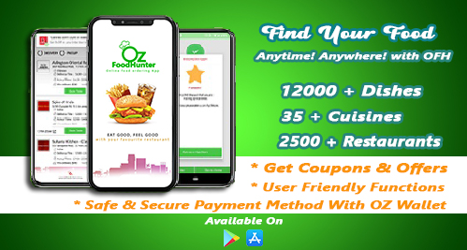](https://ozfoodhunter.com.au/)

**OZFOODHUNTER New version Mobile APP July 2021**

**Brisbane, Queensland Oz Food Hunter Pty Ltd, today announced the new version of mobile app release. This milestone is a major move for Oz Food Hunter on its mission to achieve the main goal of Oz Food Hunter.**

**OzFoodHunter App** has released a new version with a great features July 2021. In Australia Online ordering system trending among young professionals, especially during the COVID-19 it increased 57% of users during pandemic. Specially, Online Food Delivery is become more popular, trendy and helped drastically during the COVID-19.

This new comes in the wake of many recent initiatives and accomplishment of the company, including

1. Features of New app v2.9.0
2. Success of Black and White Cabs Delivery
3. Instant offers access
4. Secure OZ Wallet.

To learn more about new version 2.9.0 APP click here;

**Features of OZFOODHUNTER App:**

Since, Jan 2021 OzFoodHunter have been working to produce a secure and user friendly version to customers, after six months of hard work, in July 2021 released a very secured and user friendly APP IOS and Android v2.9.0 published.

**The Speciality of this version:**

*First,* It is a very secured Local based Commonwealth bank Payment Gateway with 3D secured. Consumers can be 100% confident to use their card details to pay through OzFoodHunter APP (IOS & Android). This version also has great secured payment options such as; Google pay, Apply pay, PayPal and American express. Users can use their Visa, Master, Diners and AMX cards to make payments.

*Secondly,* Users can track their orders on live. This version has a great order tracking future and how? After successfully accepted the order, Black and White cab drivers are assigned to pick the food and Start the meter. At the time of the meter starts from the Driver end the Tracking link will be sent out to users as a text to track the drivers status to find how far is the Driver.

*Third,* Newer version has reduced the number of steps to complete the order how? v2.9.0 has auto detecting the address, as soon as users logged in app will navigate your location with your permission and add your address into your profile. Which will reduces your time to add your address manually. All you need to do is just verify the delivery address on check out page before you make a payment.

**Success of Black and White Cabs Delivery:**

Since, we launched new version of OzFoodHunter App there are tremendous response from the customers where in 55% of new IOS customers and 43% of Android customers increased just in few months. 83% of App users are happy and re ordering through OzFoodHunter app which is very positive sign. New version were given an excellent supported for all delivery order through Black and White Cabs delivery service which was given a great confidents for users to order back, it’s also helped drivers to deliver meals on time.

[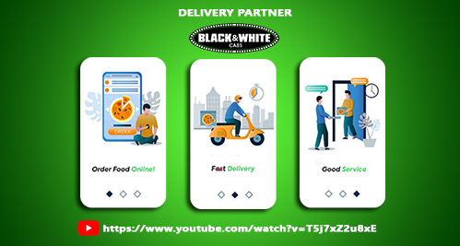](https://www.youtube.com/watch?v=T5j7xZ2u8xE)

**Instant Offer Access and OZ Wallet:**

Offers access is another unbeatable future in this new version 2.9.0 app. Users are very easy to access the offers while they are browse the menu, which will request users to choose a suitable voucher code to avail the valid offer. Offers are vary from time to time but it be available daily, weekly and monthly basis.

[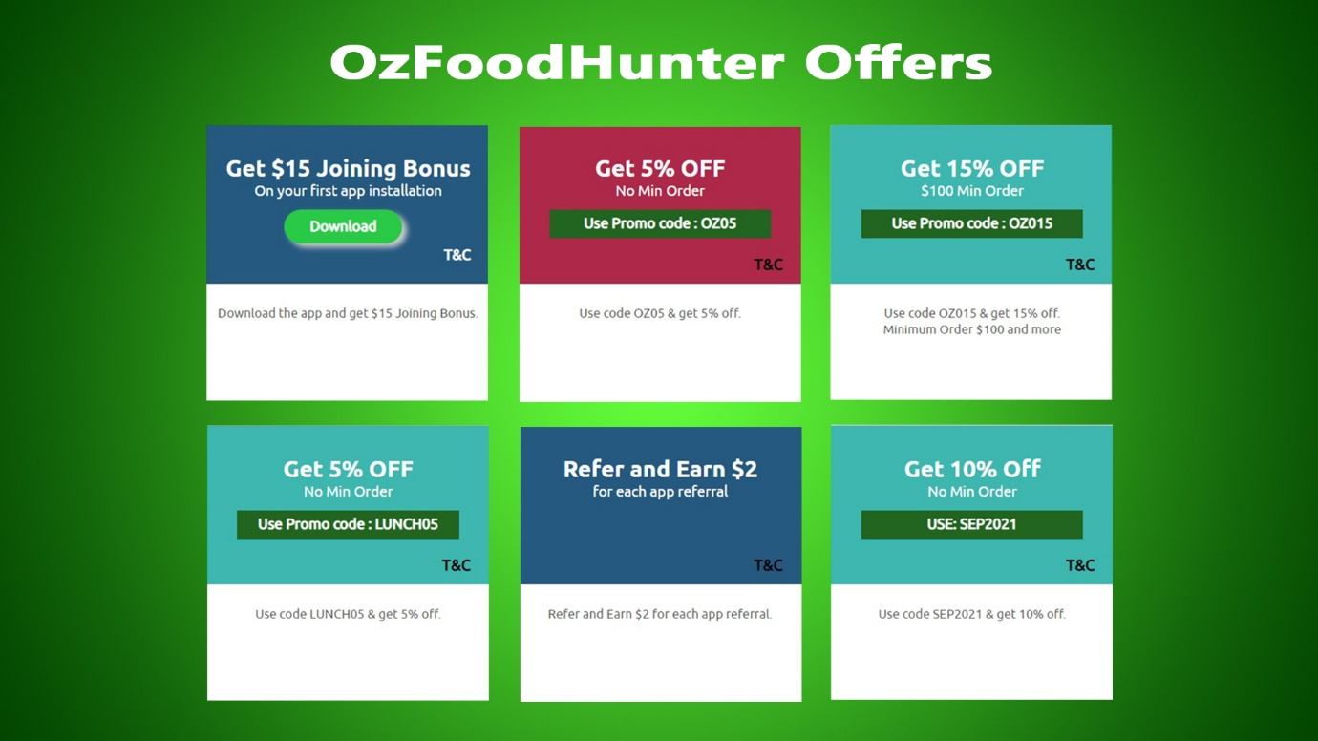](https://ozfoodhunter.com.au/offer-zone)

Oz wallet is another unique future in this version. Every successful signed up user will get credit of $15 Joining Bonus in to Oz Wallet. Which can be auto discounted on your checkout $5 max on each order.

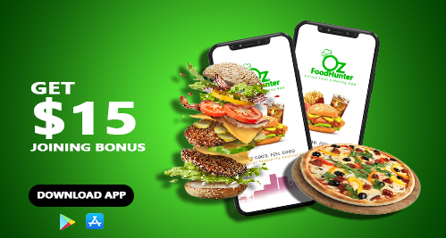

**Download the**[**OzFoodHunter App**](http://bit.ly/2qjXoUy) now and signup to enjoy our services for free and save your time by ordering your food continently with us

For More Info Visit OzFoodHunter Website [here](http://ozfoodhunter.com.au/)