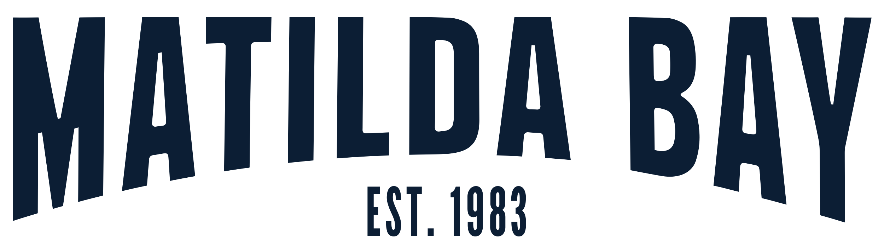

MATILDA BAY BREWERY OKTOBERFEST … IN NOVEMBER

Who said Oktoberfest had to happen in October? Never content to blindly follow tradition, Matilda Bay Brewery in Healesville, located in the picturesque Yarra Valley, will host Oktoberfest in the large venue carpark on the weekend of 12-14 November.

The brewery team invite you to dust off your lederhosen and join them under their own big top to enjoy steins of Matilda Bay’s beers brewed on-site, days of entertainment and a feast of traditional German food.

“We started planning Oktoberfest earlier in the year, and while lockdowns scuppered the idea for October, we didn’t want to miss celebrating the traditional month for all things beer,” said Matilda Bay’s Head Brewer, Harry Sexton. “Our friends and customers have missed out on so much this year through lockdowns and venue closures, so we think they’ve all earned a weekend celebrating the thing we love most here, and that’s amazing beer,” he added.

Matilda Bay is Australia’s first craft brewer, established in WA back in 1983 by the father of the craft beer industry, Phil Sexton. In the 80’s, Matilda Bay gave us Redback in 1986, Dogbolter in 1987 and Alpha Pale Ale which won a slew of awards in 2003 on release. In 2019, Matilda Bay opened in Healesville, drawing on the pristine water of the Yarra Valley and a new or improved range beers in production in the purpose-built brewery. Phil and Harry Sexton are Australia’s first craft beer dynasty, with Harry, like his Dad in the 80’s, is leading the brewing team still brandishing flavour and freshness as weapons.

From Friday the 12th, to Sunday the 14th of November Matilda Bay will be hosting a couple days of fun to celebrate their love of beer and provide a much-needed opportunity for locals and beer lovers alike to enjoy some freedom again. “It will be great to have people back in the brewery after the ups and downs of 2021. We have waited all year to have the opportunity for our team to show what we do best, make great beer and offer fantastic food and hospitality. We even have a purpose made, small batch Munich style Oktoberbräu which we will be pouring all weekend, as well as local musicians, and an Oompah band to bring the brewery to life in the most Bavarian of ways,” added Sexton.

Tickets for the event can be booked here https://bit.ly/3Bm2Sxr
Hi res images can be accessed at this link here
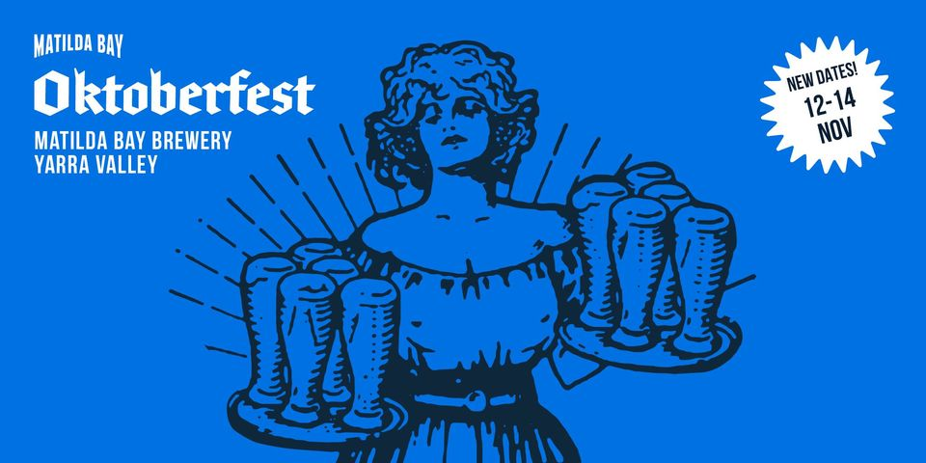

For further information, imagery or to arrange a chat with Harry Sexton, please contact Pete Dillon. pete@fearlesscollective.com.au or 0409 142 365

