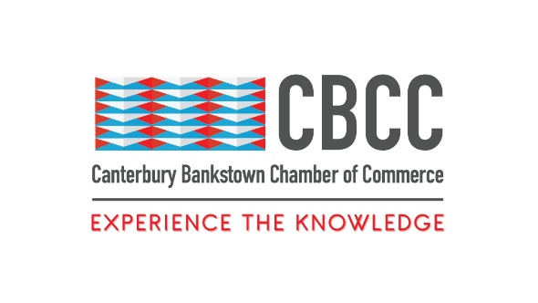
13th December 2021

FOR IMMEDIATE RELEASE

Businesses get Savvy, Sexy and Smart in Canterbury Bankstown

Sydney, New South Wales - On Saturday 11th December 2021, the Canterbury Bankstown Chamber of Commerce hosted their annual Gala Dinner event in the Bankstown Sports Club. This red-carpet event brought 400 people representing businesses and politicians across the Canterbury Bankstown area together in celebration of their hard work and dedication to business leadership and their community.
The night was filled with memorable dancing, singing and live entertainment, met with vibrant discussion around the current business environment. It was encouraging to see a revitalised hospitality industry, with delicious food and drinks provided. The event hosted a silent auction during the evening which raised a crazy $32,000 for the Garvan Institute of Medical Research. This was a remarkable amount of money to be raised, especially following the unprecedented lockdowns that New South Wales experienced over the past 18 months due to COVID-19. The chamber is thankful to all who participated in the auction and purchased the items.
The 2021 Gala Dinner hosted in the Grand Ballroom was a profound opportunity for businesses to receive awards that acknowledge their tireless efforts to create a better community. It was also an exciting time to catch up and celebrate being together again. St Merkorious Charity was awarded Social Impactor of the Year award at this year’s gala for their strong commitment to the Canterbury Bankstown area and their undeniable positive impact in the community. During 2021, St Merkorious Charity was able to purchase a walk-in freezer which has enabled them to feed hundreds of more people. During the most recent lockdown, they ran an outreach program in their local community and made a meal delivery service straight to people’s homes. The chamber was delighted to be able to recognise their outstanding contribution to all the Greater Sydney area and are very thankful for the incredible work they do.
Founder of St Merkorious, Paula Nicolas stated in an interview recently with the Daily Telegraph, “Working on the frontline, it’s undeniable how many Australians have fallen near or teetered off the brink during the challenges 2020 and 2021 have created. Job losses, underemployment, increased homelessness, and lockdowns have hit so many hard. We give them food, but they need more than food. When we deliver food, they feel there is someone asking about them, someone that cares. It’s rewarding and it means a lot to them.”
A big thank you goes to the major sponsors of the Canterbury Bankstown Chamber of Commerce for their support during 2021: Western Sydney University, Lefand, Superior Training Centre, Walker, Hope and Care and event supporters Australian First Construction Group, Sydney Metro Airports, Transdev and Bankstown City Unity Bank. These sponsorships enable the chamber to build a stronger community and create a transformative network of businesses. This opens incredible opportunities for them to run free events and workshops for businesses in Canterbury Bankstown that can upskill their workers and better the community. Their support allows the chamber to continue providing support and captivating opportunities for small local businesses going into 2022.
We thank our enthusiastic CEO Wally Mehanna who organised such an entertaining night. He is always looking for new ways to help the chamber prosper, and the gala was a great night for everyone involved. A big thank you goes to all those who attended the Gala Dinner, as the evening was a wonderful success.
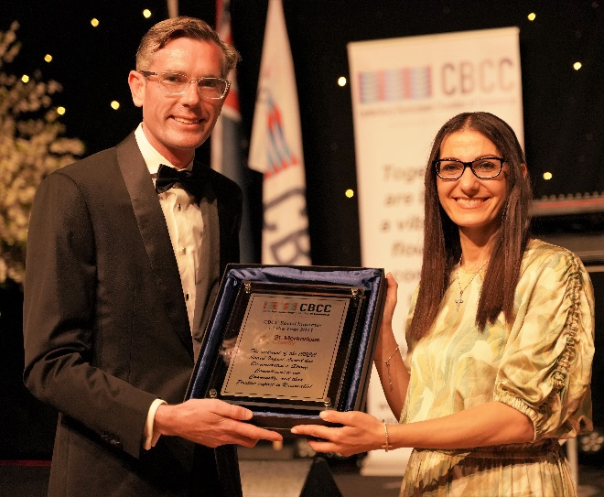
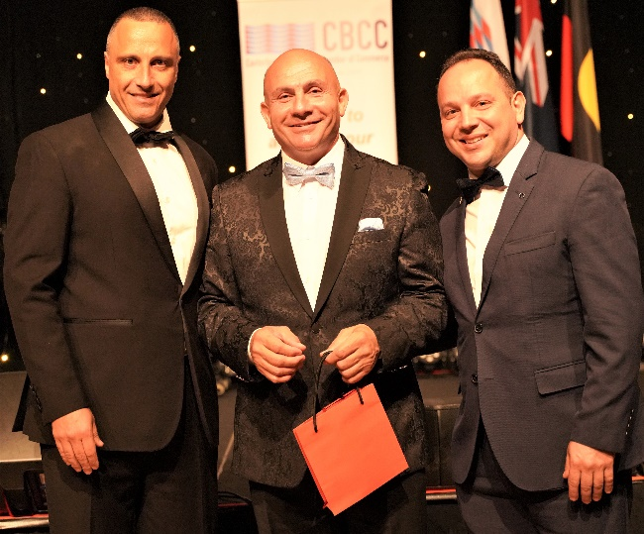
####

Contact Information
Wally Mehanna
CEO of the Canterbury Bankstown Chamber of Commerce
M: 0416 012 747
E: ceo@cbchamber.org.au

