**Media Release - Immediate Distribution - 4 February 2022**

**Contact: Amanda Lacey, 0418 448 570** [**amanda@popcom.com.au**](mailto:amanda@popcom.com.au)

**Title: Avoid a thousand dollar headache: get your child’s lost belongings back with resQR**

SYDNEY: Kids are back to school, and that means they are carrying around new technology, textbooks, and sports and music equipment around with them all day. How often is it that your energetic yet forgetful children leave their backpack on the bus, or their laptop, tablet, or phone seems to vanish into thin air? School kids are travelling around with belongings adding up to thousands of dollars in value and misplacing these important valuables can cause not only financial stress in replacing them, but a lot of emotional stress in losing them.

World-first lost item recovery system resQR has made lost valuables a much less stressful experience with their innovative product range that enables good samaritans to return your objects to you. By applying your much-loved valuables with a resQR tag, anyone who finds them can scan the QR code on the tag and you get their details to connect with them for their safe return, most importantly your details stay confidential through the process.

Co-Founder of resQR, Mat Graham, says that this system was designed to make life easier for everyone, especially parents, by knowing that important belongings can be safely returned if they get lost.

“Our vision is to enrich people’s lives through peace of mind, and this product is a perfect way for people to secure their valuables. In the last couple of years, everyone has been able to learn how to scan and use QR codes which is a core component of resQR so now the world becomes your own personal search party.

“The relief you feel when you get your possessions back is amazing, but we are also enabling people who want to do the right thing by making it easy to return belongings that they have found, we even reward them for being a rescuer.”

The resQR range includes bag tags, stickers, and screw plates that can easily be attached to any object. Finders of these items scan the QR code which takes them to a page that shows them the reward that you have set for the return of the valuables. You can set the reward to any monetary figure, or simply reward the Finders with good karma.

Finders also have the opportunity to donate the monetary reward if offered, to a list of charities including the Black Dog Institute, Westpac Rescue Helicopter Service, and more.

The products on resqrtag.com.au include options ranging from $11.99 for 6 stickers to $99.99 for the value packs. The value packs include stickers, tags, and plates, ideal for

families, that can be attached to sports equipment, technology products, travel items, and anything that can be dropped, misplaced, or left behind.

If you are looking for peace of mind when your kids hop on the bus every morning check out the resQR range today at resqrtag.com

Scan the QR code on the resQR keys & bag tag below to experience the process.

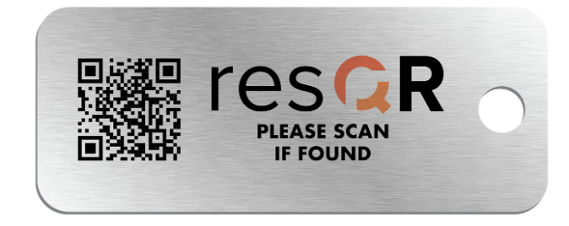

Nothing stays lost with resQR which is an Australian invented and made product.

For more information, visit resqrtag.com.au or contact:

- Mat Graham at mat.g@trakwise.com

- Amanda Lacey [amanda@popcom.com.au](mailto:amanda@popcom.com.au) 0418448570