**Natralus Australia Releases rebranded JAMA Natural Deodorant.**

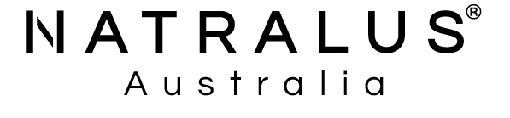

**Media Release**

**Introducing Natural Deodorant Range**

**Complementing our Natural Skin, Body & Beauty Range of Products**

***New Improved Formula***

*FOR IMMEDIATE RELEASE*

February 11, 2022

Natralus Australia is excited to launch a natural deodorant range under their own brand. Having acquired the **JAMA Australia** Natural Deodorant range in 2021, Natralus has now further improved the formula while still maintaining the same quality and effective natural base they in fact formulated initially for JAMA in 2018.

“At Natralus we believe in our brand and are passionate about our new natural organic range of deodorants,” said Natralus Australia Managing Director and CEO, John Rowe. “Since 2018 our technical team have spent many hours on researching, trialling, and testing various deodorant formulas with numerous candidates. We started out with a purpose to make the most effective natural deodorant on the market. The natural ingredients found in our Deodorants are carefully selected for their high performance based on their potency and efficacy properties. We also ensure ingredients work synergistically to complement each other for greater efficacy and the ultimate outcome is a natural deodorant that really works.”

Many conventional deodorants and antiperspirants contain heavy metals like aluminium which can block and clog pores and harsh chemicals like triclosan, parabens and talc leading to skin irritation.

Natural deodorants have been on the market for a while. A lot are ineffective and most haven’t kept up with the advances in natural chemistry nor have the ability to successfully combine specific natural ingredients which Natralus has done within their special formulas.

Natralus Australia’s purpose and passion is to create sustainable, resource-efficient, skin sensitive friendly products that are healthy for you and the environment. All of our products, including our Natralus Natural Deodorants are independently tested and clinically proven: kind, mild and safe for the skin, and dermatology approved/recommended.

Using a Natralus Natural Deodorant you can be assured that you will not only stay smelling fresh all day with long-lasting protection, you will be doing it without the need for harsh chemicals. You even have a choice of different scents so you can to mix and match what you wear or simply to choose one that suits you the best.

Ideal for those who are convinced natural deodorants would never work for them.

Natralus Australia is excited to re-introduce four variants; subtle fragrances, suitable for sensitive skin. You will be sure to find a fragrance to suit all members of your family.

***LEMON MYRTLE – UPLIFTING & FRESH***

Using the refreshing scent of Lemon Myrtle

to keep you fresh all day, while still allowing

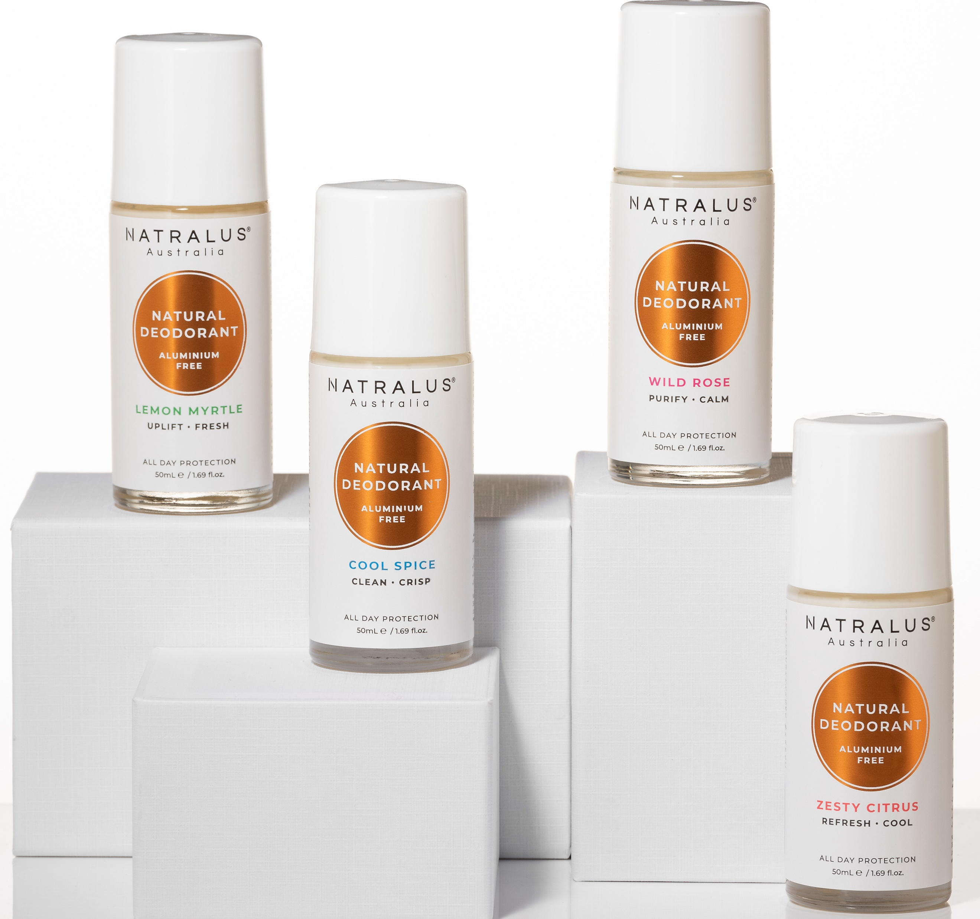

the skin to breath.

***WILD ROSE – PURIFY & CALM***

Capturing the scent of floral blooming rose,

this deodorant is designed to be effective but

gentle on skin, offering a fresh feel throughout the day.

***COOL SPICE – CLEAN & CRISP***

Blended with black pepper oil, which helps neutralise odour naturally and have a feeling of clean and crisp all day.

***ZESTY CITRUS – REFRESH & COOL***

Fresh and lively scent of pink grapefruit and Bergamot, which keeping you free of offensive odours and have a feeling of fresh and protect all day long.

Natralus Natural Deodorant not only smells good; leaving you feeling confident and fresh all day, it also contains organic aloe vera and Vitamin B5 for skin-calming and soothing qualities.

So, you can go natural with confidence!

Natralus Australia is a South Australian family owned and operated Natural Skin, Body & Beauty care Brand.

The philosophy of this Indie brand stems from family history and remains the same today as they continue to carefully select natures finest ingredients to create unique blends that ensure their products can deliver effective results for their customers.

Celebrating over 10 years supplying natural, organic products to Australian families and recently branching into the US Market, this innovative business is now launching into the Natural Deodorant segment.

Learn more about Natralus at [www.natralus.com.au](http://www.natralus.com.au)

Please direct inquiries to:

John Rowe Managing Director [John.rowe@natralus.com.au](mailto:John.rowe@natralus.com.au) 0419186380

Lyn Semola

[lyn.semola@natralus.com.au](mailto:lyn.semola@natralus.com.au)

+61 8 8382 3000