Daniels Donuts Williams Landing is giving away a year’s FREE donuts!
“Few things are more magical than fresh donuts!” One lucky winner will receive free donuts for a year! “
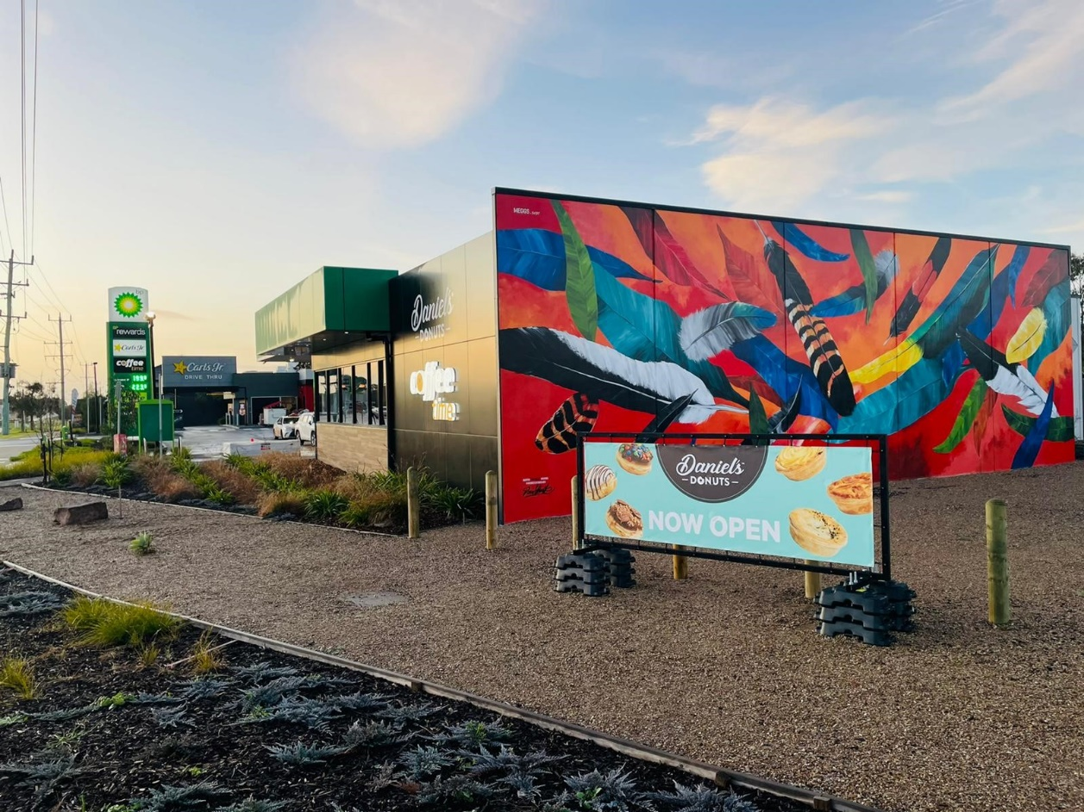
Jasbe have opened their seventh Daniels Donut kiosk at Williams landing. Setting the industry standard in store design, Williams Landing feels more like an upmarket café rather than a petrol station. Architecturally designed, with beautiful interiors the store is a must see.
Known for their generous giveaways Jasbe have not failed to impress with their latest competition- Free donuts for a year! Purchase any 6 pack to enter the draw to win. Competition starts Sunday 28th August and ends Monday 19th September. (Only at, 73 Sayers Rd Cnr Palmers Rd Williams Landing)
“We love to give back to our customers and giveaways are one way we do this. With the cost-of-living pressures we would like to spread some joy to our customer lives.” Said Retail Manager Alex Be.
Daniel’s Donuts infamously known for their Fresh Cream & Jam, they offer over 50 donut flavours to choose from, including vegan and gluten free options. For savoury lovers you can’t beat Daniel’s New Zealand style chunky cheese and mince pies. Also, on offer Coffee Time barista coffee and hand scooped milkshakes.
Be sure to drop into Williams Landing before the 19^{th of} September and go in the draw to win a year’s free donuts!
For the latest Jasbe giveaways Click here.

www.jasbe.com.au
