**emerginC Brings Cold-Pressed Chemistry Rawceuticals Luxury Range to Australia**

*Through distributor Spa Circle Brands, the first cold-pressed chemistry range comes to Australia*

Spa Circle Brands, the exclusive distribution office for salon exclusive US brands in Australia, introduces the unique, award-winning, cold-pressed chemistry range, emerginC’s Rawceuticals, to Australian spas and salons. Rawceuticals blends a variety of active, cold-pressed plant, fruit and seed oils into its proprietary skin and body care formulas. Cold processing helps retain the natural ingredient integrity and activity, while finished formulas are only minimally heated in line with industry “raw” standards .

“When the samples arrived for our team, I quickly realised why Rawceuticals is available in some of North America’s most luxurious spas,” Brad McDonald, Director of Spa Circle Brands, said. “Rawceuticals is in a league of its own. The quality of ingredients is obvious and will take any facial or body service to the next level.”

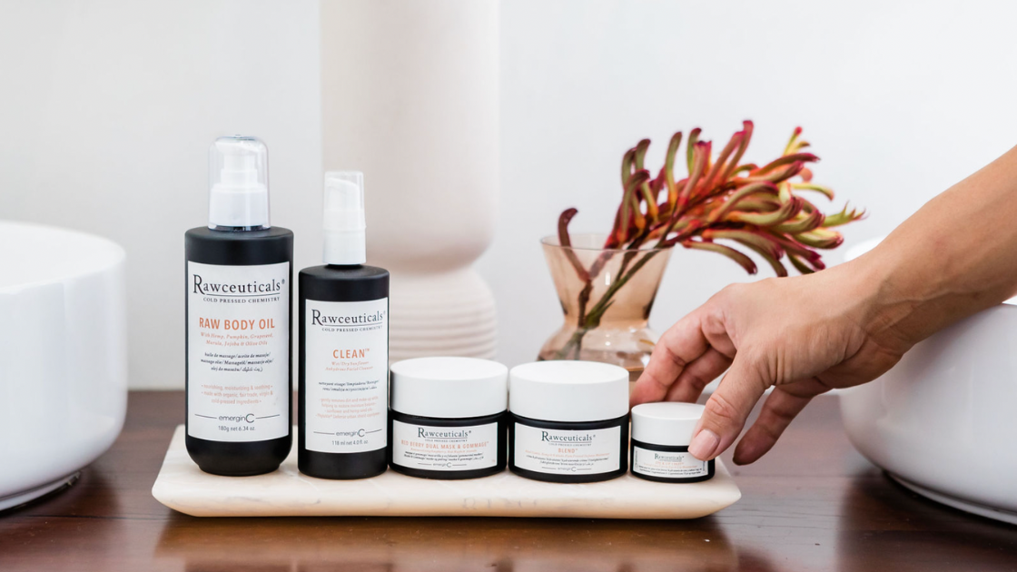

Rawceuticals blends pure, active cold-pressed plant extracts and other natural ingredients to help moisturize, soothe, nourish, and fight the appearance of fine lines and wrinkles and fight against environmental irritants. Ingredients include plant, fruit and seed oils and extracts from the “immortal flower”, marula, hemp, sunflower, chia, sesame, carrot, black cumin, olive, coffee, Kakadu plum, coconut, tomato, raspberry and more. Formulas include fair trade and virgin oils, including virgin cocoa butter.

Luxury salon treatment offerings include the experiential Walk in the Woods Facial, Orchid Stem Cell Renewal Treatment, Argentiere Ice Cap Facial and the Hydrating Hemp Facial.

“This peerless, revolutionary range plays on natural, cold-pressed trends to create effective, luxury skin care with a unique look and feel,” emerginC’s Founder Ian Lirenman said. “Our products are minimally processed, natural and mostly organic and there are few ranges out there that can bring such a perspective, from our pressed “Blend” moisturizer to our all-purpose Salvation Serum to our Red Berry Dual Mask and Gommage.”

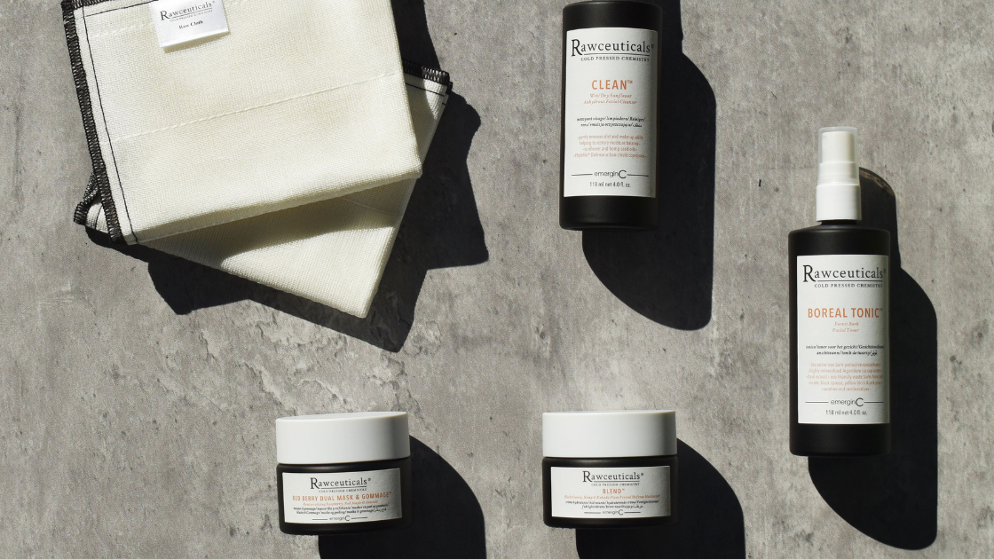

emerginC strives to be an industry leader in sustainability, from their their industry-first “buy one, plant one” tree planting program (over one million trees planted and counting), their innovative emerginBees bee habitat initiative and emeginCeeds organic vegetable seed program, aimed at providing a healthy and thriving local ecosystem for plants, people and animals in local communities. Packaging choices include glass, biodegradable jar caps, and other sustainable choices. emerginC also works with [carbonfund.org](http://carbonfund.org) to reduce its environmental impact and strives to source its ingredients ethically and sustainably wherever possible, including the use of natural, organic and fair trade ingredients. Its offices operate on wind power and approximately 80 percent of its products are manufactured with with wind power.

Learn more about emerginC’s Rawceuticals range or any of their other brands at [www.emerginc.com.au](http://www.emerginc.com.au) To become a salon or spa stockist, visit [www.spacircle.au](http://www.spacircle.au)

Follow Spa Circle on Instagram [www.instagram.com/myspacircle](http://www.instagram.com/myspacircle)

# # #

**About Spa Circle Brands**

Spa Circle Brands is an Australian distributor that specialises in supply to salons, spas and skin clinics. Originally launched in 2019 by bringing the viral Los Angeles, CA-based professional spa brand Esthemax to Australian shores, the husband and wife team quickly grew to representing Esthemax, emerginC, Scientific Organics, Rawceuticals, Bryght Skim Lightening, MSKIN PRO and their own mineral sunscreen brand, Sunny Skin. For more information, visit [www.spacircle.au](http://www.spacircle.au)

**MEDIA CONTACT**

Contact: Danielle McDonald

[danielle@spacircle.au](mailto:danielle@spacircle.au)