**Sunny Skin Officially Launches in North America**

*The Australian sunscreen brand debuted in the United States with a pop up in Showfields at Miami Beach Florida.*

Sunny Skin, an Australian sunscreen brand, officially launched in North America with a pop up in Showfields in Miami Beach, Florida. Sunny Skin creates mineral face sunscreens for rosacea, eczema, hyperpigmentation and sensitive skins. Showfields is known as “the most interesting store in the world” for their revolutionary retail concept built to engage and inspire customers’ sense of discovery through revolving experiences with brands. Sunny Skin will be featured at Showfields Miami through February 11.

“I love that we are kicking off the official US launch with Showfields,” Sunny Skin CoFounder Danielle McDonald said. “I come from a background as a facialist in the treatment room and at Spa Circle Brands, a part of my job is to build beautiful experiences for spas and salons across all of the brands we represent, so partnering with a retailer that focuses on creating sensory, engaging experiences is everything I could dream of and more.”

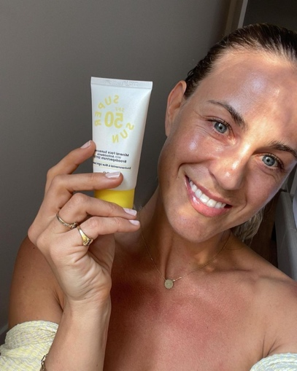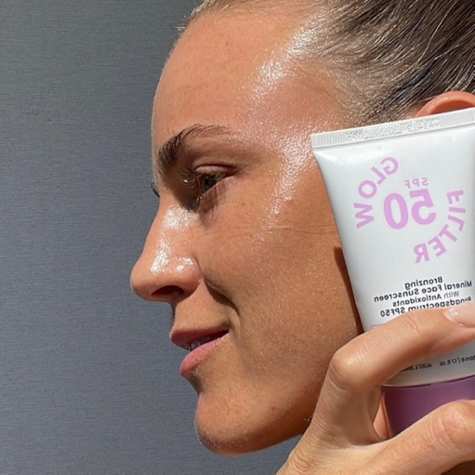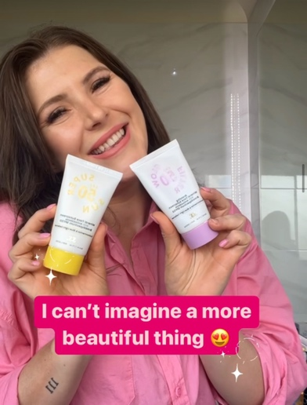

Sunny Skin was inspired by CoFounder Danielle McDonald’s son’s eczema journey as she was determined to create a product that protects against UVA, UVB, blue light and environmental pollution. The Super Sun is free of the top 8 allergens, including peanuts, dairy, shellfish and others, and protects against sun damage and improves skin tone.

Sunny Skin has two primary sunscreen products, Super Sun SPF50 and Glow Filter SPF50. Both products work under makeup in addition to on their own. The potent antioxidant tomato fruit extract contains a naturally glowing carotenoid, enhancing the skin’s healthy glow and instant anti-redness correction. They are also highly nourishing, which smoothes the skin and acts as a strong base under makeup.

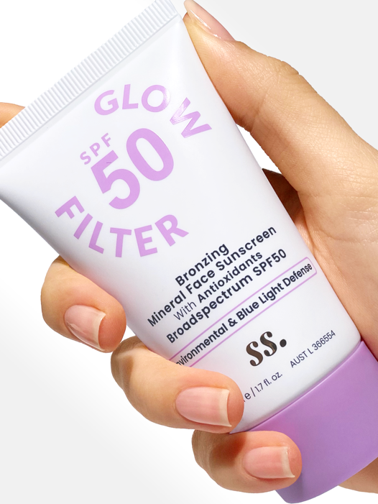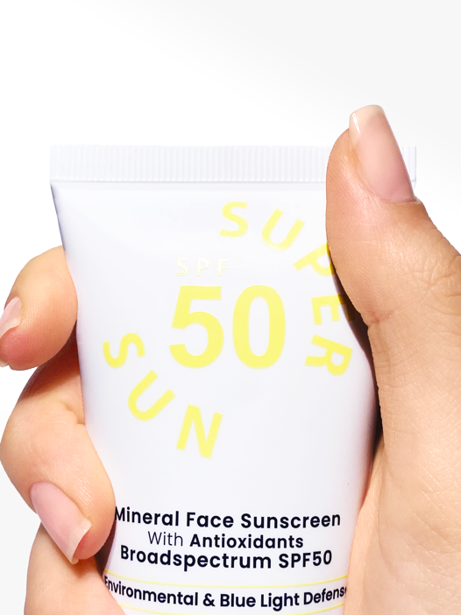

This is not the first foray into North America for the brand. Through their online store. Sunny Skin had already been selling to customers in the United States.

“We’ve had a lot of orders and inquiries coming from North America so it made sense to set up a distribution centre for our US customers,” Sunny Skin CoFounder Brad McDonald said. “We are super excited to begin this journey and our official launch with Showfields in Miami.”

To learn more about Sunny Skin, or to check out their online store, visit [www.sunnyskin.com](http://www.sunnyskin.com) To become a Salon Stockist in North America, visit [www.sunnyskinclinics.com](http://www.sunnyskinclinics.com) , and to become a Salon Stockist in Australia, visit [www.spacircle.au](http://www.spacircle.au)

Follow Sunny Skin on Instagram at [www.instagram.com/mysunnyskin](http://www.instagram.com/mysunnyskin)

# # #

**About Sunny Skin**

Launched in 2021, Sunny Skin is the brainchild of Australian Facialist Danielle McDonald. Inspired by her son’s eczema journey beginning at six months, she knew she wanted to create an allergy-free, mineral-based sunscreen to protect against UV, blue light and environmental pollution, but also be compatible for clients undergoing a skin journey with acne, barrier repair, pigmentation, sensitivity and inflammation. Learn more at sunnyskin.com.