8th December 2022

**FOR IMMEDIATE RELEASE**

**Women In Leadership: #EmbracingEquity In Canterbury-Bankstown**

Sydney, New South Wales – On Wednesday 8th March 2023, the Canterbury Bankstown Chamber of Commerce (CBCC) will be holding a Women in Leadership event to observe International Women’s Day and the theme for 2023, #EmbraceEquity.

Celebrating Women in Leadership roles, the CBCC aims to empower women from all levels of business to strive to achieve their goals. As the fastest-growing Chamber of Commerce in Sydney and representing one of the most diverse LGAs in Australia, the CBCC understands the distinctive challenges that women face. In particular, with the Canterbury-Bankstown community representing over 200 languages, the CBCC is committed to ensuring that women of all cultural backgrounds can receive the support they need to thrive and succeed.

Guest speakers from Western Sydney across various industries will be invited to share their stories to inspire local business communities and learn how to enact change in line with the theme for International Women’s Day 2023, #embraceequity. Past guest speakers from CBCC’s Women in Leadership events have included: Joanne Tonks, General Manager of Watertight Group, Lee de Winton, Chair of Western Sydney Airport’s Forum and 2019 AFR 100 Women of Influence, Karen Webb, the 1st Female NSW Police Commissioner, Danielle Emerton, Commander of Auburn Police Area Command and Superintendent in NSW Police Force, and Nancy Youssef, founder of Classic Finance and Classic Mentoring and Coaching.

Wally Mehanna, CEO of the CBCC, believes that endorsing, supporting, and empowering women in business is the backbone of a thriving economy and community.

“Women make up nearly 50% of the Australian workforce, and over the last two decades, women business operators have increased by 46%,” says Mehanna. “They are a crucial and integral part of our business community, but they still face enormous challenges.”

Unconscious gender biases, underrepresentation in key fields such as finance or STEM industries, gender pay gaps, and other barriers can prevent women from fully participating in business.

“Many women suffer from ‘imposter syndrome’ and lack confidence in their skills and abilities. By inviting successful women from different sectors to share their stories at our Women in Leadership event, we hope to show our attendees that they are essential and greatly enrich and strengthen our business communities,” says Mehanna.

The CBCC’s Women’s Committee plays an instrumental role in ensuring that the Women in Leadership event is a success. The Committee helps women in business network, connect, and support other women. The Committee developed the Women’s Safety Charter to increase the safety of women and girls within Canterbury Bankstown and is instrumental in driving change and improving the life and well-being of women in Western Sydney.

“Half of our Board is made up of women to ensure that our work will truly support women in business. Two of them, Antoinette [Khalil, principal lawyer of Khalil Family Lawyers] and Tracy [Minett, CEO of the Minett Group], are on the Women's Committee. However, there is still work to be done until our business community truly embraces equity,” says Mehanna. “Until men and women share equal opportunities within businesses, we at the CBCC are committed to supporting, uplifting, and inspiring women in business.”

The CBCC’s Women in Leadership event will be held on Wednesday 8th March, 2023 at the William Inglis Hotel in Warwick Farm, NSW. Ticket sales will begin from the 15th of December, with ticket prices starting from $50.00 per person. Contact [ceo@cbchamber.org.au](mailto:ceo@cbchamber.org.au) for more information about the event.

Join us and become part of the change to #EmbraceEquity.

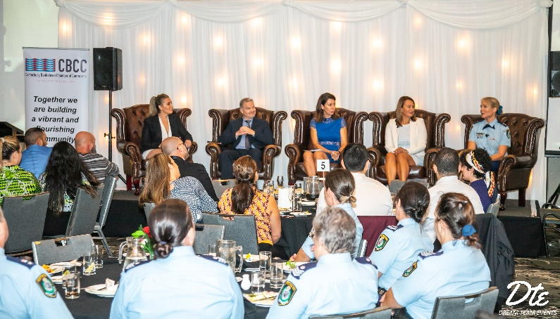

|  |  |
| --- | --- |
| |  | | --- | |  | |

####

**Contact Information**

Wally Mehanna

CEO of the Canterbury Bankstown Chamber of Commerce

M: 0416 012 747

E: ceo@cbchamber.org.au