FOR IMMEDIATE RELEASE

Introducing the New Esthemax Hydrojelly: The Ultimate Solution for Impaired Barrier, Sensitive, and Inflamed Skin

Spa Circle Brands, a leader in the professional beauty industry, is proud to announce the launch of the Esthemax Blue Glacier Cryo Hydrojelly Mask with Glacier Clay & Organic Gotu Kola. This new addition to the Esthemax Professional line of Hydrojelly Masks is designed to soothe inflammation, redness, and blemishes, while promoting radiant, healthy skin.

The Blue Glacier Cryo Hydrojelly Mask is an electrolyte-infused formula that instantly refreshes and remineralizes the skin. Formulated without parabens, sulfates, phthalates, talc, or corn starch, this mask is ideal for those with impaired barrier, sensitive, or inflamed skin, as well as those dealing with acne or scarring.

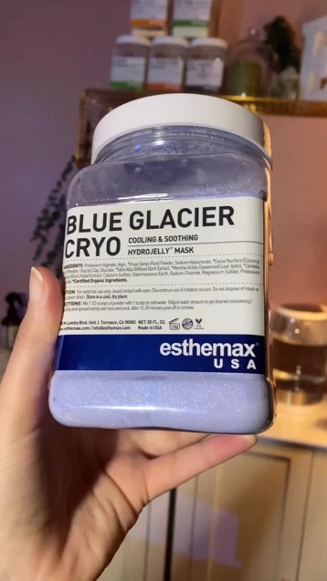  

The mask's low temperature benefits are also perfect for those looking to calm inflammation and control pigmentation, resulting in brighter skin. Cold therapy shrinks blood vessels and causes the muscles of the face to constrict, which can reduce swelling, dark circles, and patches, providing a unique workout for the structure of the face.

Key ingredients in the Blue Glacier Cryo Hydrojelly Mask include:

Glacier clay, which contains more than 60 nourishing minerals that help promote anti-aging, collagen formation, and healthy cellular function. It absorbs toxins and excess sebum and naturally exfoliates dead skin, while supporting a healthy skin microbiome.

Xylitol, which cools the skin by absorbing heat and provides a soothing sensation. It helps fight bacterial skin infections and clears up irritated skin, as well as boosts skin hydration by enhancing the skin's natural levels of hyaluronic acid.

Organic Gotu Kola, which repairs and reduces scarring, treats acne, and calms sensitive skin. It promotes the growth of new skin, regenerates connecting tissue, enhances collagen synthesis, and improves skin elasticity.

Organic electrolytes from coconut water, which help restore skin moisture and prevent dehydration by drawing water into skin cells. They moisturize without adding excess oil and help balance the skin's natural moisture and pH levels, while removing toxins and excess oils to reduce inflammation and breakouts.

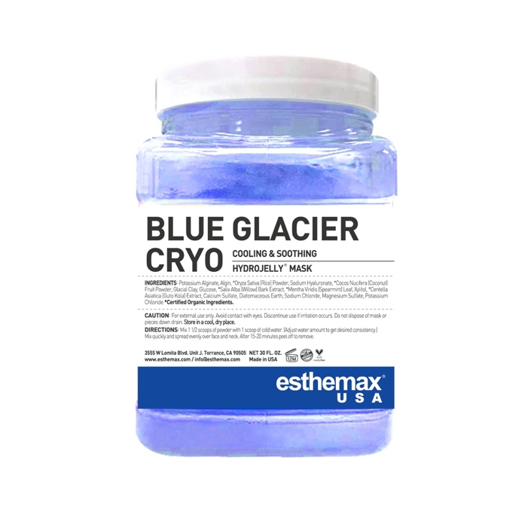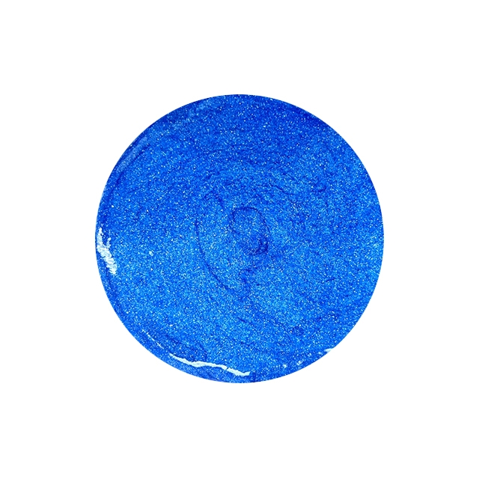

"We are thrilled to offer our clients the Blue Glacier Cryo Hydrojelly Mask, which has quickly become an aesthetician favorite in the US," said Danielle, General Manager of Spa Circle Brands. "Spa guests love the cooling effect and the smoother, tighter feeling they experience after using this mask. We're confident that the mask's unique blend of nourishing minerals, organic ingredients, and low temperature benefits will provide an unparalleled skincare experience."

The Blue Glacier Cryo Hydrojelly Mask is a trade only product available in an 850g package, which includes 10 applications. To learn more about the mask or to place an order, please visit [www.spacircle.au](http://www.spacircle.au)

About Spa Circle Brands

Spa Circle Brands is a leading provider of high-quality beauty and wellness products. With a commitment to excellence and customer satisfaction, Spa Circle Brands is dedicated to helping customers look and feel their best. For more information, visit the Spa Circle Brands website at [www.spacircle.au](http://www.spacircle.au)

Contact

Danielle McDonald   
Spa Circle Brands   
0402212477

[www.spacircle.au](http://www.spacircle.au)