FOR IMMEDIATE RELEASE

Spa Circle revolutionises product ordering and management for salon owners with new app

Spa Circle, a leading provider of professional beauty products, announces the release of its innovative new app, now available on both Android and iOS. Designed specifically for salon owners, the Spa Circle app offers a seamless, efficient and convenient way to order and manage products.

With the Spa Circle app, salon owners can browse an extensive selection of products, add them to their cart, and check out in seconds. The app also offers helpful features such as wishlists and favorite lists to save products for future reference and reordering, and instant notifications for new releases and restock notifications.

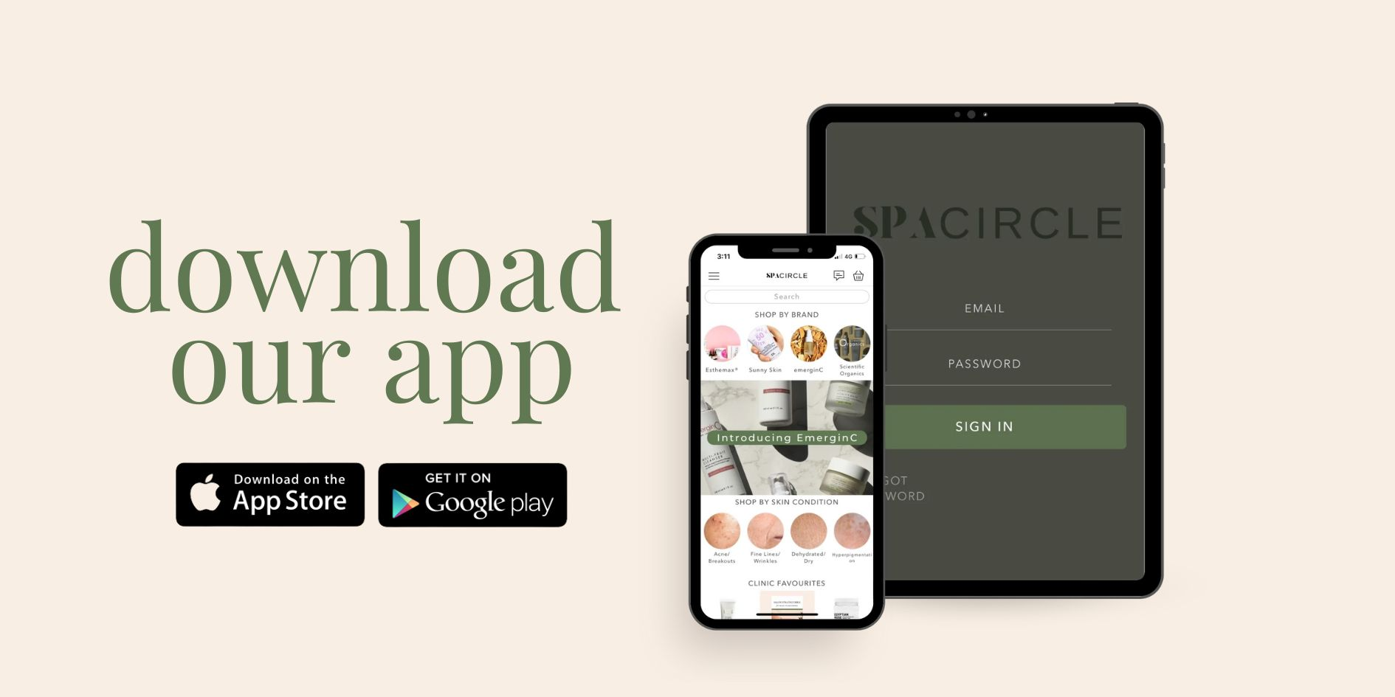

The most exciting feature of the Spa Circle app is the instant messaging feature, which allows salon owners to connect with a team of experts in real-time. Whether it's for advice, to ask questions, or to resolve issues, the instant messaging feature makes it easier than ever to receive the support you need.

"We understand that managing a salon can be overwhelming, which is why we've created the Spa Circle app to make ordering and managing products as simple and stress-free as possible," says Brad McDonald, Director "We're thrilled to bring this app to salon owners and look forward to seeing how it will positively impact their businesses."

Say goodbye to the hassle of ordering and managing products for your salon and hello to convenience and efficiency with Spa Circle. Download the app now and experience the difference for yourself!

[DOWNLOAD ON APPLE](https://apps.apple.com/au/app/spa-circle/id1663502067)

[DOWNLOAD ON GOOGLE PLAY](https://play.google.com/store/apps/details?id=co.shopney.esthemaxaustralia)

For more information, please contact [hello@spacircle.au](mailto:hello@spacircle.au)

About Spa Circle: Spa Circle is a leading provider of beauty products for salon owners. With a commitment to providing high-quality products and exceptional customer service, Spa Circle is dedicated to helping salon owners grow their businesses.