**JustCo Australia Reinvigorates the Office Concept with Game-Changing Design Trends**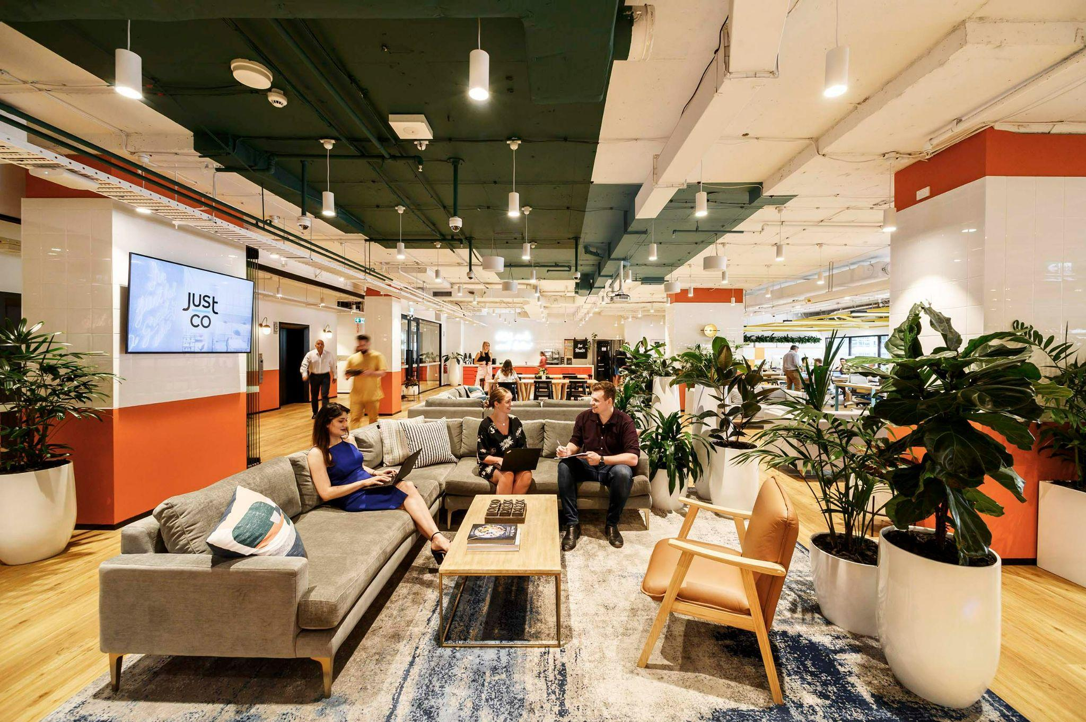

**Australia, 24 March 2023 —** Recognising the change in workforce demands, JustCo Australia redefines its office spaces with designs that have proven conducive and welcoming to the workforce. Rolling out the changes with the to-be-opened JustCo centre at 135 King Street, the core of the designs follows the three main tenets: 'hotelification' of the workplace, biophilic design, and optimal space utilisation. Through these aesthetic and facility reworks, JustCo aims to invite more enterprises to explore and reinvigorate their employees' productivity with its offerings.

**Reinventing Today’s Work Environment**

Hybrid work is now the norm for many organisations. Statista reports that 48% of companies today have distributed workforces, compared to 30% reported in pre-pandemic times. Since lifting COVID-19 restrictions, there has been a re-emergence for the return to the office as the locus of work for many organisations. To bring personnel back to the office, a human-centric design is critical to drawing people back.

JustCo's 'hotelified' centres present a new inviting face for the office concept, incorporating amenities and aesthetics more familiar to the hospitality trade to create warm, welcoming work environments. In addition, JustCo borrows from biophilic design principles to foster physiological, psychological and cognitive benefits to office workers by creating connections to Nature. For example, the newest JustCo centre at 135 King Street adopts warm, earthy, red tones reminiscent of the Australian Outback alongside abundant natural daylight and expansive city views stretching into Sydney Harbour. Like its predecessors, JustCo at 135 King Street is also equipped with adaptive workspaces. These workspaces offer [flexible solutions](https://www.justcoglobal.com/au/membership-plans/?utm_source=fp&utm_medium=organic&utm_campaign=mar23_dpr), adapting for various uses, such as hot desking, open collaboration spaces, private workstations, video-conference-enabled meeting rooms, and ergonomic furniture like posture-supporting sit-stand chairs. Moreover, the all-new 135 King Street coworking space offers end-of-trip facilities like lockers, well-stocked pantries, bicycle racks, phone booth rooms, and more.

**Lighting the Way Back to Office Spaces**

Many organisations are accustomed to flexible work arrangements and also desire for these to remain. As hybrid work arrangements present a unique set of challenges for teams to collaborate, managers need to come up with strategies for how to collaborate in this mode. Such as redefining the purpose of in-person meetings; team agreements on when and how to come together face-to-face; the etiquette governing these meetings; and lastly, new ways to think about how the office and office space supports this new form of collaboration.

As such, JustCo Australia has modelled its workspaces to be flexible enough to cover a range of work modes, with quiet zones for focused work, collaboration areas, and social nexuses for building social capital.

JustCo delivers this through cost-effective solutions for enterprises of all sizes, from A$325 monthly for a hot desk to [larger customisable office spaces](https://www.justcoglobal.com/au/enterprise/?utm_source=fp&utm_medium=organic&utm_campaign=mar23_dpr). Meeting rooms are also available for ad-hoc meetings for members who do not require office space daily. What’s more, with a single membership, JustCo members are granted access to all JustCo locations in [Sydney](https://www.justcoglobal.com/au/locations/sydney/?utm_source=fp&utm_medium=organic&utm_campaign=mar23_dpr), [Melbourne](https://www.justcoglobal.com/au/locations/melbourne/?utm_source=fp&utm_medium=organic&utm_campaign=mar23_dpr), and over 40 locations across Asia, providing unmatched workspace flexibility.

**About JustCo**

JustCo is Asia Pacific's leading provider of flexible workspace for businesses of all sizes seeking flexible solutions to nimbly scale their operations. JustCo's value proposition lies in its focus on high-quality fitouts, attractive locations, and a seamless experience via technology to work from any of its spaces. Founded in 2011 and headquartered in Singapore, JustCo has over 40 co-working spaces across nine major cities in Asia Pacific.