Spa Circle Brands Launches the First Ever Professional Beauty Marketplace, Redefining the Relationship Between Skincare Brands and Salons and Day Spas

Spa Circle Brands, an established distributor of high-quality skincare brands, is proud to announce their expansion as the worlds first Professional Beauty Marketplace launching on Friday 17th March 2023. This new platform bridges the gap between professional skincare brands and salons and day spas, offering a wide selection of professional-grade skincare products from top brands all in one place with no opening orders.

"I’ve spoken with many salon owners who have expressed many of the difficulties they face in accessing professional brands, and this is our solution to bridge this gap & support an evolving industry” says Brad McDonald, Founder and CEO of Spa Circle Brands. "Our mission is to support and empower beauty professionals, while also providing a more efficient and convenient way for them to discover and purchase products."



Figure Danielle & Brad McDonald launch Spa Circle Marketplace

Already with exclusive distribution rights in Australia for household name beauty brands like emerginC, Esthemax Hydrojelly Masks, Scientific Organics, Rawceuticals, Sunny Skin & more, Spa Circle Brands is set to revolutionise the way beauty professionals source their skincare products. In addition to providing a one-stop-shop for beauty professionals, the Professional Beauty Marketplace offers educational resources and training opportunities to help professionals stay up-to-date on the latest trends and techniques in the beauty industry.

"We're thrilled to partner with Megan Potter Organics and Skin Queen Education for our official launch to becoming the worlds first professional beauty marketplace," says McDonald. "Their professional beauty expertise and passion for the beauty industry make them the perfect partners."

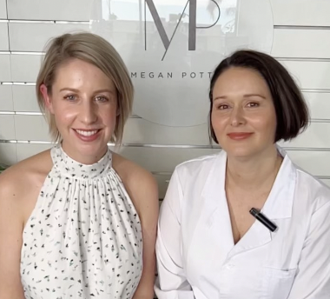

Figure Megan & Mandy Co Founders of Megan Potter Organics

To celebrate the launch of Spa Circle’s leap as a Professional Beauty Marketplace on Friday, March 17th, 2023, Spa Circle Brands is partnering with Megan Potter Organics and Skin Queen Education who are joining the platform. The launch event will feature a new Spa Circle & Megan Potter curated Wellness Facial experience, educational sessions, and exclusive discounts for Spa Circle Members.

Spa Circle Brands is committed to building a collaborative community of professional beauty brands and salons, and McDonald invites other like-minded companies to join us in this mission. "The Spa Circle marketplace model is a win-win for skincare brands and beauty salons alike," says McDonald. "It allows brands to reach a wider audience and expand their distribution channels, while providing beauty salons with a more convenient and efficient way to source their products and grow their business."

If you're a professional skincare brand or beauty salon that shares our passion for quality and innovation, visit our website at www.spacircle.au to learn more about partnering with us. Let's work together to redefine the beauty industry and empower professionals in Australia.