**MEDIA RELEASE**

Sydney NSW 2000

March 27, 2024

# Will CBD office markets stabilise at record vacancy rates?

**FOR IMMEDIATE RELEASE**

### ResolveXO Research shows that Australian CBD office contractions are levelling off following a four-year slide.

One notable trend highlighted in [**TrendXO**](https://www.resolvexo.com/research-trendxos-debut-edition) is the fluctuation in office sizes across different industries and cities.

* **In 2021, Melbourne recorded the largest average increase in office size at 60%, primarily within the legal and medical industries.** However, since then, a consistent trend of downsizing has been observed.
* 2022 marked the most significant contraction in office space over the four years, with all CBD markets reducing in average office size. **Adelaide and Melbourne were particularly affected, both recording a 31% reduction largely driven by the > 5,000sqm office size category across various industries such as Media, Financial Services, Legal, and Telecommunications.**
* In 2023, the research indicates a potential stabilisation as the dust settles on company working practices. Despite a rise in relocations last year (which would typically suggest larger office reductions when considering recent history), the **Australian CBD office market experienced the lowest level of contraction with a decrease of only 5%**.

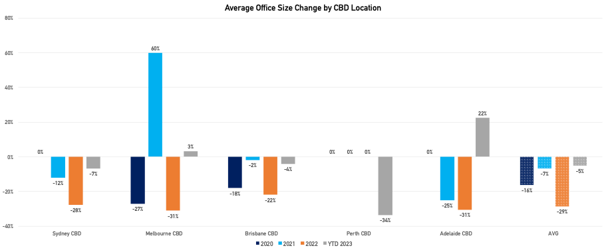

*Source: ResolveXO Research*

**The first quarter of 2024 has already shown signs of stabilisation as companies solidify their work arrangements**, be it flexible, hybrid or traditional office models.  However economic uncertainty and an increasing number of stranded assets will continue to shape the Australian office market.

The Property Council of Australia has reported a vacancy rate of 12.9% for Australian CBD prime assets, compared to 14.5% in the secondary market. **Stranded assets are a growing concern as vacancy remains elevated and largely concentrated within secondary grade** due to:

1. Shifting working models
2. Changes in industry needs (technological advancements)
3. Outdated buildings lacking modern amenities and efficiencies
4. A lack of energy efficiency features or ESG consideration

It's no surprise the research points to a **sustained preference for high-quality office space**, with tenants favouring prime and refurbished character buildings over less desirable options.

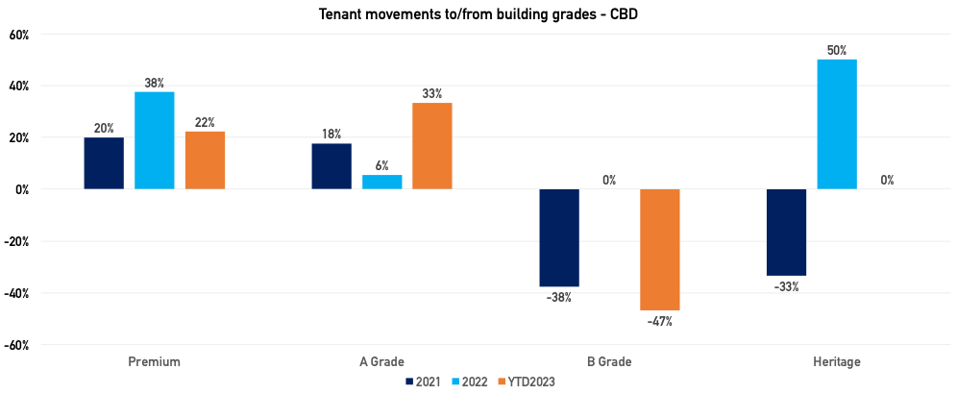

*Source: ResolveXO Research*

### **Then what?**

The issue of stranded assets in CBD office markets has been well documented [including my brief thoughts in a [previous post](https://www.linkedin.com/pulse/can-stranded-office-buildings-become-logistics-hubs-mastrullo-rz8pe/?trackingId=vAMI0QxvQPC%2BFRnpPOLBJQ%3D%3D)], however without a solution, a continued rise in these assets could lock the market into a 'high vacancy-high incentive' environment.

While as a Tenant Advisor, I like achieving record incentives for my clients, this may have long-lasting impacts that ultimately hinder a broader market recovery.

**ABOUT:**[**TrendXO**](https://www.resolvexo.com/research-trendxos-debut-edition)**breaks down ResolveXO's transaction data highlighting tenant trends and insights, by office market.**

###

**About ResolveXO**

ResolveXO exclusively represents business occupiers of commercial and industrial premises to strategically plan, negotiate and secure the best achievable property outcome.

**Contact**

Kristina Mastrullo

Head of Research & Property Strategist

[kristina.mastrullo@resolvexo.com.au](mailto:kristina.mastrullo@resolvexo.com.au)

+61 422 126 379

www.resolvexo.com