**MEDIA RELEASE**

Sydney NSW 2000

March 27, 2024

# Can Stranded Office Buildings Become Logistics Hubs?

**FOR IMMEDIATE RELEASE**

The e-commerce industry needs more last-mile delivery centres, but logistics space is tight. Here's a novel idea: Could we repurpose stranded, suburban office assets into logistics hubs?

**Pros:**

* Prime Locations: Suburban offices are often conveniently located near arterial roads and connections, ideal for last-mile delivery.
* Revitalisation Play: Filling vacancies would boost occupancy and generate income for owners.

**Cons:**

* Structural Challenges: Upgrading offices for logistics may be expensive and time-consuming.
* Regulatory Hurdles: Zoning changes and permits could slow redevelopment.

**The Numbers Tell a Story:**

While traditionally, the office-industrial rental delta would exclude this concept from further thought, effective rents for both sectors continue to converge.

Current Average Rent & Incentive Comparison (Indicative, $/sqm):

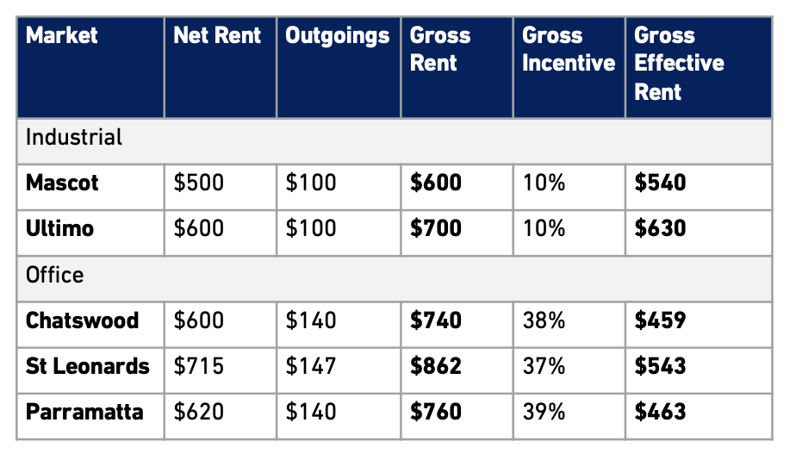

*Source: ResolveXO Research*

**The Takeaway:**

Comprehensive analysis is needed but with sustained high office vacancy rates, growing pressure on aging office assets and the continued supply-demand imbalance in logistics hubs, options beyond residential, BTR or assisted living office conversions may be worth exploring.

###

**About ResolveXO**

ResolveXO exclusively represents business occupiers of commercial and industrial premises to strategically plan, negotiate and secure the best achievable property outcome.

**Contact**

Kristina Mastrullo

Head of Research & Property Strategist

[kristina.mastrullo@resolvexo.com.au](mailto:kristina.mastrullo@resolvexo.com.au)

+61 422 126 379

www.resolvexo.com