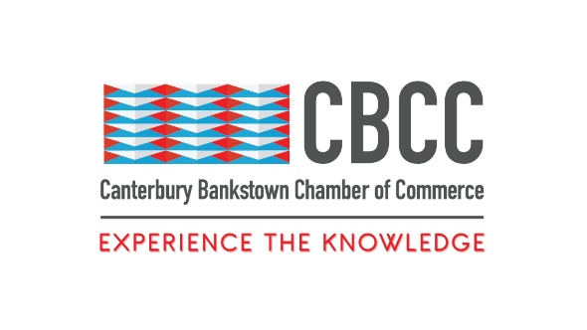
24th July 2024

FOR IMMEDIATE RELEASE

Empowering Women with Financial Confidence: CBCC's BRAVE Microcredential in Personal Finance Basics
Canterbury Bankstown Chamber of Commerce Teams Up with Western Sydney University to Offer Free Financial Literacy Course for Women
Sydney, New South Wales – The Canterbury Bankstown Chamber of Commerce (CBCC) proudly announces the BRAVE Microcredential in Personal Finance Basics in partnership with Western Sydney University. As part of the CBCC’s BRAVE project, this Microcredential is part of the CBCC’s ongoing commitment to support and uplift women in our community, helping them build confidence and essential life skills to navigate their financial futures with assurance and knowledge.
The BRAVE Microcredential: Personal Finance Basics is designed to equip participants with a comprehensive understanding of personal finance, covering crucial topics such as money management, budgeting, saving, investing, and debt management. This course, free for all BRAVE members, aims to empower participants to make informed financial decisions, establish and maintain healthy financial habits, and develop an attitude of financial responsibility.
Course Highlights include:
- Comprehensive Financial Education: Participants will gain a thorough understanding of key personal finance principles, enabling them to manage their money wisely and effectively.
- Practical Skills: The course focuses on real-world financial situations, helping participants to apply their new skills in everyday life.
- Confidence Building: By the end of the course, participants will feel secure and positive about their financial futures, having developed the confidence to take control of their finances.
- Life Skills Development: The course covers essential life skills related to personal finance, including mindset, goal setting, employment, and decision-making.

BRAVE Project
As part of the CBCC"s BRAVE Project, which aims to help women find the bravery to become who they want to be, this Microcredential ensures that our BRAVE participants have a strong financial understanding to build their dreams. This includes women looking to return to the workforce or enhance their professional skills. A Certificate of Completion from Western Sydney University will be provided upon completion, adding significant value to participants’ resumes and demonstrating their commitment to financial literacy and personal growth. And as a bonus, this Microcredential is free for all BRAVE participants!

Join Us Today
The CBCC invites all to take advantage of this incredible opportunity to enhance their financial literacy and gain valuable skills for a secure financial future. Whether you're looking to return to work, advance in your career, or simply gain better control of your finances, the BRAVE Microcredential in Personal Finance Basics is the perfect stepping stone towards achieving your goals.
For more information and to register for the course, please visit our website at BRAVE Microcredential: Personal Finance Basics.

About Canterbury Bankstown Chamber of Commerce:
The Canterbury Bankstown Chamber of Commerce is the fastest-growing Chamber in Greater Sydney, counting over 680 members from various industries and cultural and religious backgrounds. Our mission is to support and uplift the local community through connection and collaboration to make Canterbury Bankstown the most ideal place to live, study, work, and do business.



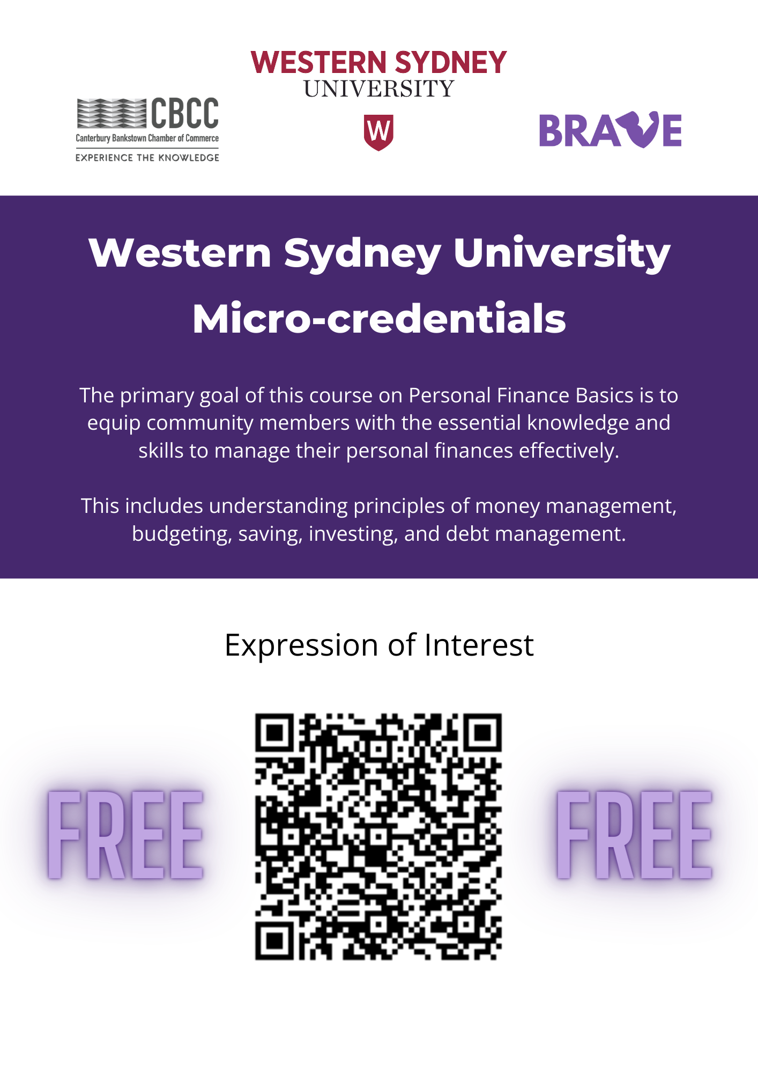
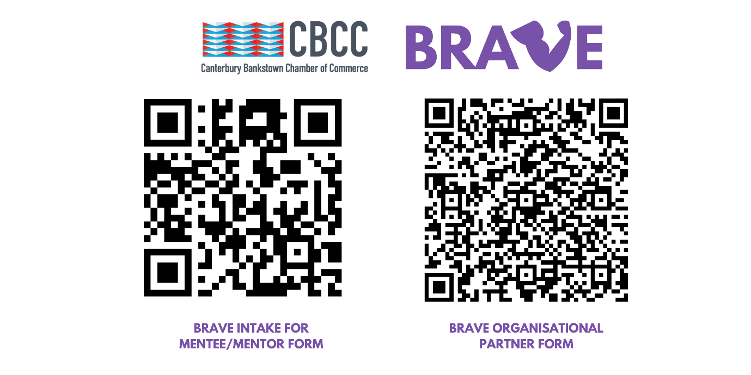
####
Contact Information
Wally Mehanna
CEO of the Canterbury Bankstown Chamber of Commerce
M: 0416 012 747
E: ceo@cbchamber.org.au

