
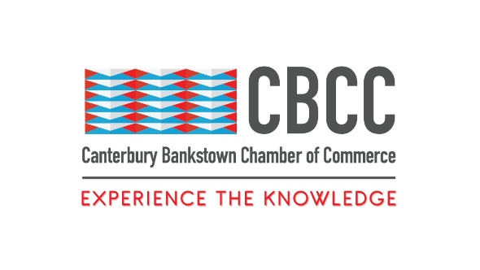
22nd August 2024

FOR IMMEDIATE RELEASE

Celebrating People with Disability: CBCC’s Special Lunchtime Event with Hon. Bill Shorten MP
Sydney, New South Wales – Celebrate and advocate for people with disability at noon on Thursday 26th September 2024 at Western Sydney University – Bankstown City Campus.
The Canterbury Bankstown Chamber of Commerce (CBCC) is proud to announce a lunchtime event dedicated to celebrating the achievements of people with disabilities in our community. This event promises to be an inspiring and impactful event that highlights the importance of inclusion and accessibility, and recognises the contributions of individuals with disabilities in the workplace and beyond.
We are honoured to welcome the Hon. Bill Shorten MP as our esteemed guest speaker for this event. A long-time advocate for disability rights and the Minister for the National Disability Insurance Scheme (NDIS), Minister Shorten will share his insights on the progress made in supporting people with disabilities, as well as the work that still needs to be done. His experience, passion, and dedication to the cause will undoubtedly provide valuable perspectives and inspire all attendees.
In addition to the Minister’s keynote address, the event will feature a panel discussion that will explore a range of topics, including the importance of accessibility in the workplace, the benefits of employing people with disabilities, and the role of businesses in driving social change. The discussion will provide practical insights and strategies that businesses can implement to become more inclusive and supportive of people with disabilities.
The CBCC would like to thank the generous support of Major Sponsor, My Guardian. As a leading provider of in-home care services that empower individuals with disabilities to live independently and with dignity, My Guardian is committed to delivering personalised care that meets the unique needs of each client and ensures that they can enjoy the highest possible quality of life. Their involvement in this event highlights their dedication to supporting people with disabilities and advocating for their rights. Visit their website here: https://www.myguardian.com.au/
Additionally, the CBCC would like to thank event sponsors Disability Forever Homes (website: https://www.bcpropertyagents.com.au/) and Hope and Care (website: https://hopeandcare.com.au/) for their support. These organisations are leaders in their respective fields, dedicated to improving the lives of people with disabilities and making our community a more inclusive place for all.
‘Celebrating People with Disability’ is more than just an opportunity to network and learn; it is a chance to be part of a movement that values inclusion and champions the rights of people with disabilities. By attending this event, you will gain valuable insights and connections whilst contributing to a broader conversation about how we can create a society where everyone has the opportunity to succeed and thrive.
This event is free for CBCC members and $10 for non-members. Buy tickets today. https://events.humanitix.com/the-canterbury-bankstown-chamber-of-commerce-business-after-five-celebrating-people-with-disability?hxchl=hex-pfl
Event Details:
- Date: Thursday September 26th 2024
- Time: 12:00pm – 2:30pm
- Venue: Western Sydney University – Bankstown City Campus
- Dress Code: Business Casual
About Canterbury Bankstown Chamber of Commerce:
The Canterbury Bankstown Chamber of Commerce is the fastest-growing Chamber in Greater Sydney, counting over 680 members from various industries and cultural and religious backgrounds. Our mission is to support and uplift the local community through connection and collaboration to make Canterbury Bankstown the most ideal place to live, study, work, and do business.
###
Contact Information
Wally Mehanna
CEO of the Canterbury Bankstown Chamber of Commerce
M: 0416 012 747
E: ceo@cbchamber.org.au

