Top 10 Mooncake Brands in Sydney, Australia - 2024
The Mooncake Festival, also known as the Mid-Autumn Festival, is a time to celebrate family, togetherness, and tradition. In Sydney, the festival has become increasingly popular, and finding the best mooncakes is a priority for many. Here is a well-curated list of the top 10 mooncake brands available in Sydney, based on quality, popularity, and unique offerings.
The brands are listed in no particular order, ensuring a delightful experience for every mooncake enthusiast:

1. Hong Kong MX (美心月餅)
Hong Kong MX (Maxim's) is undoubtedly one of the most recognized and beloved mooncake brands worldwide. Their mooncakes are known for their authentic taste, high-quality ingredients, and consistent excellence. The Double Yolk White Lotus Seed Paste mooncake is a classic favorite, while their Snow Skin Mooncakes offer a refreshing modern twist. Maxim's mooncakes are a must-try for anyone looking to experience the true essence of traditional Chinese mooncakes.
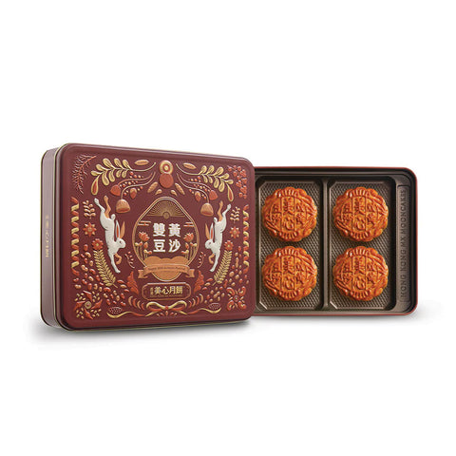
2. Sweet Lu
Sweet Lu is a brand that has gained popularity for its innovative and aesthetically pleasing mooncakes. Their Moon Shadow Gilded Mooncake Gift Box and Romantic Star and Moon Mooncake Gift Box are not just treats for the palate but also visually stunning, making them ideal gifts. The combination of traditional and modern flavors, such as Custard Lava and Jade Rabbit Rising, makes Sweet Lu a top contender in Sydney's mooncake market.
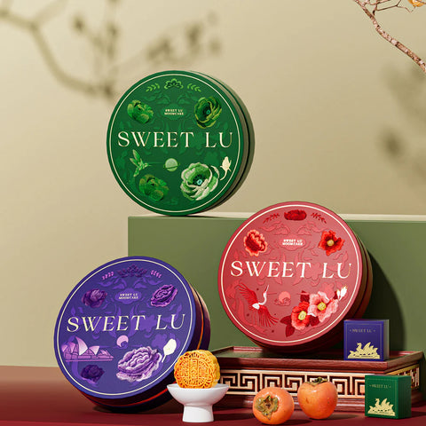
3. G-LAB
G-LAB stands out for its premium offerings, combining luxury with tradition. Their Black Truffle & Custard Mooncake is a unique blend of rich flavors, while their Pistachio Cream Cheese Snow Skin Mooncake is a lighter, yet equally indulgent option. G-LAB's mooncakes are perfect for those looking to indulge in something special during the Mooncake Festival.
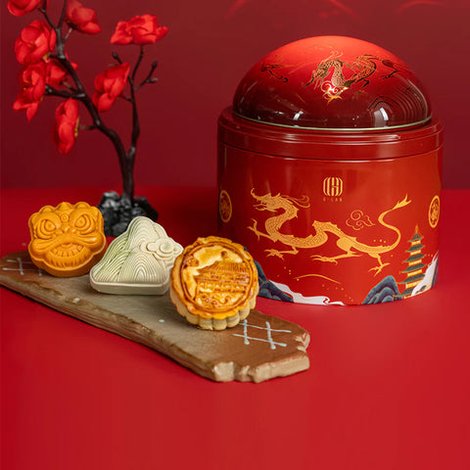
4. Likoufu
Likoufu is a brand that strikes a balance between tradition and innovation. Their Double Yolk Pure White Lotus Paste Cantonese Mooncakes are a timeless choice, while their Cheese Lava Custard Cantonese Mooncakes offer a modern twist that has been well-received. Likoufu's wide range of flavors and consistent quality make it a reliable choice for mooncake enthusiasts.
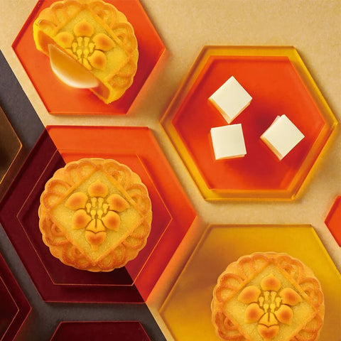
5. Baiwei
Baiwei is known for its traditional Cantonese mooncakes, which have a loyal following. Their Double Yolk White Lotus Seed Paste Mooncake Gift Box is a popular choice, offering a rich, flavorful experience. Baiwei also provides assorted mooncakes, allowing for a variety of tastes in one box, making them a favorite for family sharing.
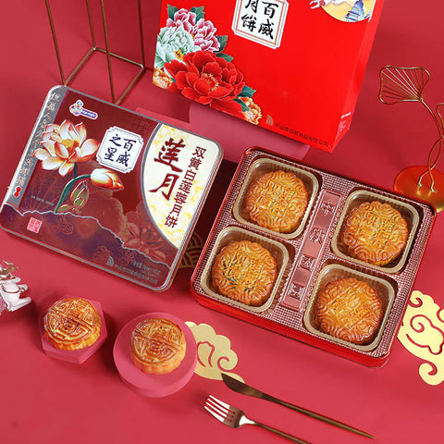
6. Casa Hana
Casa Hana offers beautifully packaged mooncakes that are as delightful to look at as they are to eat. Their Low Sugar Double Yolk White Lotus Mooncakes cater to health-conscious consumers without sacrificing taste. Additionally, unique flavors like Pandan & Black Sesame add a touch of creativity to their lineup. Casa Hana is perfect for those looking for a premium mooncake experience.
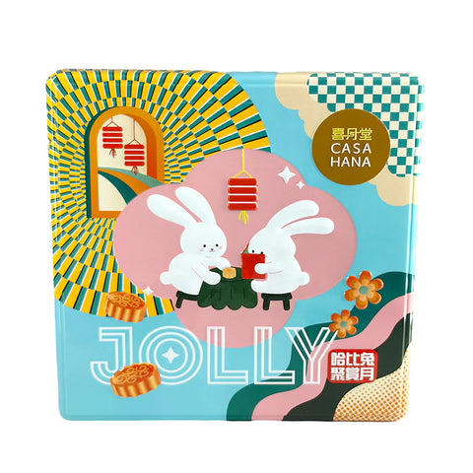
7. October Fifth
October Fifth is a brand that brings a touch of Macau's rich culinary tradition to Sydney. Their Mixed Nuts Mooncakes and Seven Stars Mooncake Gift Set are some of their standout products. October Fifth is known for its commitment to traditional recipes and high-quality ingredients, making their mooncakes a cherished choice.
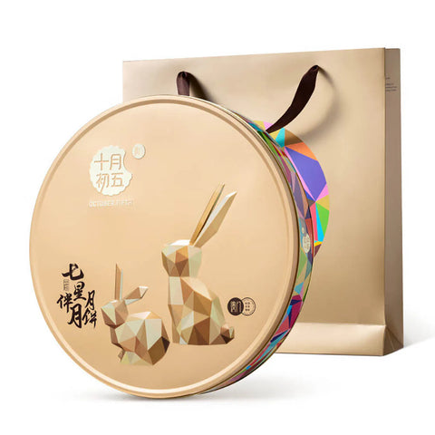
8. Wing Wah
Wing Wah is another iconic brand that has made a name for itself with its traditional recipes. Their Custard Mooncakes are particularly popular, offering a smooth and rich filling that is loved by many. Wing Wah's commitment to quality and tradition makes it a trusted brand for mooncake lovers.
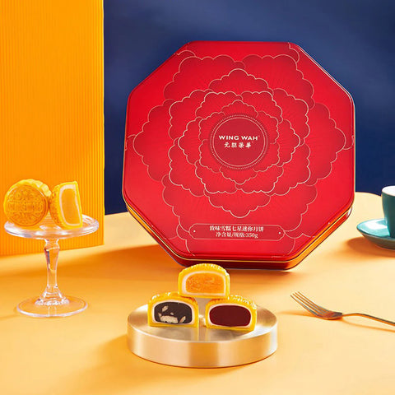
9. Hernan Musang King
For those who love durian, Hernan Musang King offers mooncakes made with the finest Musang King durian. Their Durian Snow Skin Mooncakes are a delicacy, combining the strong, distinctive flavor of durian with the soft, chewy texture of snow skin. This brand is perfect for those looking to try something different during the festival.
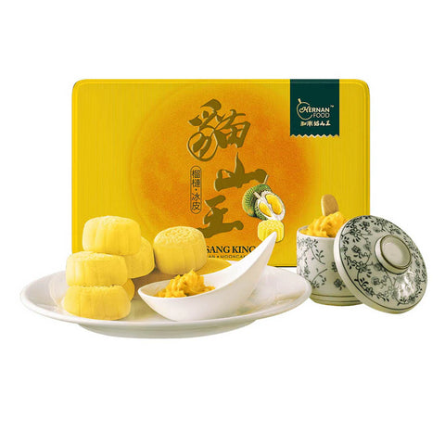
10. Palace Museum
The Palace Museum mooncakes are a nod to China's rich cultural heritage. Their packaging is often inspired by traditional Chinese art, making their mooncakes a perfect gift for the festival. The Mid-Autumn Mooncake Gift Box offers a variety of flavors, each carefully crafted to provide an authentic and refined experience.
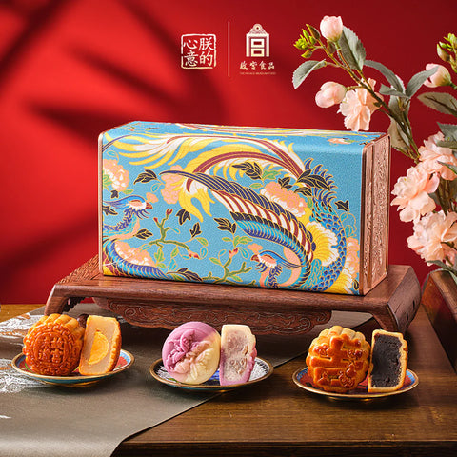
Conclusion
These top 10 mooncake brands in Sydney offer a wide range of flavors and styles, ensuring that there's something for everyone during the Mooncake Festival. Whether you prefer traditional flavors like those from Hong Kong MX and Baiwei, or more innovative options from brands like G-LAB and Sweet Lu, you’re sure to find the perfect mooncake to celebrate this special occasion.

For more information on prices and to explore the full selection of mooncakes, visit www.umall.com.au.

