Umall Asian Supermarket Introduces Revolutionary Robotic System to Enhance Warehouse Efficiency
Sydney, 27 August, 2024 – In a groundbreaking move to redefine the Asian grocery shopping experience, Umall Asian Supermarket has deployed a cutting-edge robotic system in its warehouse operations. This strategic advancement aims to streamline logistics, reduce delivery times, and improve overall customer satisfaction, setting a new standard in the Asian supermarket industry.
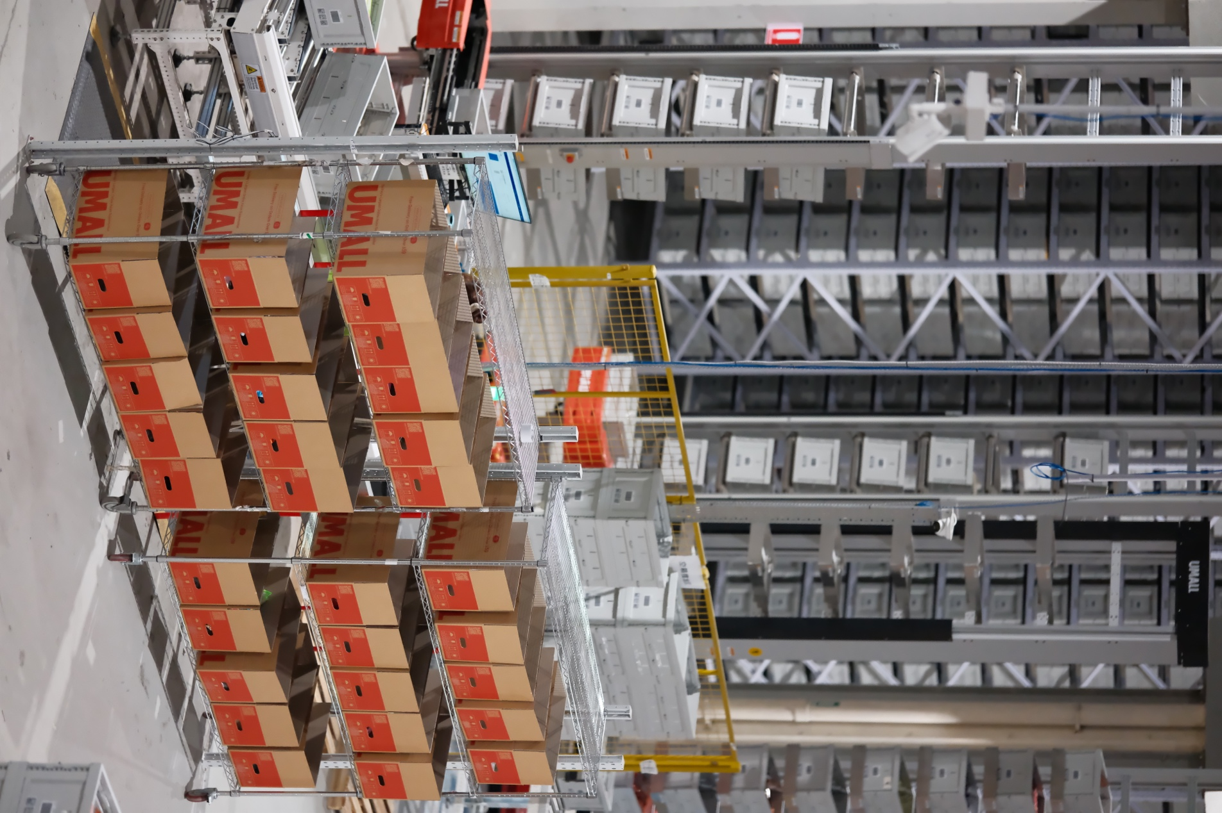

Umall Asian Supermarket: An Innovator in Asian Grocery Solutions
Founded in 2021, Umall Asian Supermarket has quickly become a prominent name in the Australian grocery market. Known for offering a wide range of Asian groceries and delivering exceptional customer service, Umall is now taking a significant leap forward with the integration of advanced robotics into its warehouse operations. This move aligns perfectly with Umall's mission to provide a seamless and efficient shopping experience for its customers.
Stan Chen, Director at Umall, expressed his enthusiasm about the new development: "The introduction of robotics into our warehouse is a pivotal step in our journey towards innovation. This technology will not only enhance our operational efficiency but also elevate the shopping experience for our customers by ensuring faster and more accurate deliveries."
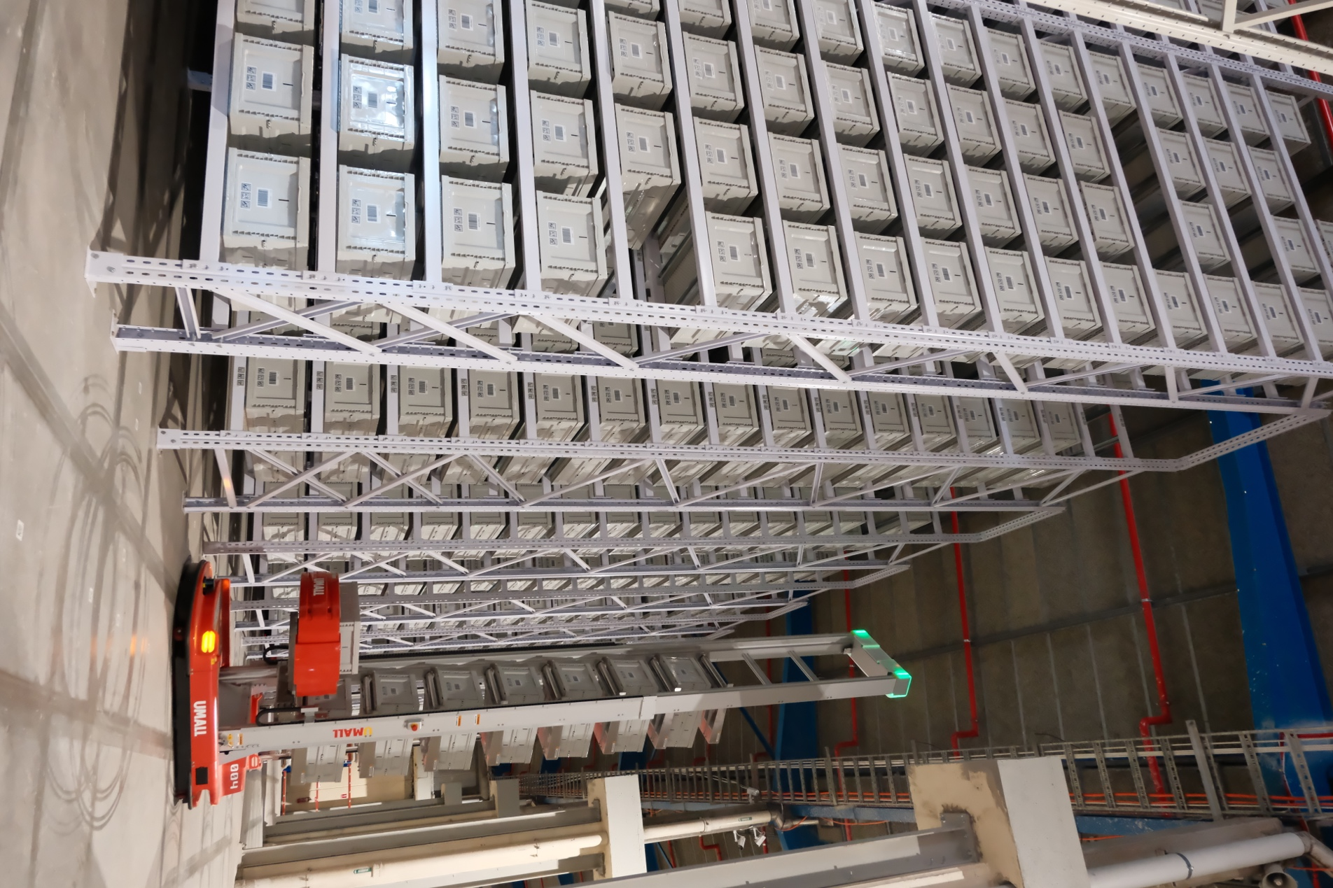

How Robotics is Transforming Umall's Warehouse Operations
The newly implemented robotic system at Umall's warehouse is designed to automate various aspects of order fulfillment, including picking, packing, sorting, and inventory management. By reducing human error and increasing operational speed, these robots ensure that customers receive their orders promptly and accurately.
The robots are equipped with advanced algorithms and machine learning capabilities, allowing them to continuously improve their performance. As Umall's operations expand, the robotic system will become even more efficient, further enhancing the customer experience.
"Adopting this advanced technology sets a new benchmark for the Asian supermarket industry," Chen added. "Our goal is to provide our customers with the best possible shopping experience, and this robotic system is a crucial step towards achieving that."

Customer Benefits: Faster Deliveries and Improved Product Availability
One of the most significant advantages of the new robotic system is its impact on delivery times. With the ability to process orders more quickly and accurately, Umall can offer faster delivery options to its customers. This includes expanding its same-day delivery service to more areas in Sydney, making it even more convenient for customers to access their favorite Asian groceries.
Additionally, the robotic system enhances product availability by optimizing inventory management. This means that customers can expect fewer out-of-stock items and a more extensive selection of products when shopping at Umall.
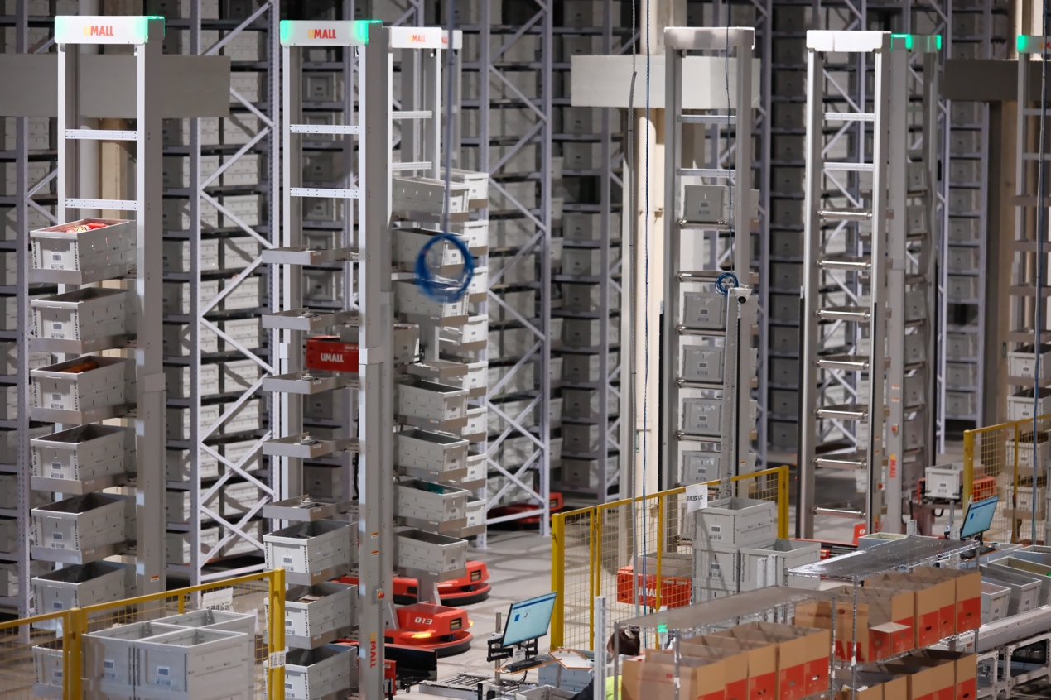

Umall's Commitment to Innovation and Customer Satisfaction
The introduction of robotics is just one of the many ways Umall is striving to innovate and improve its services. The supermarket has already made significant strides in enhancing the customer experience through its user-friendly website, which offers exclusive deals and promotions, as well as a loyalty program that rewards repeat customers.
Looking ahead, Umall has ambitious plans to continue its growth and innovation. Future enhancements include the development of a mobile app, personalized shopping recommendations, and expanded delivery zones. By leveraging advanced data analytics and smart warehousing, Umall aims to provide a superior shopping experience, making it the go-to destination for Asian groceries in Australia.
"We are constantly looking for ways to improve and innovate," said Chen. "Our commitment to our customers is at the heart of everything we do, and we will continue to invest in technologies and strategies that enhance their shopping experience."
For more information, or to start shopping, visit Umall Asian Supermarket. Stay connected with Umall through their social media channels for the latest updates and promotions.

With the integration of its new robotic system, Umall Asian Supermarket is set to revolutionize the Asian grocery shopping experience, making it faster, more efficient, and more convenient for customers across Sydney and beyond.

