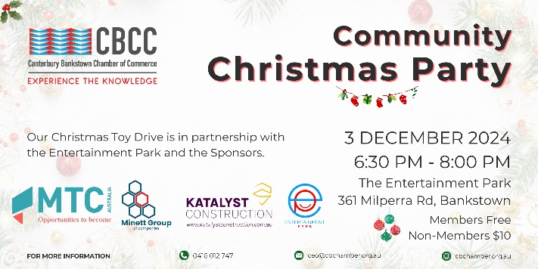
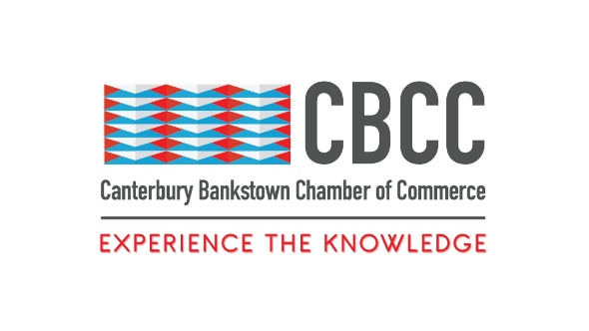
5th September 2024

FOR IMMEDIATE RELEASE

Jingle and Mingle: Wrap Up 2024 at the CBCC’s Christmas Party
Sydney, New South Wales – The Canterbury Bankstown Chamber of Commerce (CBCC) is excited to invite you to the CBCC 2024 Christmas Party, a joyous community celebration that brings together the spirit of the holiday season and the heart of giving.
Held at the Entertainment Park in Milperra, the CBCC’s annual Christmas Party is designed to be a fun and inclusive event for the entire community. Whether you’re young or young at heart, there will be something for everyone to enjoy, from bowling and arcade games to the largest indoor e-karting arena in Sydney. Need a break between games? Light refreshments and soft drinks will give you the energy you need to keep having fun!
Beyond the celebrations, the CBCC Christmas Party is not just about spreading holiday cheer. It’s about coming together as a community one last time before the new year to support those who might not experience Christmas cheer through the CBCC Christmas Toy Drive.
This year, the Toy Drive is dedicated to making a difference in the lives of families and children living with autism or facing homelessness. The holidays can be a particularly difficult time for these families, and the Toy Drive’s goal is to ease some of that burden by providing toys and gifts that can bring a smile to a child’s face. Gifts will be distributed by the following charities: Maronites On Mission, Autism Community Network, and Mission Australia.
If you want to contribute, please bring your gifts to the Entertainment Park from the 10th of November and place them under the Christmas tree. Your gift is sure to bring joy to a child and their family in need, making their holiday season a little brighter.
This event would not have been possible without the generous support of event sponsors, Minett Group (https://minettgroup.com.au/), Katalyst Construction (https://www.katalystconstruction.com.au/), MTC Australia (https://mtcaustralia.com.au/), and Entertainment Park (https://entertainmentpark.com.au/). The CBCC warmly thanks them for helping make this event possible.
Join the CBCC 2024 Christmas Party and be part of an unforgettable event that will make a difference for a child facing homelessness or experiencing autism. Bring your family, bring your friends, and bring a toy to donate to the Christmas Toy Drive. Together, we can spread the joy of the season and ensure that every child in our community has a reason to smile this Christmas. Get your ticket today: https://events.humanitix.com/the-canterbury-bankstown-chamber-of-commerce-2024-christmas-party
Event Details:
- Date: Tuesday 3rd December 2024
- Time: 6:00pm – 8:30pm
- Venue: The Entertainment Park, 361 Milperra Road, Bankstown Aerodrome NSW 2200
- Cost: $10 for nonmembers, free for members and children under 12
About Canterbury Bankstown Chamber of Commerce:
The Canterbury Bankstown Chamber of Commerce is the fastest-growing Chamber in Greater Sydney, counting over 680 members from various industries and cultural and religious backgrounds. Our mission is to support and uplift the local community through connection and collaboration to make Canterbury Bankstown the most ideal place to live, study, work, and do business.
###
Contact Information
Wally Mehanna
CEO of the Canterbury Bankstown Chamber of Commerce
M: 0416 012 747
E: ceo@cbchamber.org.au

