**Sri Lanka: Asia's Hidden Safari Gem**

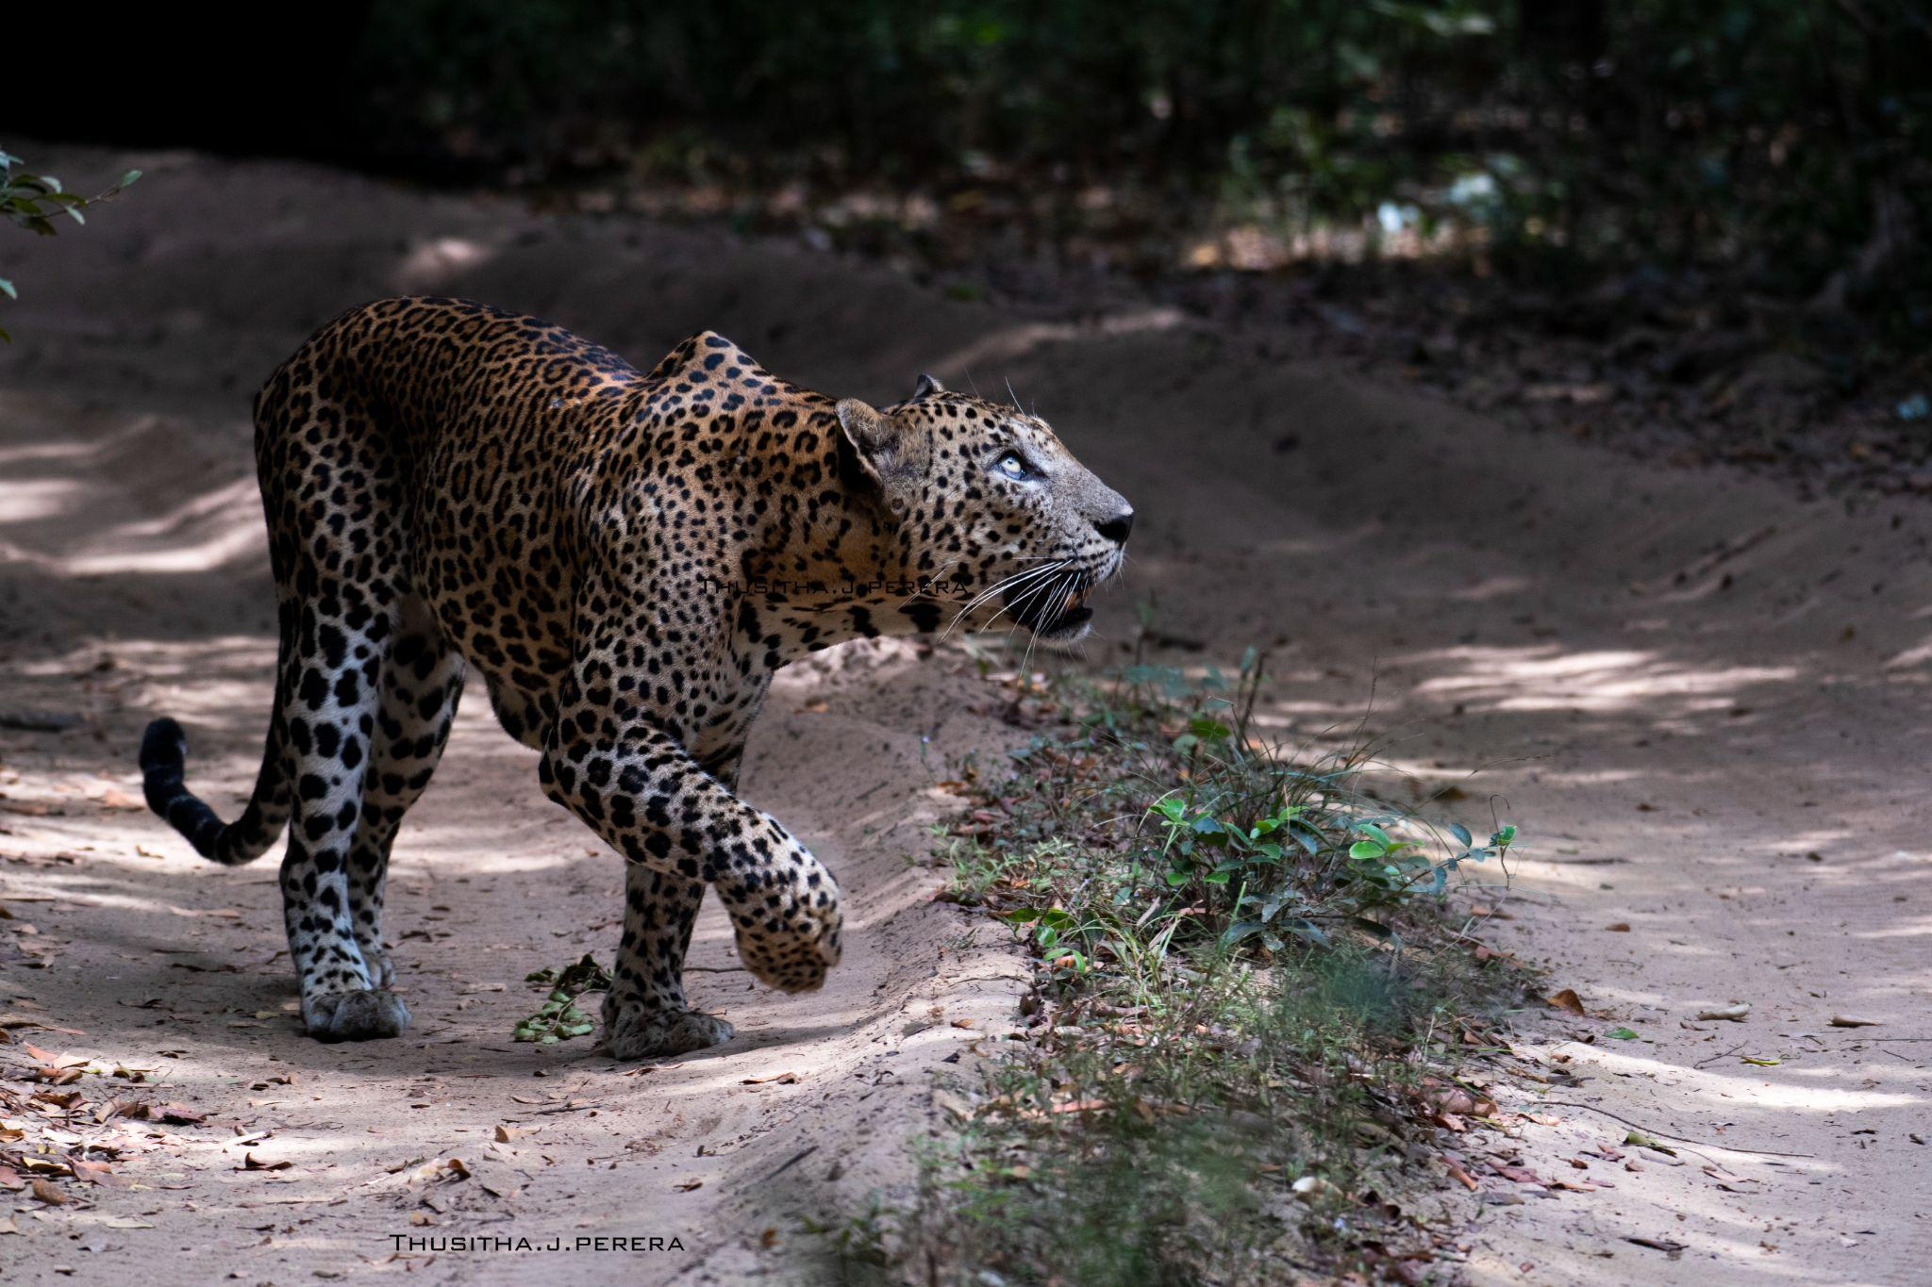

Sri Lanka has long been renowned for its lush landscapes, pristine beaches, and rich cultural heritage. However, one of the island’s best-kept secrets is quickly gaining global attention – its incredible safari experiences. As one of Asia’s top safari destinations, Sri Lanka offers wildlife enthusiasts the chance to explore a unique ecosystem that boasts a rich diversity of flora and fauna, all within the country’s 26 national parks.

From the elusive leopards of Yala NationThusithaal Park to the majestic herds of elephants roaming freely in Udawalawe Or Minneriya, Sri Lanka’s national parks provide a safari experience that rivals even the most famous African counterparts. What makes Sri Lanka stand out is the impressive array of wildlife and the ease and accessibility of safari tours. Sri Lanka’s safaris perfectly balance exploration and comfort for travellers seeking an unforgettable wildlife adventure.

**A Wildlife Wonderland**

Sri Lanka’s wildlife parks are teeming with animals and bird species that will leave any nature lover in awe. Visitors can spot sloth bears, sambar deer, wild water buffalo, peacocks, and saltwater crocodiles – all in their natural habitats. Yala National Park, the country’s most visited and best-known park, is famous for having one of the highest leopard densities in the world. Meanwhile, Udawalawe National Park guarantees sightings of large elephant herds, a highlight for many tourists.

However, more than the wildlife that makes Sri Lanka a standout safari destination. The island’s varying terrains, from dense jungles and grasslands to coastal regions, provide visitors with a truly immersive experience of Sri Lanka's natural beauty. Each park offers a unique backdrop, whether the rolling dunes of Yala or the lush wetlands of Wilpattu.

**Accessible and Adventure-Ready**

One of Sri Lanka’s key advantages as a safari destination is its accessibility. Unlike some African countries where reaching safari parks can be logistically challenging, Sri Lanka’s parks are well-connected by road, making it easy for visitors to arrange day trips or overnight stays with minimal hassle. Jeep safaris are readily available at most parks, with experienced local drivers and guides ready to provide an authentic wildlife experience.

Thusitha Perera, a wildlife photographer and tour manager at Tripstar Lanka, a leading travel agency in Sri Lanka, highlights the unique appeal of Sri Lankan safaris:  
***"What makes Sri Lanka special is the diversity of wildlife and landscapes packed into such a small island. You can go from observing leopards in Yala to witnessing elephants in Udawalawe, all within a few hours' drive. The ease of access means anyone, from seasoned photographers to first-time safari-goers, can enjoy a world-class wildlife experience without the long travel times often required in other parts of the world."***

As more travellers discover the wonders of Sri Lankan safaris, the island is set to solidify its status as Asia’s hidden gem for wildlife exploration. Whether you’re an adventure seeker, a nature lover, or a luxury traveller, Sri Lanka’s national parks offer an unforgettable experience that captures the island's wild beauty.

For more information, please contact

Thusitha Perera

Inbound Tour Manager,

Tripstar Lanka Travel & Tours

No 2, Church Road, Ratnapura, Sri Lanka.

Phone:AU +61 424622151

SL +94 777 679 440

Email: tours@tripstarsrilankatours.com

Website : [www.tripstarsrilankatours.com](http://www.tripstarsrilankatours.com)

<https://tripstarsrilankatours.com/wp-content/uploads/2024/07/Yala-Safari-Sri-Lanka-800x600-2.jpg>

<https://tripstarsrilankatours.com/wp-content/uploads/2024/09/Thusutha-Perera.jpg>

<https://tripstarsrilankatours.com/wp-content/uploads/2024/07/minneriya-jeep-safari-Sri-Lanka-2-800x600-1.jpg>