**Hydrate and Glow: The Secret to Radiant Skin at Any Age**

*Melbourne, Australia  
3rd October 2024  
  
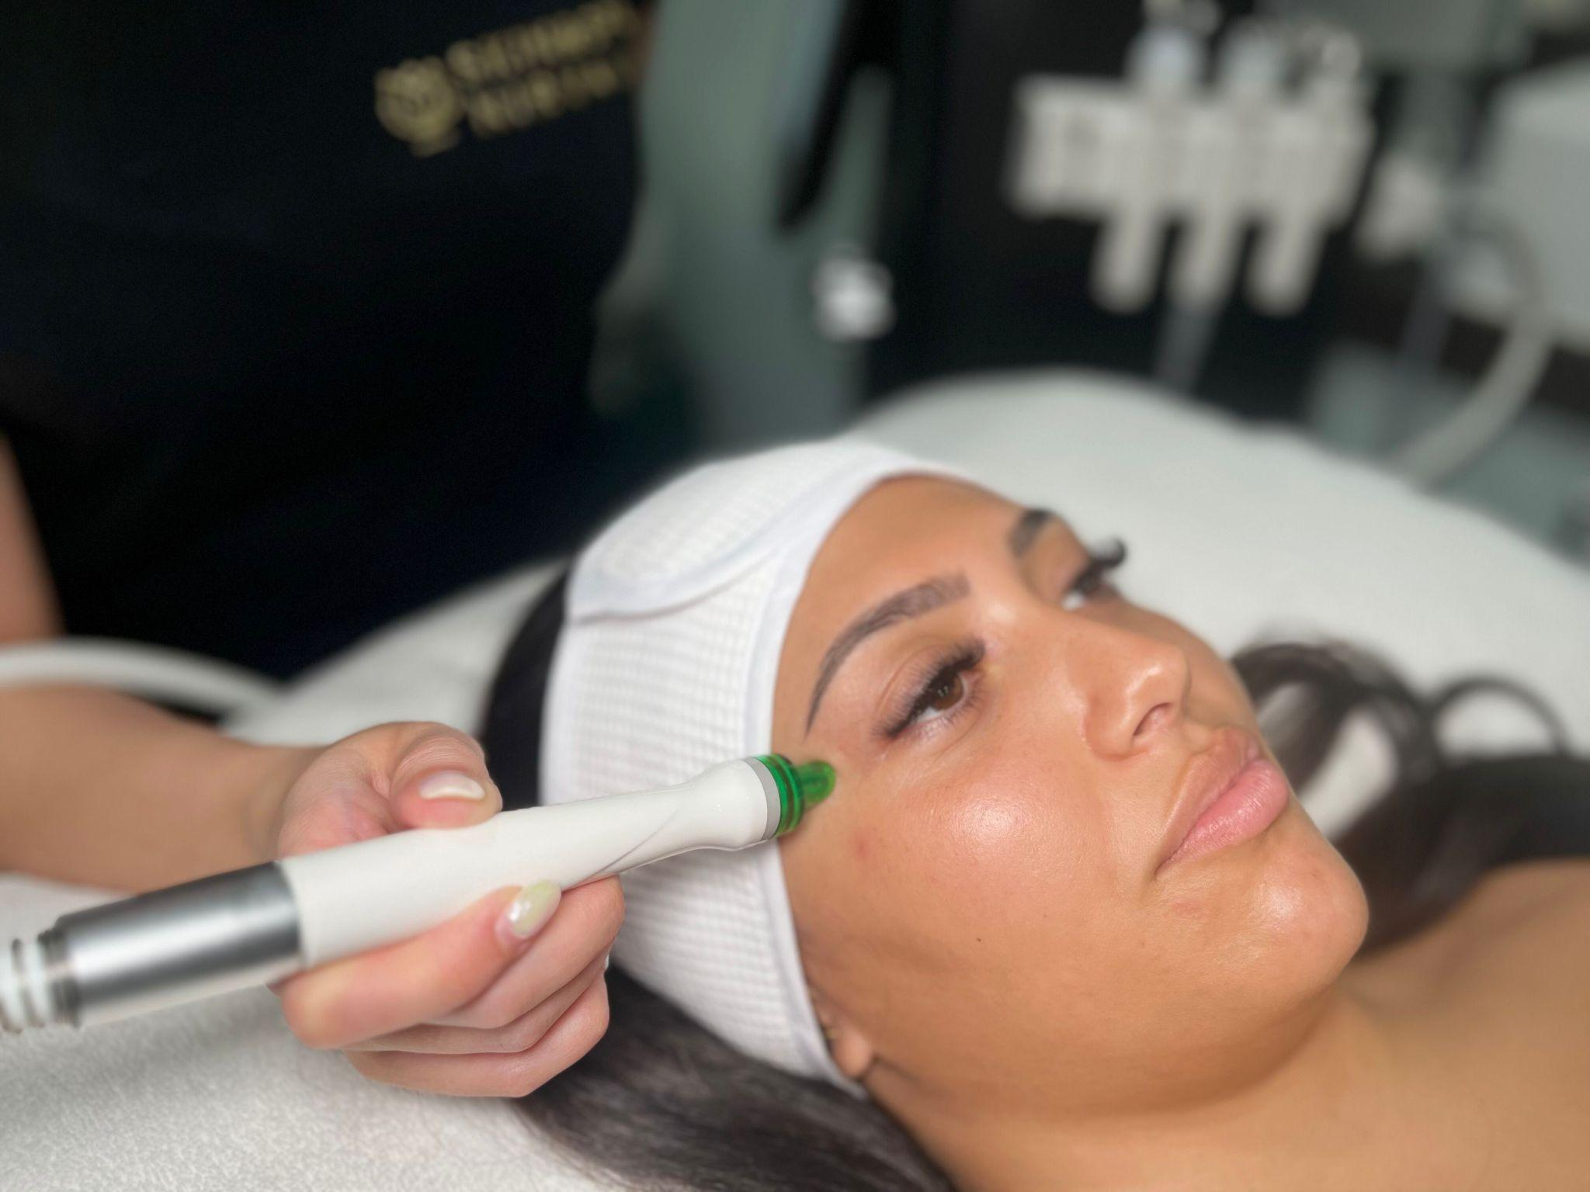*

In skincare, achieving a radiant complexion isn’t bound by age. The Hydrafacial Hydrate and Glow treatment is a suitable option for both young professionals and mature women to revitalise and maintain healthy, glowing skin.

Hydrafacial Hydrate and Glow combines deep cleansing, exfoliation, and intense hydration to revitalise the skin and ensure long-lasting radiance. This advanced treatment removes impurities and dead skin cells while infusing the skin with hydrating serums and antioxidants, providing a noticeable glow immediately after the treatment.   
  
It is a perfect remedy for dullness, fine lines, dehydration, and congested pores, making it a must-have for those looking to enhance their skin's health and appearance.  
  
Unlike traditional facials, the Hydrafacial is both gentle and highly effective, catering to all skin types and concerns. With its nourishing and protective qualities, it’s a go-to treatment for anyone—from those aiming to prevent early signs of aging to those addressing mature skin challenges. No matter your age, the outcome is always a refreshed, revitalised, and radiant complexion.

Mal, a registered cosmetic nurse and founder of Melbourne’s Skin & Spa Nirvana shares her expertise on the Hydrafacial Hydrate and Glow treatment:  
  
“The Hydrafacial is perfect for anyone wanting a healthy, hydrated glow. It’s suitable for all skin types and ages, delivering a gentle but powerful boost to hydration and radiance. The feedback from our clients is consistently positive—they love the instant results and leave each session with smooth, glowing skin."

Contact Skin & Spa Nirvana for more information on the Hydrafacial Hydrate and Glow treatment and to book a consultation.

**Contact Details:**

**Name:** Mal  
**Mobile:** 0422125569  
**Email:** info@skinandspanirvana.com.au  
**Website:**<https://skinandspanirvana.com.au/>

**Address:**Skin & Spa Nirvana  
45 McNamara Ave,  
Airport West VIC 3042  
P: (03) 9330 2955

**About Skin & Spa Nirvana**Skin & Spa Nirvana is a leading Skin & Laser Clinic in Melbourne, offering a range of personalised skin treatments, cosmetic aesthetics, laser hair removal, and other services designed to promote skin health and overall well-being.