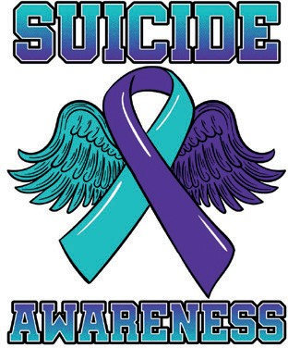

**This International Men’s Day, November 19th, 2024, will see the largest visual presentation of male suicide in the world on the lawn in front of Parliament House, Canberra from 7 am to 3 pm.**

Media Release 12/11/2024

2500 empty shoes visual presentation of male suicide in Australia.

This International Men’s Day, November 19th, 2024, will see the 3rd annual visual presentation of male suicide in Australia on the lawn in front of Parliament House, Canberra from 7 am to 3 pm.

This is the largest visual presentation of male suicide in the world.

The purpose of this moving presentation is to raise awareness of the scale of the issue and how current approaches are failing to stem the epidemic by focusing primarily on mental health instead of addressing the major push-factors that drive situational distress in men and boys.

To achieve this crucial shift of focus a dedicated Minister for Men’s Health & Welfare should be promptly instated to guide and facilitate the change in focus and approach that is so desperately needed to help turn the tide.

For this reason, we’re asking all Australians to join us on the day if possible, or to help in any other way you can to help raise awareness and spread the message through our communities and join the call for a Minister for Men’s Health & Welfare.

This community awareness event is coordinated by grass roots lived experience survivor’s and families of the fallen.

For the last 2 years we have put this event on to raise awareness for the leading cause of preventable deaths in adult males. In 2023 we went to the effort to put this presentation on 2 times in one week.

This year will be the 4th presentation.

While many have thankfully expressed their support, so far our plea has mostly been falling on deaf ears. Mainstream media have proven reluctant to cover the event so far and it seems the event and its message are also being suppressed in social media to some extent.

To this end, we humbly ask our fellow Australians to join us in sharing the event on their social media platforms to help overcome the apparent algorithmic black hole. When posting, please include the hashtag #2500toomany.

Men are told “it ain’t weak to speak”. They’re told “men don’t reach out”. They’re told all sorts of things but what men in situational distress really need is not to be talked at but simply have their concerns listened to and their welfare considered.

This epidemic is taking one male every 3 hours on average. 19,800 ambulance attendances in 2023. [ 2 ambulances per hour on average].

2500 Men and boys lay their souls on the lawn every year, they are speaking, they are reaching out. Mostly men going through “situational distress”. We need to open this dialogue and start saving our men and boys.

NOBODY IS LISTENING. Please help us.

Please help the men and boys in your life…

10 am opening ceremony,

12 pm ribbon tying remembrance.

Talks

3pm pack up.

Please help us.

For Interviews with Paul Withall: 0457 100 010

Video: <https://www.youtube.com/watch?v=-tz34G0dv5c>

Facebook: <https://www.facebook.com/profile.php?id=100066793477202>