# Google Site Reputation Penalty Hits Major News Publications: CNN, USA Today, Forbes Advisor, and More

On 19th November, Google updated its site reputation penalty, introducing stricter enforcement measures and expanded criteria for identifying abusive content. This update builds upon the initial enforcement that began on 5th May 2024, adding new mechanisms to better detect and penalise manipulative practices involving third-party content. For more details, you can refer to the [official update here](https://developers.google.com/search/blog/2024/11/site-reputation-abuse)

Google has begun enforcing its new site reputation abuse policy, resulting in significant delistings of subsections from well-known websites such as CNN, USA Today, LA Times, and Forbes Advisor (previously available as Forbes Advisor AU in Australia). This enforcement is part of Google's ongoing effort to combat 'site reputation abuse'—a tactic where unrelated or low-quality third-party content is hosted on trusted domains to unfairly boost search rankings.

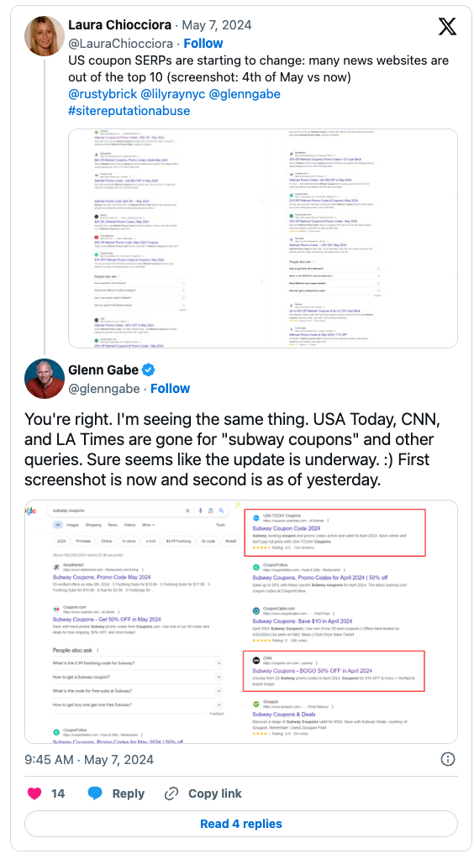

The move aims to curb "parasite SEO," which, according to Tharindu Gunawardana, SEO Consultant based in Melbourne, Australia, is a tactic where content is hosted on reputable domains to unfairly leverage their ranking power. Such third-party content, often irrelevant to the primary domain, is hosted purely to manipulate search rankings.

[Danny Sullivan](https://x.com/searchliaison/status/1787654709802643910) from Google stated, "*We’re currently only taking manual actions. The algorithmic component will come later, as we’ve mentioned, but it’s not live yet."*

This suggests that many Australian publishers may not have received the penalty yet, unless they were impacted by the initial enforcement on 5th May.

Under the new policy, Google defines site reputation abuse as "third-party content produced primarily for ranking purposes and without close oversight of a website owner." This type of content is considered spam and will face penalties, including delisting or manual action against the site.

We can see that the news.com.au/coupons section dropped its visibility after 5th May.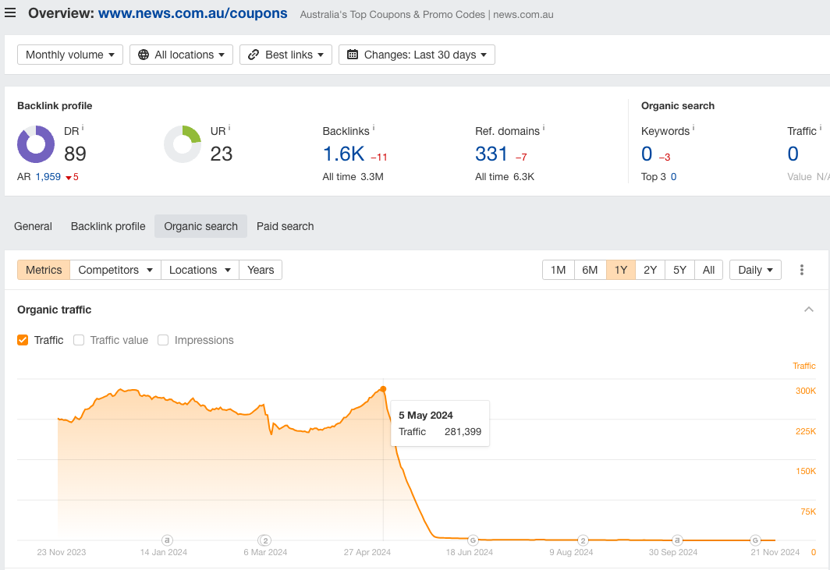

Many major publishers that host coupon sections were affected, along with review sites like Forbes Advisor, which rely heavily on affiliate income.

**Not All Third-Party Content Is Spam**

Importantly, Google has clarified that not all third-party content will fall under the scope of spam. Native advertising and advertorials, when used properly and intended for the publication's regular readers, are not considered manipulative or deceptive. These types of advertising formats are often transparent and integrated into the publisher's editorial strategy, providing genuine value to readers.

## Implications for Australian Publishers

*“Google's new site reputation penalty is impacting major publications, making it essential for Australian publishers to reassess their content strategy and revenue streams. Unrelated affiliate content, like coupon sections or third-party reviews, has become a liability that could hurt long-term search performance. It is important to note that not all third-party content is considered spam. Google's clarification provides opportunities for compliant third-party content, such as native advertising or advertorials that can still provide value to regular readers."*

— Tharindu Gunawardana, SEO Consultant, Founder of [SearchMinistry](https://searchministry.au/).

This change may lead to a shift in partnership strategies as Australian publishers reconsider the value of third-party content partnerships that could risk Google's penalties.

This policy shift does not mean SEO is dead. Australian publishers should also consider investing in future technologies such as AI-driven content personalisation and Large Language Model (LLM) marketing to stay ahead in the digital marketing landscape.

For more information, please contact

**Tharindu Gunawardana**

SEO Consultant and Founder, SearchMinistry Media

P:0452457068

E: growth@searchministry.au

<https://searchministry.au/>   
  
Resources   
Tweet Links - [https://x.com/glenngabe/status/178762970067360201](https://x.com/glenngabe/status/1787629700673602013)

<https://x.com/searchliaison/status/1787654709802643910>

[Google update link](https://developers.google.com/search/blog/2024/11/site-reputation-abuse)