**The $50K Problem: Why a Quarter of Australian Small Businesses Can’t Break Through 50K Revenue Barrier**

Australia’s small businesses form the backbone of the economy, accounting for 97.2% of all enterprises, according to the [Australian Bureau of Statistics (ABS)](https://www.asbfeo.gov.au/small-business-data-portal/number-small-businesses-australia). However, despite their vast presence, many face significant challenges in achieving growth. 24.7% report an annual turnover below $50,000, underscoring a critical challenge: the $50k problem.

So, why do so many small businesses fail to break this revenue barrier? And what can be done to help them thrive?

### **Understanding the $50k Problem**

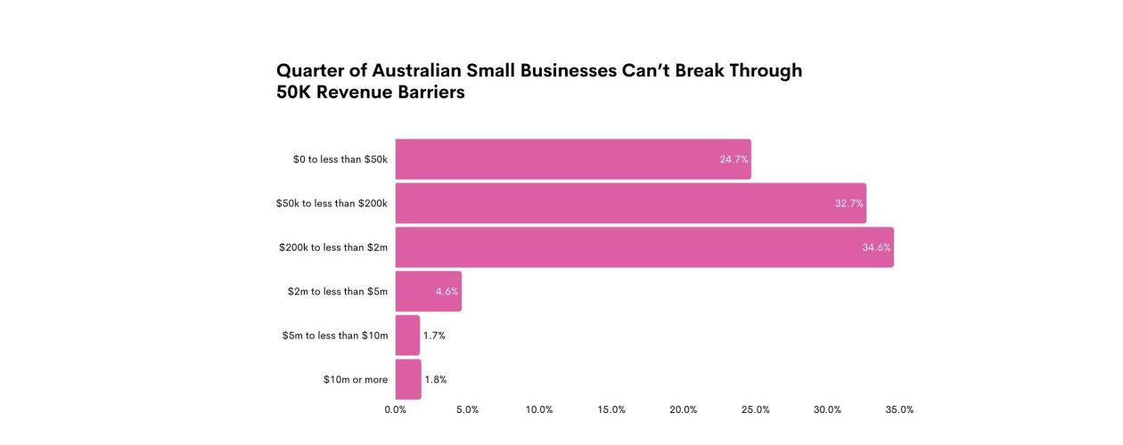

The $50k revenue ceiling affects nearly one in four small businesses in Australia, particularly self-employed or non-employing entities. With 62.5% of small businesses being self-employed, they often lack the resources—such as access to capital, marketing expertise, or infrastructure like efficient supply chains—needed to scale effectively. Rising costs, limited access to technology, and the absence of streamlined processes create barriers that prevent these businesses from reaching their potential.

Additionally:

* **Limited Workforce**: Only 8.7% of small businesses employ 5-19 people, highlighting the struggle to expand.
* **Declining Growth**: A 1.4% decline in businesses employing 1-4 people in 2023-24 indicates the increasing difficulty of even modest expansion.

### **Australia’s Limited Digital Support for Businesses**

Australia has implemented some initiatives, but they need to catch up compared to Singapore's Productivity Solutions Grant (PSG), which offers direct financial grants, a wide range of pre-approved digital tools, and high funding support to help SMEs adopt technology effectively. One such program is the **Australian Small Business Advisory Services (ASBAS)**, which offers low-cost advisory services for digital operations, website development, social media, and data privacy. However, ASBAS needs more financial grants or subsidies for a larger-scale digital transformation.

**The Gap in Support:**

* **No Direct Grants for Digital Tools**: Unlike Singapore, Australia needs more funding to cover digital implementation costs.
* **Limited Digital Marketing Focus**: There needs to be targeted assistance for small businesses needing to boost digital marketing.
* **Minimal Ongoing Support**: ASBAS provides guidance but not the financial backing essential for growth.

### **Learning From New Zealand: Digital Boost Program**

New Zealand's **Digital Boost Program** provides another inspiring example of supporting small businesses in their digital journey. The program offers free training courses, webinars, and digital tools designed to help SMEs build their online presence and improve productivity. This initiative focuses on enabling business owners with practical skills to utilise digital technologies effectively.

**How Digital Boost Supports SMEs:**

* **Free Digital Training**: Accessible courses and webinars help SMEs learn about digital marketing, website development, and using cloud-based solutions.
* **Tailored Digital Solutions**: SMEs are guided through selecting and implementing the most suitable digital tools for their business needs.
* **Community Support**: The program fosters a community where businesses can share insights and experiences, contributing to collective growth.

New Zealand’s approach highlights the importance of ongoing education, practical guidance, and community support in driving digital transformation for SMEs.

### **Learning From Singapore: The Productivity Solutions Grant (PSG)**

Singapore’s **Productivity Solutions Grant (PSG)** is a transformative initiative that provides up to 50% funding support for SMEs that are adopting digital solutions. For instance, a local retail business in Singapore used PSG funding to implement an e-commerce platform, which resulted in a 30% increase in sales within the first year. This grant has dramatically reduced financial barriers, helping businesses leverage tools like CRM systems, digital marketing, and e-commerce platforms.

**How PSG Empowers SMEs:**

* **Wide Range of Solutions**: SMEs can access tools for SEO, social media marketing, and more.
* **High Funding Support**: By covering up to 50% of qualifying costs, PSG makes digital transformation accessible.
* **First-Time Digital Adoption**: PSG encourages SMEs to build an online presence and boost operational efficiency.

This model shows how subsidies can directly address revenue challenges, helping small businesses scale.

### **How Digital Marketing and Technology Can Bridge the Gap**

*"For small businesses to achieve sustainable growth, investing in new technologies, optimising processes, and adopting digital marketing are crucial steps. If governments offered support comparable to Singapore's initiatives, such as direct grants and funding for digital adoption, we could see substantial improvements in the growth and competitiveness of small enterprises."*

— Tharindu Gunawardana, Founder at Searchministry Media

Despite limited government support, digital marketing and technology remain powerful tools for small businesses to overcome the $50k barrier. For example, a small café in Sydney used social media marketing to promote its new menu, significantly increasing customer visits and ultimately surpassing the $50k revenue mark. Here’s how:

* **Cost-Effective Marketing**: Platforms like Google Ads and Facebook Ads allow small businesses to reach their target audiences efficiently and affordably.
* **E-commerce Growth**: Shopify and WooCommerce enable businesses to sell online and access larger markets with minimal investment.
* **AI-Powered Efficiency**: AI tools can automate repetitive tasks, personalise customer interactions, and generate valuable data insights.
* **Streamlined Processes**: CRM systems and marketing automation platforms can improve operational efficiency, opening doors for growth.

### **The Role of Policymakers: Closing the Gap**

Australia must enhance its support for small businesses to thrive in a digital-first economy. Drawing from Singapore’s PSG, policymakers should consider:

* **Introducing Digital Transformation Grants**: Subsidizing digital tools like CRM systems and digital marketing platforms would encourage innovation and adoption.
* **Expanding ASBAS With Financial Support**: Coupling advisory services with grants would make digital transformation more accessible.
* **Nationwide Digital Marketing Education**: Government-sponsored workshops and courses could empower business owners to implement effective strategies.
* **Incentives for Technology Adoption**: Tax breaks or rebates for technology investment could ease the financial burden of digitalisation.

For more information, please contact

Tharindu Gunawardana

SEO Consultant and Founder, SearchMinistry Media

P:0452457068

E: growth@searchministry.au

<https://searchministry.au/>

Resources

<https://www.asbfeo.gov.au/small-business-data-portal/number-small-businesses-australia>   
  
Images:

<https://searchministry.au/wp-content/uploads/2024/11/50K-Problem-Banner-1-1260x500.jpg>

<https://searchministry.au/the-50k-problem-why-a-quarter-of-australian-small-businesses-cant-break-through-revenue-barriers/>