Perth’s Ghost Wetlands Come Alive: One Backyard at a Time

Perth, Western Australia
More than 80% of Perth’s once-thriving wetlands have vanished. Over half a million acres have been drained, filled in, and built upon to make way for urban development. Today, only 10% of the city’s original wetland area remains, and that fraction continues to shrink due to fragmentation, pollution, and degradation.

This drastic transformation has had profound ecological consequences not just for Perth but for the country at large. Australia is a world leader in habitat clearing, logging, and species extinctions and currently holds the worst record for fauna extinction on the planet. Over 100 species are now listed as threatened or endangered, including:

- 23% of mammals
- 9% of birds
- 5% of higher plants
- 7% of reptiles
- 16% of frogs
- 9% of freshwater fish

But while the past paints a sobering picture, restoration efforts offer a hopeful path forward in the city's heart.

Resurrecting Wetlands in Urban Perth

Using a combination of historical mapping, environmental science, and local collaboration, efforts are underway to identify and recreate Perth’s “ghost wetlands” forgotten ecological zones that still carry the potential for revival.

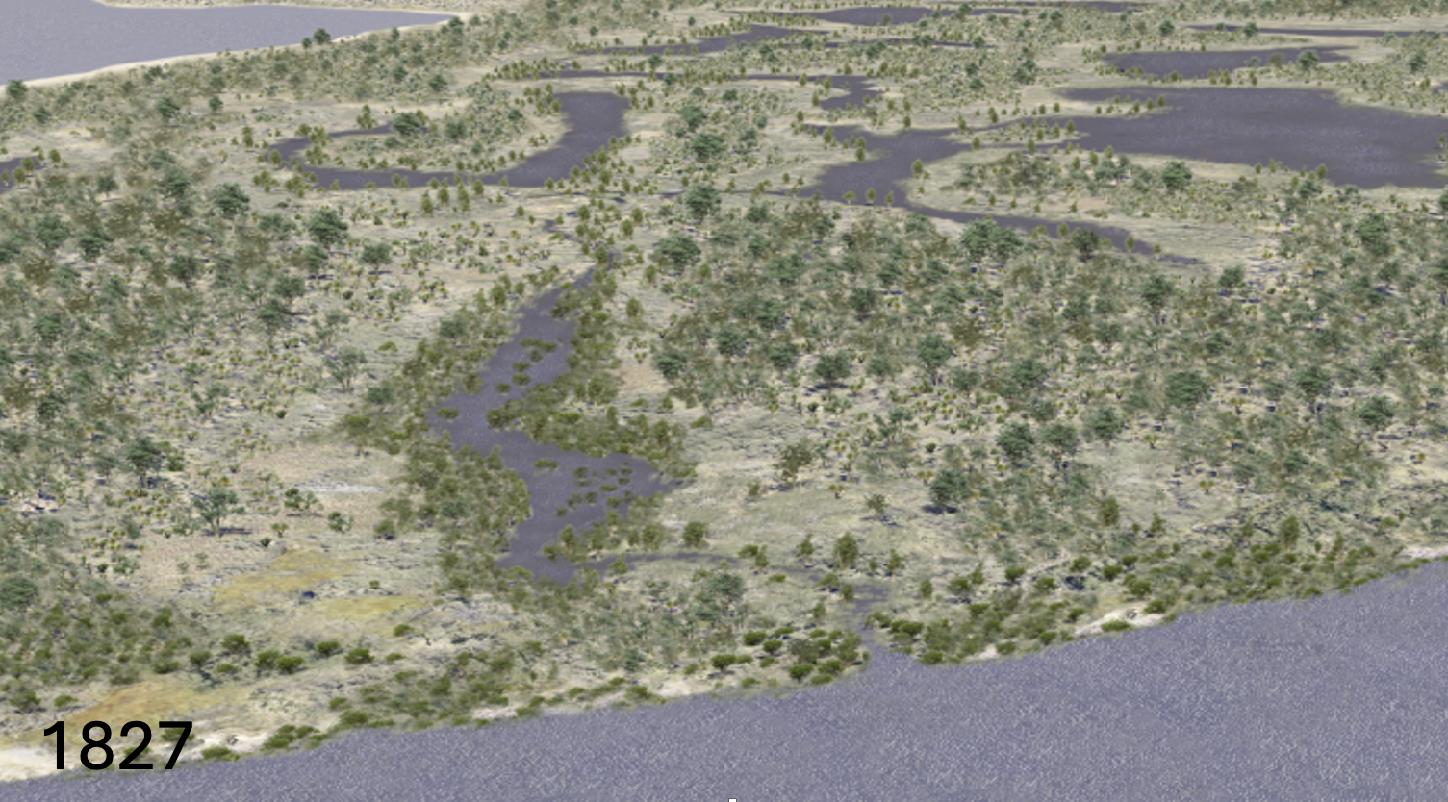

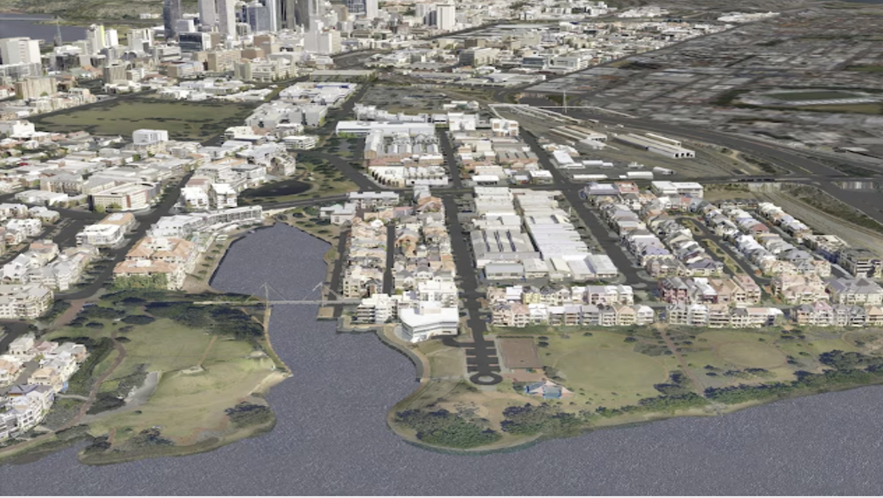

“We’re helping people understand what this landscape once looked like, and how parts of it can be brought back not through large-scale construction, but through smart, ecological design,” says Dulana, Founder of Pases Aqua, a Perth-based ecological water systems company.

These projects include:

Transforming backyard pools into natural wetland pools that attract birds, frogs, and insects.

Rehabilitating old farm dams and urban drainage basins into functioning ecosystems.

Introducing native wetland plants that naturally filter water, sequester carbon, and restore soil health.

Collaborating with schools to build educational wetlands that teach students about ecology and biodiversity.

Why It Matters
Wetlands are not just scenic features — they are ecological powerhouses. They:

- Provide critical habitat for wildlife
- Improve water quality by filtering runoff and pollutants
- Act as carbon sinks to help combat climate change
- Mitigate flooding by absorbing excess stormwater
- Cool urban areas and reduce the heat island effect

“Even in a suburban backyard, we can restore ecological function,” Dulana explains. “These are not symbolic gestures. They’re real systems that support life, clean our water, and reconnect us to nature right where we live.”

Contact Information

For more information about transforming dams into billabongs with the expertise of PASES Aqua, please contact:

Dr. Dulana Herath
PASES Aqua
Email: admin@pases.com.au
Phone: +61 407 372 156
Website:https://www.pasesaqua.com.au/natural-swimming-pools-dams/natural-swimming-dams/

