Media Release

GREAT DIVIDE MINING POWERS AHEAD

AT CHALLENGER SITE

Great Divide Mining has marked an operational milestone as it enters its’ third consecutive week of operating the processing circuit at the Challenger Mine, located in Adelong, NSW. The company is focused on a mine-site clean-up campaign, targeting the tailings and legacy ore heaps at surface.

“This continuation of processing operations confirms and tests our maintenance and repair work carried out at the site over previous months,” said Justin Haines CEO.

“The reactivated Challenger plant has now proven operational stability, with consistent throughput and strong early gold recovery,” he said. “Your readers can check out the action with a series of short videos we’ve put up on the GDM website at greatdividemining.com.au ”

“Some of the GDM upgrades are still being installed,” he went on, “ especially upgrades to Challenger’s electrical systems.

“Reprocessing material at surface, allows us to test the re-commissioned plant and equipment under load, while simultaneously unlocking value from the site by recovering gold that’s already been mined.”

“It’s also an environmentally responsible approach to resource management. It’s simple, it’s smart, we pay a few bills along the way, and, we end up with a tidy and safe work environment,” said Haines.

“Still,” smiles Haines, “I can’t wait for that first Gold pour.”

ENDS

## For further information:

Justin Haines, CEO

e [justin.haines@greatdividemining.com.au](mailto:justin.haines@greatdividemining.com.au)

m +61 (0)418 876 420

## Great Divide Mining Ltd (ASX: GDM)

Great Divide Mining is an Australian Gold, Antimony and critical metals miner, explorer and developer with five projects across 17 tenements (including two in application). GDM’s focus is on operating producing assets within areas of historical mining and past exploration with nearby infrastructure, thus enabling rapid development. Through a staged exploration and development programme, GDM intends to generate cash flow from its initial projects to support further exploration across its portfolio of highly prospective tenements.

<https://greatdividemining.com.au/>

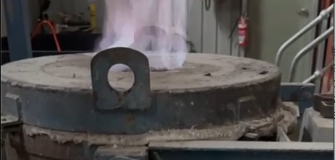

Challenger Furnace ready for first Gold pour.