Media Release

GREAT DIVIDE UPGRADES CHALLENGER MINE – HITS 90-DAY MILESTONE

Great Divide Mining (ASX:GDM) reports operations at the Challenger Mine in Adelong continue to progress, as the company marks three months into its expected 12-month recommissioning program for the site including the crushing and milling circuits and processing plant

“Taking a cautious and methodical approach, the team has successfully recommissioned the milling circuit after implementing critical upgrades to the plant’s control systems, delivering improved automation, stability, and operational safety. The new mill drive finally gives us the reliability we need from the mill” said GDM’s CEO Justin Haines.

“The crusher’s electrical system has also been upgraded to meet current safety standards,” he said.

“These upgrades are important for the long-term use of the crushing and milling circuits, and confirm GDM’s commitment to the Challenger Mine, and to our philosophy of ‘do it once, do it properly’”.

“Early-phase processing trials have proven very encouraging. While throughput remains intentionally moderate, plant personnel have been able to fine-tune key parameters, build operational familiarity, and validate equipment performance under live conditions,” said Haines.

“We’re pushing forward prudently,” said Haines. “Our strategy is to become completely comfortable with each component of the operation before ramping up throughput.”

“This is not a race - it’s about getting it right,” he said, “it’s the crawl, walk, run approach.”

As the site enters the next quarter of the recommissioning schedule, Challenger Mine remains focused on safe, incremental advancement, with throughput to be scaled in line with operational confidence and plant readiness.

“We’re proving, at an early stage, production continuity. Check out our growing concentrate stockpile,” he smiles.

“Still, I can’t wait for that first pour !”

ENDS

## For further information:

Justin Haines, CEO

e [justin.haines@greatdividemining.com.au](mailto:justin.haines@greatdividemining.com.au)

m +61 (0)418 876 420

## Great Divide Mining Ltd (ASX: GDM)

Great Divide Mining is an Australian Gold, Antimony and critical metals miner, explorer and developer with five projects across 17 tenements (including two in application). GDM’s focus is on operating producing assets within areas of historical mining and past exploration with nearby infrastructure, thus enabling rapid development. Through a staged exploration and development programme, GDM intends to generate cash flow from its initial projects to support further exploration across its portfolio of highly prospective tenements.

<https://greatdividemining.com.au/>

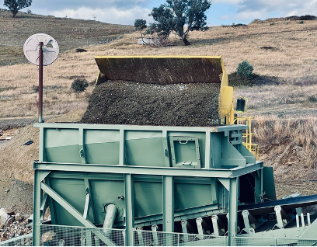

Production at Challenger Mine, Adelong NSW