Media Release

Great Divide Mining applauds Bougainville Mineral Investments.
Great Divide Mining (ASX:GDM) has applauded Bougainville Mineral Investment’s Ltd (BMI) bold move to build its’ Bougainville headquarters within the community in which it will operate, in Iokomori Village, within the Taonita Teop Constituency.
“This milestone makes BMI the only mining exploration company in the region to base its headquarters directly within the very community it serves,” said Paul Ryan, Chairman, “It’s a decision that not only brings operations closer to the field, but demonstrates a powerful message of trust, inclusion, and responsibility.”
“BMI is putting down roots in the local community,” said Ryan, “not just as a visitor or investor, but as a genuine long-term partner. The immediacy and intimacy of this approach fosters greater communication, transparency, and shared decision-making between local landowners and the company”.
Great Divide Mining’s CEO, Justin Haines commended BMI for this forward-thinking and people-centred initiative.

“This model of place-based governance and operational presence reflects a new standard in how mining companies can and should engage with traditional landholders -through respect, proximity, and care,” said Haines.
“As environmental stewards and development partners, we believe this move underscores a deeper commitment to sustainability and to the cultural and ecological integrity of the Taonita Teop region,” he said.

“BMI’s decision sets a precedent for how mining operations can be integrated respectfully and responsibly into the social fabric of local communities,” he went on.
“Great Divide Mining wishes Bougainville Mineral Investments continued success as they bring this vision to life,” said Haines.

ENDS

For further information:

Justin Haines, CEO
e justin.haines@greatdividemining.com.au
m +61 (0)418 876 420

Great Divide Mining Ltd (ASX: GDM)
Great Divide Mining is an Australian Gold, Antimony and critical metals miner, explorer and developer with five projects across 17 tenements (including two in application). GDM’s focus is on operating producing assets within areas of historical mining and past exploration with nearby infrastructure, thus enabling rapid development. Through a staged exploration and development programme, GDM intends to generate cash flow from its initial projects to support further exploration across its portfolio of highly prospective tenements. GDM serves as project manager to BMI.
https://greatdividemining.com.au/

Bougainville Mineral Investments Ltd (BMI)
BMI is partnering with the emerging nation of Bougainville to assist in founding a responsible resources sector, with significant landholder ownership. 6 projects are staged for delivery, 5 display significant gold and copper prospectivity, with at surface resource mineralisation and high-grade target evident. First mining tenement has been granted at Teop, with 1 granted exploration licence and a further 2 exploration licences in application. Located on the Pacific Ring of Fire, 9,980 km of Helimag surveys have identified 64 targets of interest.
https://bougainvillemi.com.au/

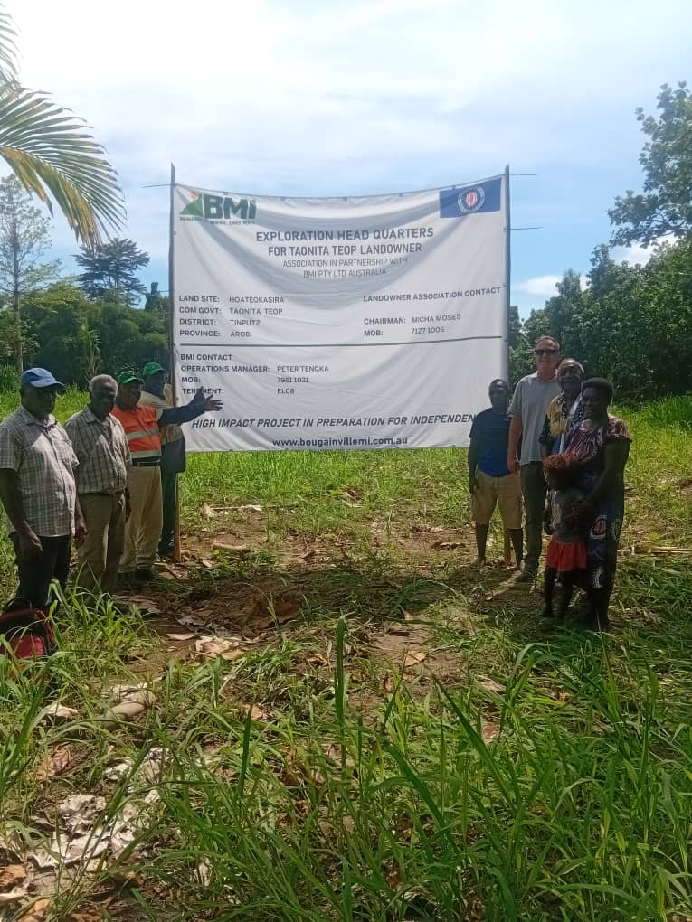
BMI’s new headquarters to be built in Yokomori Village, within the Taonita Teop Constituency.

