Media Release

GREAT DIVIDE PARTNERS WITH DART AT COONAMBULA

Great Divide Mining Ltd (ASX:GDM) announced today that it had completed the definitive agreement with Dart Mining NL (ASX:DTM) to farm-out GDM’s Coonambula Project, including the historic Banshee Antimony Mine.

DTM will pay $250,000 to GDM and in return receive a 15% holding in GDM’s 6 exploration tenements. DTM has been appointed Project Manager of the Coonambula Joint Venture and is required, within 2 years, to complete 4,000m of exploratory drilling and prepare 2 geological and resource reports, which when completed will see its’ holding increased to 51%.

“This farm-out provides GDM with a non-dilutive capital injection of $250,000,” said GDM’s CEO Justin Haines, “in addition to the CEI grant monies of over $180,000 recently awarded to GDM”

“Further, GDM gains an experienced, able and willing commercial partner to drive advanced exploration at our high potential Coonambula project,” he went on.

“It allows GDM to advance multiple projects, while remaining focused on accelerating project development, operations and revenue commencement,” said Haines.

“GDM is sticking to the plan we presented to shareholders when we listed less than 2-years ago,” said Haines, “we continue to explore areas of high prospectivity and also evolve the business to explorer-miner.”

“Can’t wait for the first gold pour at Challenger,” he smiles.

ENDS

## For further information:

Justin Haines, CEO

e [justin.haines@greatdividemining.com.au](mailto:justin.haines@greatdividemining.com.au)

m +61 (0)418 876 420

## Great Divide Mining Ltd (ASX: GDM)

Great Divide Mining is a Gold, Antimony and critical metals miner, explorer and developer with five projects across 17 tenements (including two in application). GDM’s focus is on operating producing assets within areas of historical mining and past exploration with nearby infrastructure, thus enabling rapid development. Through a staged exploration and development programme, GDM intends to generate cash flow from its initial projects to support further exploration across its portfolio of highly prospective tenements.

<https://greatdividemining.com.au/>

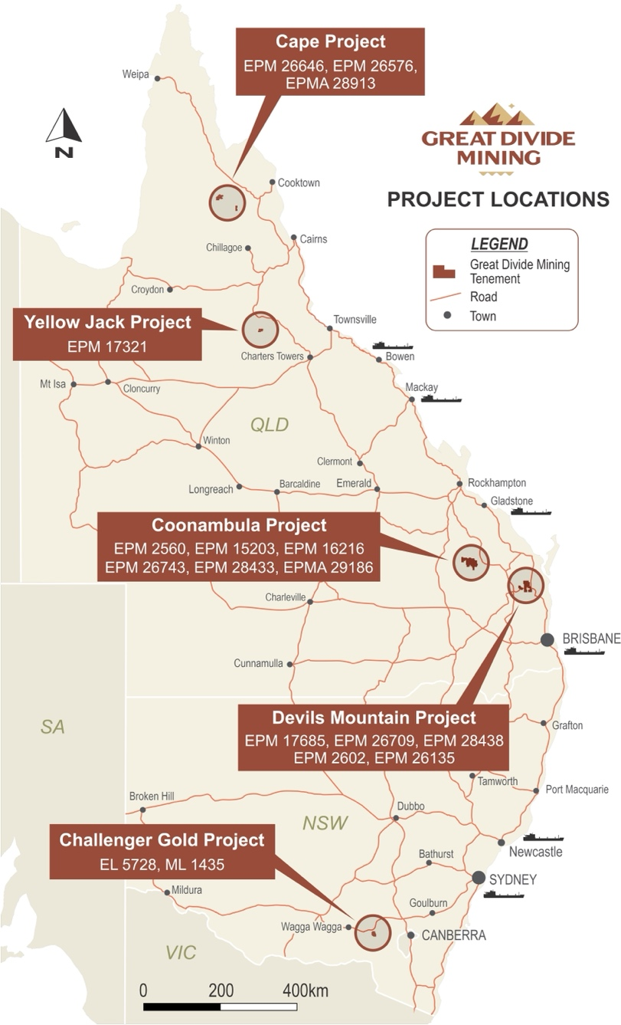

GDM from Explorer to Explorer-Producer.