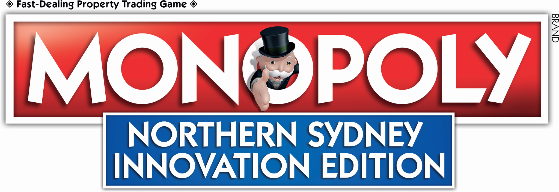

**MONOPOLY, THE WORLD’S FAVOURITE FAMILY BOARD GAME, IS COMING TO NORTHERN SYDNEY!**

Imagine having your company featured as a property on MONOPOLY, the most popular board game in the world. If your business is an innovator based in Northern Sydney, now’s your chance!

This is your one and only opportunity to be featured alongside key influencers in the innovation space on this once in a lifetime edition.

The team at North Sydney Innovation Network (NSIN), a non-profit organisation, has partnered with Winning Moves and Hasbro to create this first ever MONOPOLY board showcasing innovative Australian businesses and startups.

This edition will see local innovators replace Mayfair and Park Lane from the original MONOPOLY board and include customised “Community Chest” and “Chance” playing cards, making the entire game a truly Northern Sydney experience.

From today until **30 June**, you can tell us which companies you’d like to see featured on the board via the official Northern Sydney Innovation MONOPOLY [Facebook page](https://www.facebook.com/Northern-Sydney-Innovation-Monopoly-103475835238841), [Twitter page](https://twitter.com/MonopolyNorth), or by emailing [Monopoly@northsydneyinnovation.org](mailto:Monopoly@northsydneyinnovation.org)

The NSIN is a not-for-profit promoting the contribution of innovation-driven enterprises—particularly startups and fast-growth organisations in the North Sydney, the Northern Beaches and the whole North Shore.

Chair of the North Sydney Innovation Network (NSIN) Jonathan (Jono) Herrman said, “I’m thrilled to bring this edition to Northern Sydney to bring attention to the many innovative and forward-thinking organisations in this area.”

Winning Moves, manufacturers of the official Northern Sydney Innovation version of MONOPOLY licensed from Hasbro, say the game will be sold through exclusive local businesses.

Dale Hackett, Custom Games Manager at Winning Moves**,** said: “We’re so excited to bring this globally loved game to Northern Sydney. We want to ensure that this edition represents the best-in-class, most innovative businesses in the area.

“We’re asking locals like you to recommend which companies you think should be on the board. Everyone from startups and coworking spaces to forward-thinking corporations, research and educational institutions based in Northern Sydney are eligible to sponsor a space—so get involved!”

Dale adds, “This edition will be everything you love about the traditional board, adapted in a way that Northern Sydney residents will enjoy for generations to come. There will also be opportunities in the coming months for locals to get involved in the creation of this game, so be sure to follow us on [Twitter](https://twitter.com/MonopolyNorth) or [Facebook](https://www.facebook.com/Northern-Sydney-Innovation-Monopoly-103475835238841) to stay in the know.”

MONOPOLY first hit the shelves in 1935 – since then it has been played by more than 1 billion people. Today, it is played in 114 countries and enjoyed in over 47 different languages.

Cast your vote today on our [Facebook](https://www.facebook.com/Northern-Sydney-Innovation-Monopoly-103475835238841), [Twitter](https://twitter.com/MonopolyNorth), or by emailing [Monopoly@northsydneyinnovation.org](mailto:Monopoly@northsydneyinnovation.org)!

*© 2020 Hasbro, Inc. All Rights Reserved.*

**ENDS**

**EDITOR’S NOTES**

Northern Sydney locals can suggest their top properties from today until **30 June**.

Suggestions can be made via:

* Facebook: <https://www.facebook.com/Northern-Sydney-Innovation-Monopoly-103475835238841>
* Twitter: <https://twitter.com/MonopolyNorth>
* Email: [Monopoly@northsydneyinnovation.org](mailto:Monopoly@northsydneyinnovation.org)

**CONTACTS**

Jono Herrman, NSIN Chair

Monopoly@northsydneyinnovation.org

+61 419 977 970

Dale Hackett, Custom Games Manager - Tourism

Dale@winningmoves.com.au

+61 (2) 9437 3713

**ABOUT**

***About North Sydney Innovation Network (NSIN)***

*The North Sydney Innovation Network promotes and enhances the contribution of innovation-related businesses, particularly new startups and fast-growth businesses, to the economy and society of the Northern Sydney region.*

*The NSIN connects startups, established businesses, VCs/investors, government agencies, NFPs, and education institutes. NSIN supports events, an online community, policy and advocacy initiatives and the development of a major innovation precinct for Northern Sydney.*

***About Hasbro, Inc.***

*Hasbro (NASDAQ: HAS) is a global play and entertainment company committed to Creating the World's Best Play Experiences. From toys and games to television, movies, digital gaming and consumer products, Hasbro offers a variety of ways for audiences to experience its iconic brands, including NERF, MY LITTLE PONY, TRANSFORMERS, PLAY-DOH, MONOPOLY, BABY ALIVE and MAGIC: THE GATHERING, as well as premier partner brands. Through its entertainment labels, Allspark Pictures and Allspark Animation, the Company is building its brands globally through great storytelling and content on all screens.*

*Hasbro is committed to making the world a better place for children and their families through corporate social responsibility and philanthropy. Hasbro ranked No. 1 on the 2017 100 Best Corporate Citizens list by CR Magazine, and has been named one of the World’s Most Ethical Companies® by Ethisphere Institute for the past eight years. Learn more at* [*www.hasbro.com*](http://www.hasbro.com/)*, and follow us on Twitter (@Hasbro) and Instagram (@Hasbro)*