**Adelaide based Personal Trainer wins the WBFF Fitness Model title and earns the coveted WBFF PRO CARD**

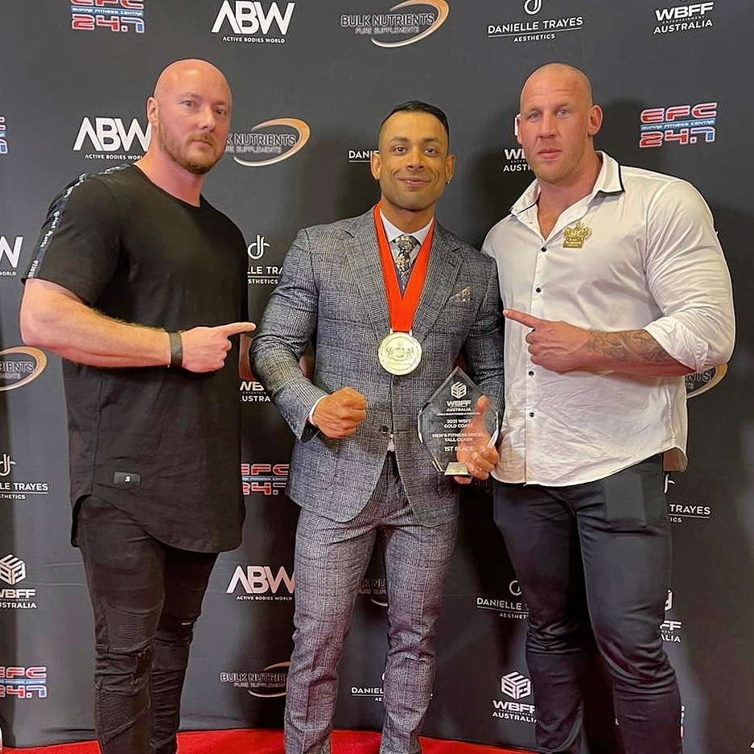

This year couldn’t have started any better for Syed Ali. An Adelaide based Fitness Model and Online Personal Trainer after winning the WBFF Australia AM Show (Men’s fitness model – Tall division) held at the Star Casino, Gold Coast on the 17th of April 2021 and earning his WBFF PRO Athlete status.

The World Beauty, Fitness, and Fashion [WBFF] is known for hosting the most prestigious and professionally run shows in the industry. The WBFF combines fitness, beauty and modelling while promoting health and fitness worldwide.

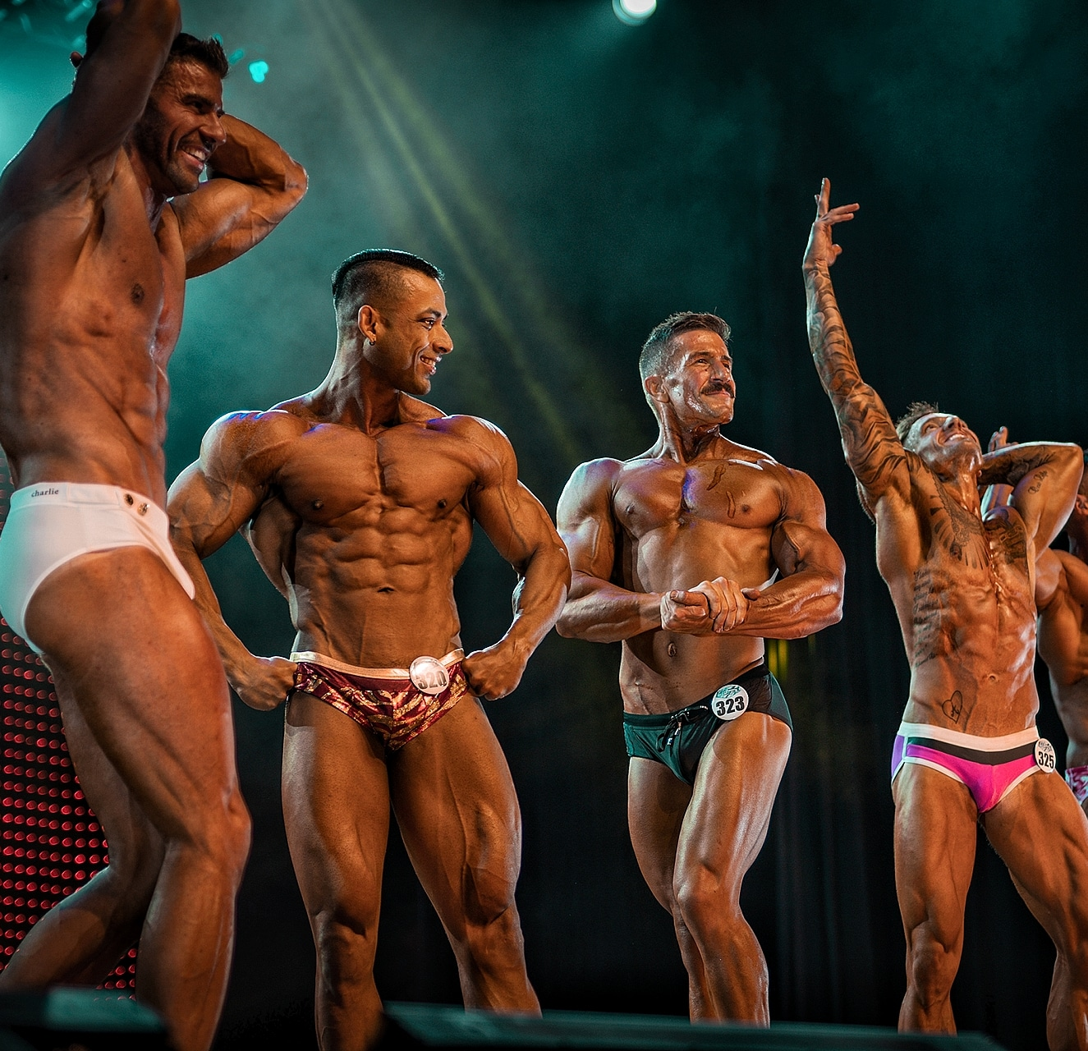

This was Ali’s third attempt at the title. He was placed as runner up in his last two attempts in May 2019 and October 2019. Despite coming short of his goal each time, he did not let his losses defeat him or his dream to take the win.

Ali states, “I did not let the two defeats discourage me. I requested for feedback after each loss, went back to the drawing board, worked on my weaknesses and came back with an improved package each time. I feel so happy and blessed to be rewarded for my hard work.”

His dedication and relentless attitude finally paid off with this incredible accomplishment.

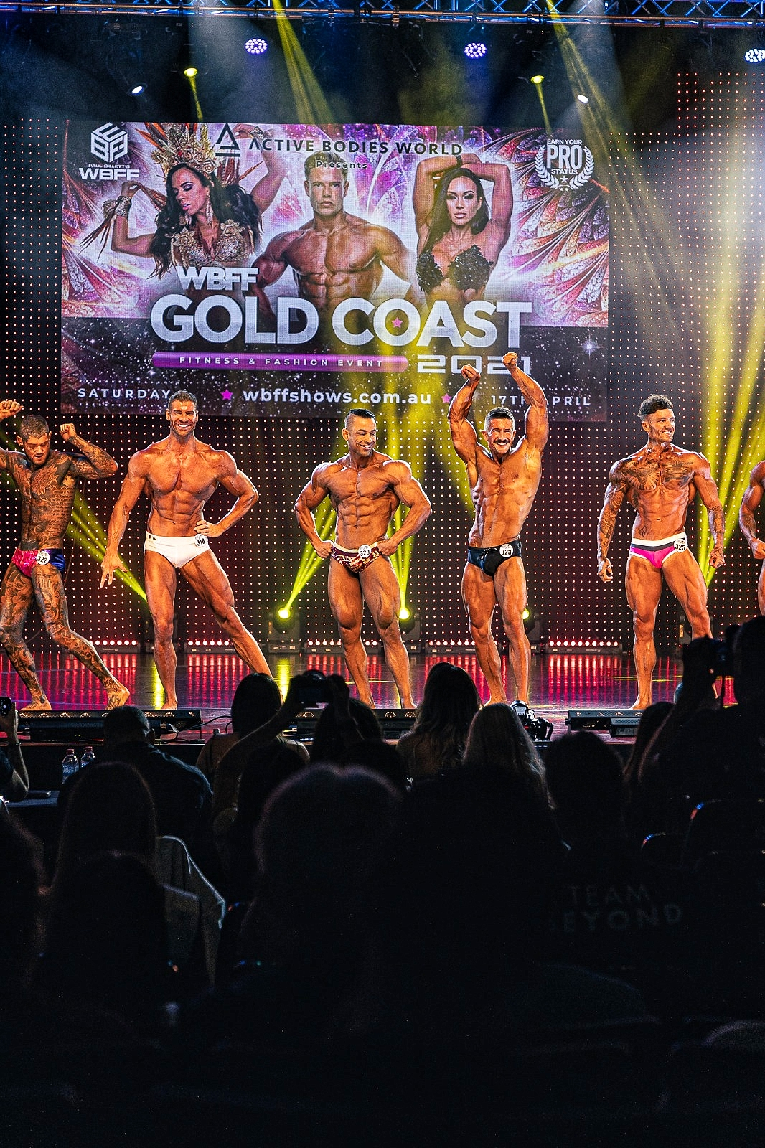

Winning the WBFF Show is just the beginning for Ali. He has no intention of resting on his laurels after conquering the Amateur Division. His next goal is to take on the Professional Division.

His short to medium term goals includes winning the WBFF Australia PRO Championship and represent Australia at the WBFF World Events.

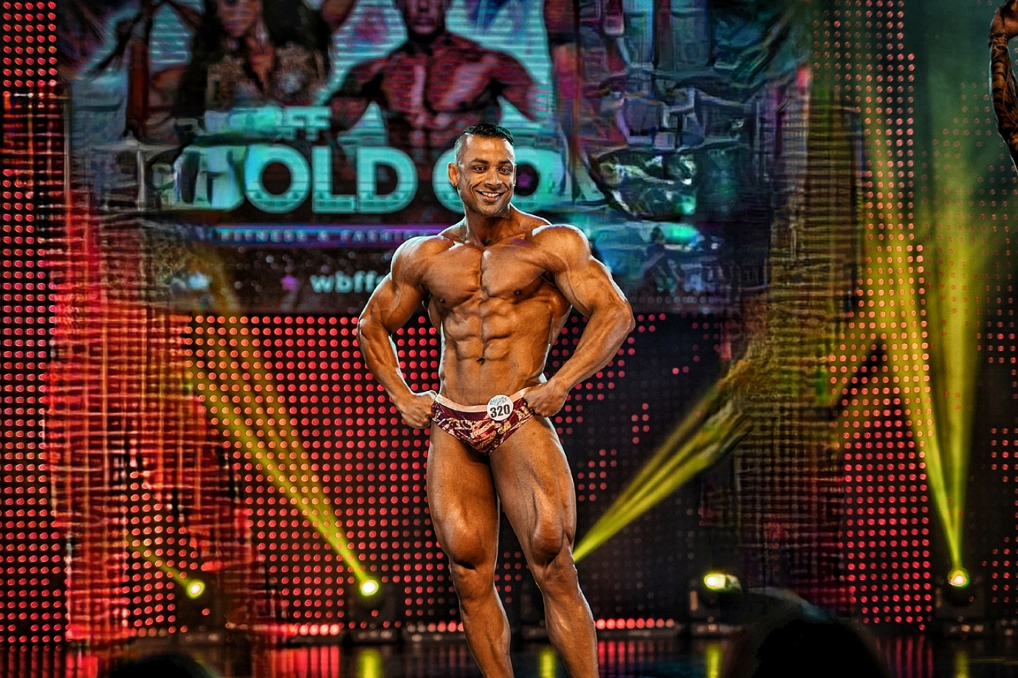

Outside of competing, Ali is an Online Personal Trainer with the [Daredevil Fitness Crew](https://www.daredevilfitness.com), a company that he founded with a fellow WBFF PRO – Koach Keith. The Daredevil Fitness Crew aims to become one of Australia’s top Body Recomposition teams specialising in areas of general population transformations, physique coaching, and competition preparation for both Men and Women competing in the WBFF and federations like the IFBB, ICN, NABBA, ANB and others.

Ali plans to make his PRO Debut this coming October. Be sure to follow his journey on Instagram at [@daredevilfitness](https://www.instagram.com/daredevilfitness/)