**ADCX ( Australian International Digital Currency Exchange )** announces partnership with **ROO Protocol** in order to develop a unique financial system integrating DeFi+DAO+NFT+ cross-chain technology

One of the hottest topics these days is that **ADCX – Australian International Digital Currency Exchange** just announced a mind-blowing partnership with one of the most interesting new projects right now, **ROO Protocol** (a blockchain infrastructure protocol focusing on NFT )

As an emerging asset class, on a global scale, cryptocurrency is moving closer to mainstream finance with an unprecedented momentum of development. Lately, Coinbase Global, Inc., one of the largest cryptocurrency exchanges in the world, reported blowout earnings for the second quarter of 2021, supported by the increasing popularity of Bitcoin, Ethereum, Cardano and other cryptocurrencies, but also because of the emerging NFT market among retail investors. In the past year, large companies such as Tesla, Paypal, Square, Goldman Sachs, and Morgan Stanley have successively invested or deployed the crypto industry.

In mid-July 2021, the well-known Australian foundation, [**ADCX Australian International Digital Currency Exchange**](https://www.adcx.com.au/#/)**,** announced that they will focus on the deployment of the NFT+Defi field, adding another fire to the crypto market.

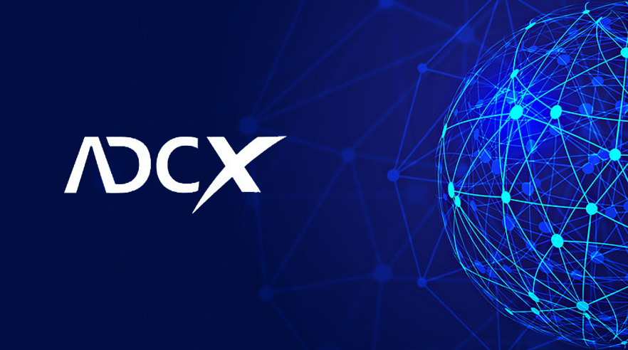

**ADCX ( Australian International Digital Currency Exchange ) Background:**

ADCX is a cross-chain asset exchange protocol based on the Ethereum Network. It is mainly used in NFT asset mortgage lending and NFT liquidity mining. A DeFi financial system incorporating DeFi+DAO+NFT+Cross-chain technology has been designed to provide services such as issuing, trading various assets and liquidity mining (e.g., DeFi, NFT, token trading strategies) through the ADCX protocol.

The ADCX team **has acquired a digital currency exchange license** from the **Australian Government**. Members of the team, mainly from Australia, Canada and Japan, are innovators in DeFi. Technical backbone are professional DApp developers, adhering to the technology-based, relying on the strength of capital and community, aiming to build ADCX into a comprehensive cross-chain financial platform, opening a new chapter in DeFi.

[**ROO Protocol Background**](https://rooprotocol.com/en/index.html)**:**

Roo Protocol is a decentralized financial system that combines NFT+DeFi+DAO+cross-chain technology and aims to provide DeFi and NFT services such as NFT marketplace, NFT building, NFT auction, NFT launchpad and so on.

**The NFT booming period…**

Earlier, due to the popularity of Bitcoin, Dogecoin and Cardano on Twitter, many people learned about cryptocurrencies for the first time. With NFTs, not only do you have ownership, you have ownership on the blockchain, you have ownership that is transparent for everyone to see.

Different from the first exploration attempts of many large traditional enterprises or capital, the **ADCX Foundation**, established in 2015, has conducted research and investment in many areas of the blockchain industry, involving Layer 2, NFT, cryptocurrency derivatives trading, and the Polkadot ecosystem He has invested in more than ten entrepreneurial projects such as Леникс, TokenEpoch, Bit Cloud and other key areas, and the actual assets under management have exceeded 100 million U.S. dollars.

**The CEOs of Fortune 500 companies lead many industry experts, and the ADCX creative team has a strong lineup**

In terms of the formation of the main creative team, ADCX's core lineup has frequently attracted public attention. The current CEO of ADCX is Dan Ciocan, the former operating officer of Fujitsu Consulting (Fujitsu). Regarding the new position and mission, Dan said: “ADCX will usher in a new era, allowing everyone to enjoy the financial inclusiveness brought by encryption technology. NFT will become a new type of asset that benefits everyone. "Fujitsu is a world-leading information and communication technology company, the world's fourth largest IT service company, the second largest enterprise hard disk manufacturer, and a long-term global Fortune 500 company.

Dan formally came into contact with Bitcoin and blockchain in 2016 and was quickly attracted by them. He firmly believes that this technology will have revolutionary significance for the financial industry. In the following years, Dan focused on blockchain development, artificial intelligence applications and traditional business intelligence scenarios. He is very good at formulating company development strategies and team operations in professional fields. He is a leader with great entrepreneurial spirit.

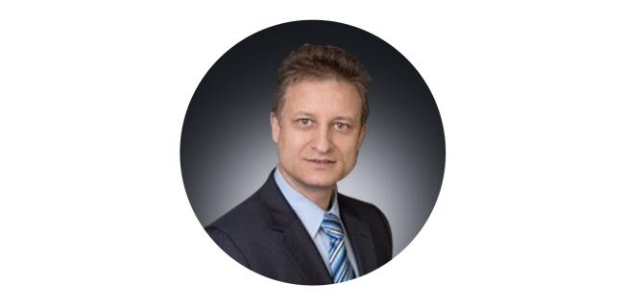  
**ADCX CEO Dan Ciocan**

In the latest ADCX team lineup, the CFO and CMO are **Micheal McCluskie** and **Cosmin Muresan**, respectively. Micheal is a top financial analyst and holds a Chartered Financial Analyst with the CFA Institute. He has worked in Toyota Motor, the United Nations and other organizations, and has outstanding capabilities in financial analysis and risk management. Cosmin is a 10 A senior marketing expert with more than 20 years of experience in both traditional and online marketing having a unique sense of market analysis and always seeking new market opportunities. He is confident that his keen insight will have a key impact on ADCX market development.

The most concerned technology and product development work is led by **Mark Denmeade and Jehanzeb Khan**. Mark is a senior blockchain and IT expert. He has more than 18 years of experience in data sharding and distributed clusters. And rich experience in hot and cold storage; Jehanzeb Khan served as the technical director of Electronic Arts (EA), proficient in various system languages ​​and blockchain technology applications. The industry believes that a large pool of talents on the technical line has laid a good foundation for ADCX.

**A number of well-known political and business leaders took the lead and the ADCX super consultant team was formed:**

Also gratifying is ADCX’s super consultant team. They are, **Karel ten Hoope** of Knowledgetech Consulting Inc, **Akahori Hiroyuki**, the former managing director of ITOCHU Textiles in Hong Kong, and the core consultants are well-known Australian political elites and Ernest Wong.

Ernest Wong is a very prestigious political figure in Australian politics. He was elected Mayor of Burwood, Australia in 2003, and was elected as the Deputy Speaker of the House of Lords in 2016. Speaking of being an ADCX consultant, Wong said: “Bitcoin has allowed the world to see the power of the blockchain. I am very happy to see the competitiveness and ambition displayed by the Australian Exchange. Like all cryptocurrency enthusiasts, we are full of ADCX. confidence!"

In addition, among ADCX's partners, there are many large-scale well-known companies such as **PPW Group, Australian Bullion Exchange, ITOCHU Corporation, Valorton Group, Ginza**, etc., which will provide great momentum for ADCX's subsequent expansion and development.



**Abundant access to top IP resources, ADCX community users continue to soar**

Recently, the dynamic progress of ADCX has begun to be revealed frequently. According to the ADCX community, ADCX has acquired many top IP images such as **"The Smurfs", "Mickey Mouse", and "BearBrick"**, and has also cooperated with the **Australian Bullion Exchange** to issue " Many gold and silver commemorative coins such **as Mickey Mouse and Doctor Who Monster Character Series** will be issued on the NFT chain with multiple IP images later.

The effect of rich IP resources has brought about the high activity of the community. At present, the **ADCX community has more than 200 communities** around the world, and the cumulative number of community users is close to 100,000. This number is still growing.

**Conclusion:** Past experience has shown that a good blockchain project, in addition to a good main track and a clear business model, an effective project team is the real key to the success the project. The source believes that this super team represented by Dan will take [**ADCX**](https://www.adcx.com.au/#/) to the next level and this will be the next thing the society and the encryption industry have been waiting for…

**Learn more about ADCX:**

Website: <https://www.adcx.com.au>

<https://adcx.io/frontendv1/#/swap>

Facebook: <https://www.facebook.com/ADCX-Australian-Digital-Currency-Exchange-101972005486726>

**Learn more about ROO Protocol:**

Website: <https://rooprotocol.com/>

Facebook: <https://www.facebook.com/Roo.NFT.Protocol>

GitBook: <https://rooprotocol.gitbook.io/roobdoc-en/>