28 for TWENTY EIGHT - Media Release

Meditation Can Change Lives. And Even Save Them.

28 for TWENTY EIGHT is returning in 2021, led by Making Meditation Mainstream in support of Lifeline.

Last year, local not-for-profit Making Meditation Mainstream (MMM) ran an innovative meditation campaign called ‘28 for TWENTY EIGHT’ – challenging Australians to complete 28 meditations in 28 days and raise critical funds for Lifeline.
The successful event is happening again this year during Mental Health Month, between 1-28 October 2021, and everyone is being encouraged to take part.
To register, simply visit the Making Meditation Mainstream website. You will be able to access live guided meditations every day, plus mindfulness tips and more pre-recorded meditations throughout Mental Health Month.
Jason Partington, Founder of MMM, is excited to continue his work bringing meditation to the mainstream community.
“We’re trying to dispel the view that meditation is only for certain people with certain interests,” says Mr Partington. “Through projects like ‘28 for TWENTY EIGHT’, we can bring meditation to people in a way that’s inclusive, safe and welcoming – plus, raise money to support mental health along the way.”

There’s little doubt that Lifeline can make good use of every dollar raised.
“We are experiencing a record number of crisis calls and a huge increase in demand for our local counselling services due to the impact of COVID,” says David Thomas, CEO of Lifeline Northern Beaches.
“It costs us $39 to answer a single call. While that can seem like a lot, it’s a small price to pay for a life-saving conversation. So, we’re asking ‘28 for TWENTY EIGHT’ participants to consider making a small daily donation for the duration of the campaign.

“Lifeline’s 13 11 14 crisis support line receives a call every 30 seconds, so even a dollar a day will help to save a life.”
Last year, ‘28 for TWENTY EIGHT’ raised more than $31,000. The campaign communicated the benefits of meditation to over 4 million people, engaging a daily average of 4,500 people. It also earned the title of 2020 Northern Beaches Community Event of the Year – a reflection of the impact and sense of togetherness created.
“We hope we can smash last year’s record in 2021. Lifeline is calling on all Australians to put their mental health first this year, so we are calling out to all individuals, families, schools, community groups, local business and corporates to get on board,” says Jason Partington. “As well as raising money for suicide prevention services, you could be establishing a self-care practice that makes a difference in your own life every day.”
To take part in ‘28 for TWENTY EIGHT’ simply visit our website or visit the Facebook page.

For more information, contact:
Jason Partington
Founder
Making Meditation Mainstream

Deanne Bennett
Fundraising Manager
Lifeline Northern Beaches

M 0433 780 324
M 0447 474 979
T (02) 9949 5522

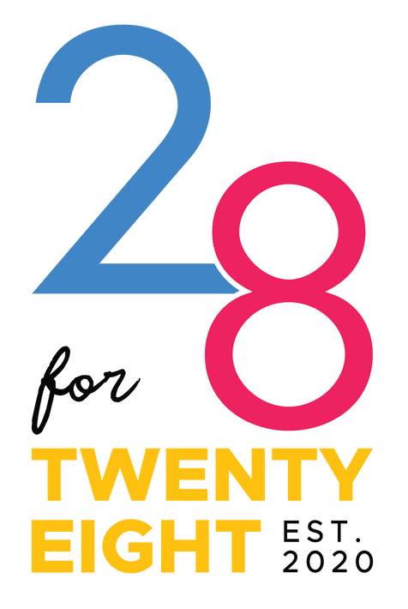E jason@meditationformen.com.au
W www.makingmeditationmainstream.com.au
E deanne.bennett@lifelinenb.org.au
W www.lifelinenb.org.au

