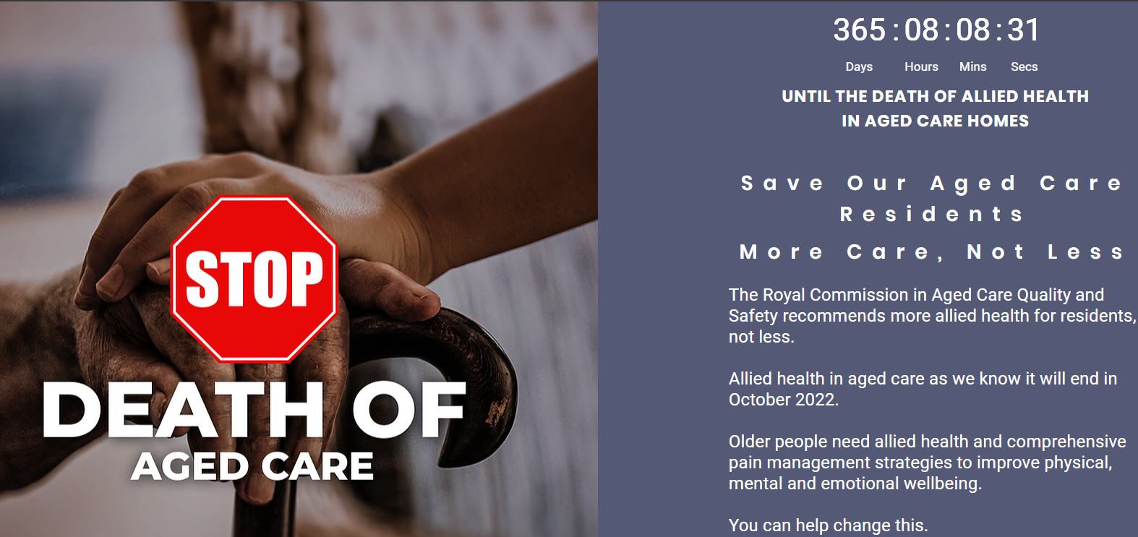
FOR IMMEDIATE RELEASE: 30th September 2021
In exactly one year Nursing home residents will not receive funding for Allied Health
The government’s new funding model does not include funding for Allied Health for Nursing home residents after 1st October 2022, which is only 365 days away.
Concerned members of the public, physiotherapists, occupational therapists, and others who work in nursing homes have joined together in a grassroots campaign worried about what will happen to older people without allied health. This campaign is called the Death of Aged Care and officially launches on the 1st of October 2021 with a subscriber only event at 12pm, exactly 1 year until allied health will not be funded. This campaign is non-political and non-industry specific and is open to anyone who wants to support better care for our elders in nursing homes.
The campaign calls on Australians to ask the Minister for Health and Aged Care, Greg Hunt, and their local member to ensure that allied health is included as a separately funded and mandated item in the new aged care funding model (AN-ACC).
“Everyone who has parents or loved ones in aged care, or even worries about what will happen when they get older, should be concerned about this change,” said Alwyn Blayse, Senior Physiotherapist and campaign organiser.
“The change means that instead of hands-on treatment for pain, our elders will be given more pain medication – which leads to more side effects. Older people will fall more and end up in hospital more. There will be more work for already over-worked nurses. This is the crisis point. If the government doesn’t amend the AN-ACC to include allied health, we will see a reduced standard of living in aged care and, we fear, more deaths.”
The government only recently confirmed that the AN-ACC, which has a proposed start date of 1 October 2022, will remove funding for allied health and after this that nursing homes will have to fund this themselves. Many homes are in financial distress and are unlikely to fund allied health from their own budgets when they have to prioritise many other care needs as well as the extra mandated nursing hours that are also part of the new AN-ACC system.
Mandated nursing hours don’t start until October 2023 which means nurses in Residential care will have a whole year without extra hours to manage complex presentations like falls without allied health support.
Research has shown that physiotherapy can reduce falls - the number one cause of preventable death in older people – by 55%.
The recent Royal Commission into Ageing Quality and Safety found that the current 8 minutes a day of allied health per resident was inadequate, and called for more allied health. The government partially accepted this recommendation. However, in the 2021 budget the federal government only allowed $27 million over 4 years for funding in the new AN-ACC funding model to improve access to allied health. This is equivalent to 2 seconds a resident per a day, which is far less allied health than older residents receive now, and much less than they need.
The campaign website www.deathofagedcare.com.au has an easy link ‘take action’ button for members of the public to express their concerns in an email directly to the minister. It also has a countdown timer from now until the 1st of October 2022, the first day that allied health will not be funded.
“In only 12 months nursing home residents will get significantly less allied health than they are getting now. Decisions are being made by nursing homes and allied health groups planning workforces in advance right now. If we don’t do something now, allied health for nursing home residents will end. Older people built this country we owe it to them to look after them. They need more allied health not less. “said Mr Blayse.

Authorised by Alwyn Blayse Physiotherapist and Campaign Director
Death of Aged Care Campaign
Level 3/826 Ann Street Fortitude Valley QLD 4006
Phone 5391 3885
stop@deathofagedcare.com.au
www.deathofagedcare.com.au

