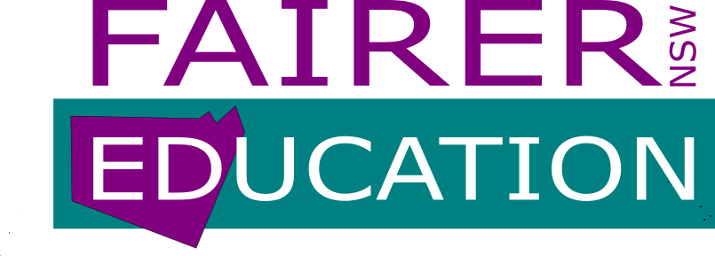

MEDIA RELEASE
Tuesday, 7th September, 2021

NEW PARTY TO FIGHT FOR FAIRER OUTCOMES FROM STATE EDUCATION

A group of prominent educators and parents is forming a political party, FAIRER EDUCATION NSW, with the aims of delivering a curriculum that properly addresses the needs of students and guarantees appropriate support and resourcing for the institutions that support them.
FAIRER EDUCATION NSW intends to present candidates to contest seats in the Legislative Council of the NSW Parliament at the 2023 state election and is seeking public support.
The party’s objectives include:
- A fairly resourced education system that will deliver increased learning outcomes for all students.

- A relevant and challenging curriculum that can be accessed by all students taught by appropriately qualified teachers.

- All levels of the education system, from early childhood to tertiary, led by accomplished, qualified educators.

- Removal of wastage and replication in the bureaucracy of NSW Department of Education.

FAIRER EDUCATION NSW includes leading school principals, educators and concerned citizens. The party convenors include:

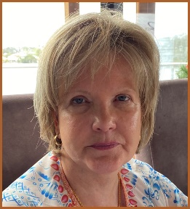
Cheryl McBride OAM is a long term principal who has based her career in some of the largest disadvantaged schools across south west Sydney. She has undertaken leading advocacy roles, and campaigned with parent and teacher groups, to promote improvement, excellence and equity for all students in NSW educational facilities.

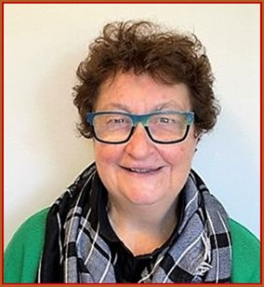
Gemma Ackroyd is a former school principal, with 37 years in the public education school system. Aside from teaching primary aged children, her varied career included teaching/leading roles in English as a Second Language, Adult Migrant Education, and Gender Equity. Gemma was awarded the Australian Centenary medal for her contribution to education.

FAIRER EDUCATION NSW president Cheryl McBride OAM says, “While there have been some gains in recognition, resources and funding for public schools, the advocacy by key education alliances has not been sufficient to prevent erosion of the integrity and reputation of education in NSW.
“False and misleading dialogue emanating from public figures, including members of Parliament, combined with impractical suggestions around the new curriculum, have destroyed the public’s faith. The current urgency of the situation encourages us to seek an independent, political platform to support and prioritise NSW Education, in particular schools, TAFE’s and universities.
“FAIRER EDUCATION NSW candidates will provide an informed and dedicated voice in the NSW Parliament. This is a unique opportunity to increase learning outcomes for all children, young people and mature age students, and to ensure continuous improvement of the curriculum. Knowledgeable, skilled and analytical students become capable, contributing citizens in a great society.”

Contact Fairer Education NSW President: Cheryl McBride OAM 0459 837 441
Website: www.fairereducationnsw.org.au
Email: info@fairereducationnsw.org.au

