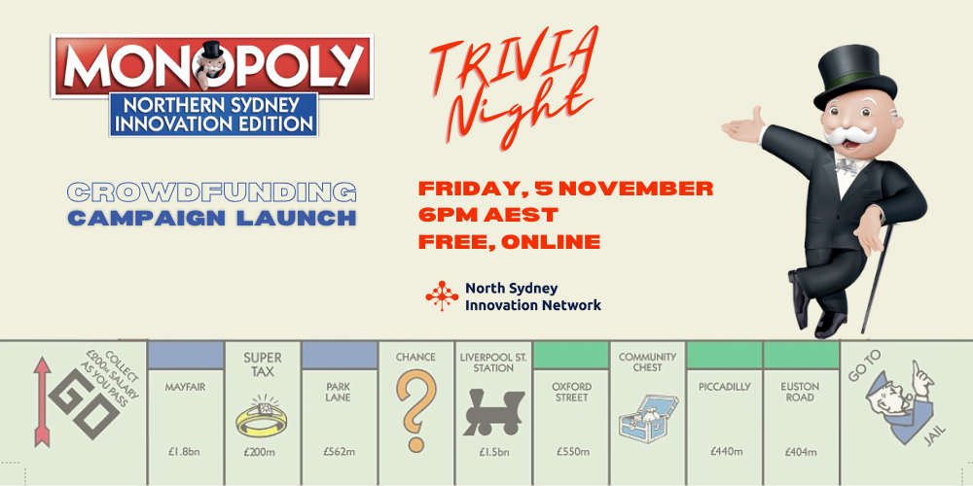
North Sydney Innovation Network Launches Crowdfunding Campaign for a Limited Edition Monopoly Board
Sydney, Australia (26 October 2021) — Be among the first to own this limited edition Monopoly Board featuring tech startups and innovative businesses in Northern Sydney! The North Sydney Innovation Network (NSIN) is about to launch their first ever crowdfunding campaign, and they’re inviting you to a free, online trivia night to celebrate.

The NSIN and trivia master Wayne Shapiro present: Trivia Night - a night of fun for everyone! This free, online event celebrates the launch of the crowdfunding campaign where you’ll get exclusive discounts and early access to purchase this limited edition Monopoly board.
This is the first ever Monopoly board showcasing innovative Australian businesses and startups. This limited edition board will feature businesses big and small that are pushing the boundaries of technology and innovation from Sydney's North Shore.
Guinness World Record holder Neil Scallan said, “I own 3,300 [Monopoly boards] at the moment, and very soon, will add the Northern Sydney Innovation Monopoly set to my amazing collection … and what a nice set that should be too!”
The kind of unique edition you’ll want to display for all to see. Playing this version will inspire you and teach your friends and get your kids thinking early about how to turn their wild ideas into real-life businesses.
The NSIN is a not-for-profit promoting the contribution of innovation-driven enterprises—particularly startups and fast-growth organisations in the North Sydney, the Northern Beaches and the whole North Shore. They run startup pitch and networking events, policy and advocacy initiatives and a vibrant online community.
NSIN Chair Jono Hermann said, “We want to showcase the innovative startups, tech and innovation that’s happening on the north shore. And, sure enough, we are now producing the first tech and innovation themed board not only in Sydney, but in all of Australia. We’re aiming to have coworking spaces, EdTech, AgTech, FinTech, some universities and research institutions … and really represent the whole ecosystem.”
Fun for families, friends, teens, kids, singles, this inclusive event will challenge your knowledge of Monopoly as well as general topics. North shore based host Wayne Shapiro has hosted more than 5,000 trivia quizzes since 2002. A true professional, this will be an engaging event for people of all ages and backgrounds.
Everyone who attends will have the chance to win a free Monopoly board, plus get early access to the crowdfunding page.
Proceeds from the sales of these boards will give the NSIN the funds they need to hire staff to run events, research data and trends, and inform government bodies about how to support innovation and tech in our local community.
Get your free ticket to Trivia Night here: https://events.humanitix.com/get-on-board-or-northern-sydney-innovation-edition-monopoly

Can’t make it to the event? No worries, you can get on the mailing list and learn more about the project here: https://mailchi.mp/96df94d38b8d/startup-monopoly
Interested in a spot on the board? Email Monopoly@northsydneyinnovation.org
ENDS
--
IMAGES

Please find images and videos in this folder:

https://drive.google.com/drive/folders/1NycLSDlK6Enx3LDCwUfVZtIJo3PFebHW?usp=sharing
CONTACTS
Jono Herrman, NSIN Chair
Monopoly@northsydneyinnovation.org
+61 419 977 970
ABOUT
About North Sydney Innovation Network (NSIN)
The North Sydney Innovation Network promotes and enhances the contribution of innovation-related businesses, particularly new startups and fast-growth businesses, to the economy and society of the Northern Sydney region.
The NSIN connects startups, established businesses, VCs/investors, government agencies, NFPs, and education institutes. NSIN supports events, an online community, policy and advocacy initiatives and the development of a major innovation precinct for Northern Sydney.

