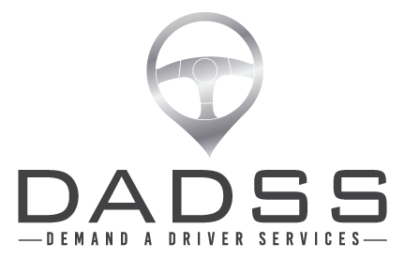

FOR IMMEDIATE RELEASE

Economical chauffeur style service, for young families.

Safe, background checked driver at a family friendly price.

Mark is a Dad and professional driver who noticed so many young families struggling at the airport to unload kids and strollers and luggage.

Mum is left on the pavement trying to hang onto the toddlers and baby while Dad goes off to find that elusive, expensive park.

Mark had a lightbulb moment and **Demand A Driver Services** was born.

Not only for families, but for anybody who’s suffered the stress of trying to get their car to the mechanic and back on a busy workday.... or what if you need a fleet car, or van, or even truck...taken to a different location.

Don’t stress out over your schedule, leave it to a **DADSS**

This is a new service, fully developed locally for the safe, stress free and friendly transfer of young families to and from the airport.



Kind Regards

Mark Houlton

Proprietor

Ph 0455 529 006